Additional questions on Amino acids, dipeptides, tripeptides and proteins
All of the following questions have not (as yet!) appeared in the NCEA Level 3 Exams

1.
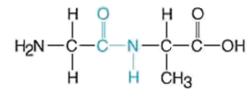
“The dipeptide glyclyalanine is made up of amino acids.” Discuss this statement

2. Draw the structural formula of the following amino acids

Serine  2-amino-3-hydroxypropanoic acid  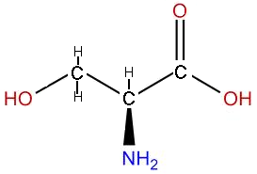 | Glycine  aminoethanoic acid  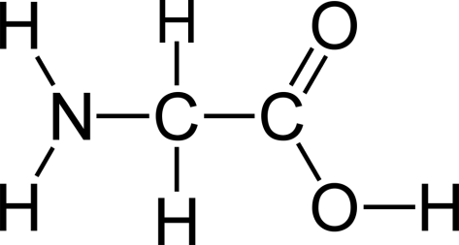 | Alanine  2-aminopropanoic acid  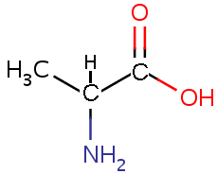

Draw a small section of silk, a polymer made up of repeating unit of the amino acids, put a square box around all of the peptide links
glycine - serine – glycine – alanine – glycine – alanine in that order

3. Draw the structures of alanine (2-aminopropanoic acid) as i) a zwitterion ii) in acidic solution and iii) in basic solution

© 2018 https://www.chemical-minds.com

