ANSWERS: Additional questions on Amino acids, dipeptides, tripeptides and proteins

1. The dipeptide glyclyalanine is made up of two different amino acids, we know this because of the letters “di” in dipeptide. The names of the two amino acids are glycine and alanine.

The structure for glycine is  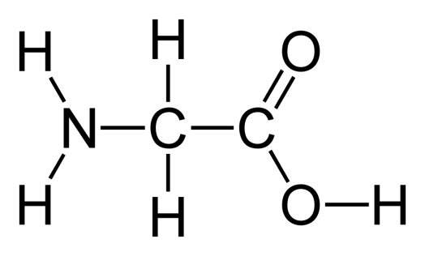 | and the structure for alanine is  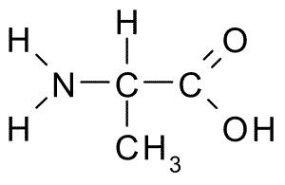

The -ine ending of the glycine is changed to -yl because glycine it's -OH is lost in the condensation/dehydration reaction forming the dipeptide.

The bond between the two amino acids is known as a peptide bond. This is a condensation reaction because a large molecule is formed with the loss of a small molecule (H₂O). A hydroxy (-OH) group is lost from the carboxyl group of the glycine and a hydrogen atom (-H) is lost from the amino (-NH₂) group of the alanine. Glycylalaine is not the only dipeptide that can form between these two amino acids, they can combine in the reverse order to form acylglycine,
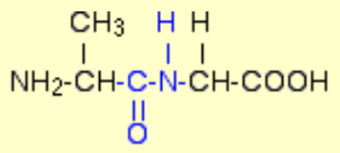
in which case the hydroxy (-OH) group is lost from the carboxyl group of the alanine and the hydrogen atom (-H) is lost from the amino (-NH₂) group of the glycine.

2.
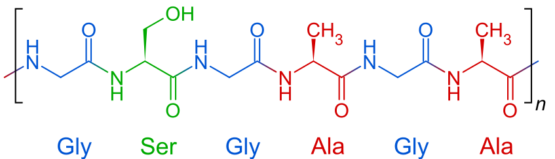
3.
Alanine  zwitterion  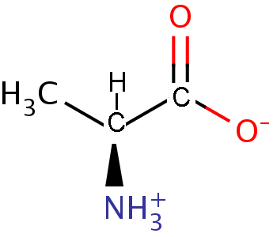 | Alanine  in acidic solution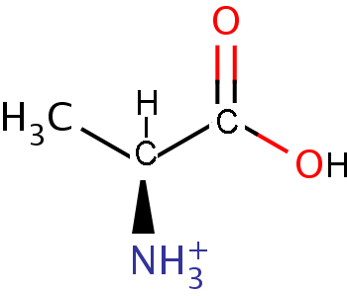 | Alanine  in basic solution  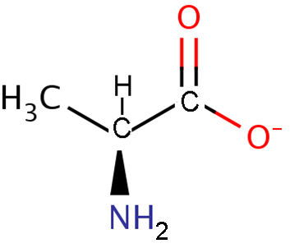

© 2018 https://www.chemical-minds.com

