ANSWERS: Additional questions on experiments or demonstrations involving polarity
1. When a balloon is repeatedly rubbed on a woollen jumper or cloth, electrons (which have a negative charge) are transferred to the balloon. When the charged balloon is brought near to the water the balloon pushes negatively charged electrons in the water away, leaving a positively charged area of the water which is attracted to the balloon. So the stream of water is deflected towards the balloon. This experiment proves that water is a polar molecule and every molecule of water has a negatively charged end at the oxygen and positively charged ends at the hydrogens.
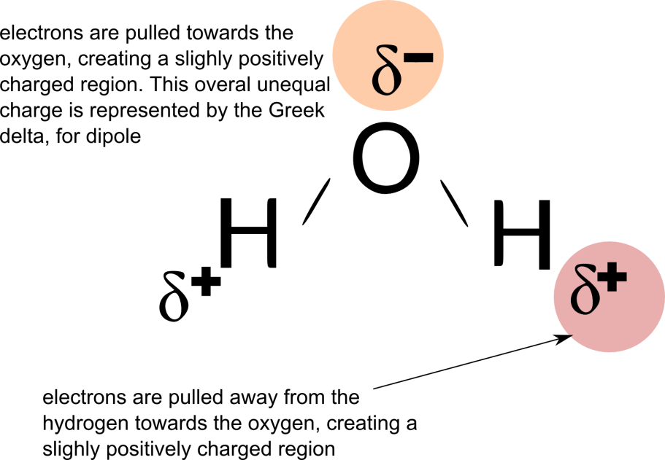
2. Set up a burette containing propan-2-ol. Allow the propan-2-ol to run from the burette in a steady stream. Charge a plastic ruler or balloon on a woollen jumper. Bring the charged plastic ruler/balloon near the stream of each liquid. If the propan-2-ol is polar the stream of propan-2-ol will be deflected by the charged ruler/balloon. If the propan-2-ol is non polar the stream will not be affected at all. As propan-2-ol is a polar molecule we are expecting to see the stream of propan-2-ol being deflected by the charged ruler/balloon.

3. Lycopodium powder will not mix with the water because it is hydrophobic or water hating. When you stick your hand into the powder and water, the force of your hand makes the powder particles stick to your fingers and push the molecules of the water away, therefore the powder is like a water repellent.This proves that the water is polar, and the powder is nonpolar. These properties mean that the two substances will not dissolve or mix with each other. The molecules of the powder try to stay away from the molecules of the water. In addition, the powder is mostly less dense than the water and will float on the top.

4. Iodine solution (I₂) is non-polar and has a brown colour, when water is mixed with the iodine solution the solution remains brown. Dichloromethane is a non-polar solution which is colourless, as dichloromethane is less dense than water the dichloromethane will be seen as a separate layer floating on top of the water (in a similar way to the effect seen when oil floats on water). After the solution is inverted in the separating funnel and left to settle, the top layer of dichloromethane will turn a purple colour due to the iodine molecules moving into top layer of dichloromethane. Both iodine and dichloromethane are non-polar molecules. The lower layer of water will now be colourless as all of the iodine solution has moved from the water up to into the dichloromethane where it (the iodine) is more soluble.

5. The solution of blue food colouring in water is polar and will not mix with the colourless propan-2-ol which is non-polar, so two distinct regions will be seen in the petri dish.
6. Bromine (Br₂) is a non-polar molecule so it is only slightly soluble in water which is a polar solvent. When the solution of bromine and water is mixed with cyclohexane, the bromine molecules move into the cyclohexane layer because cyclohexane is also non-polar. This causes the top layer of the solution (containing bromine and cyclohexane to become a purple colour), whereas the bottom, more dense layer is colourless water. © https://www,chemical-minds.com

