Additional questions on bond enthalpy

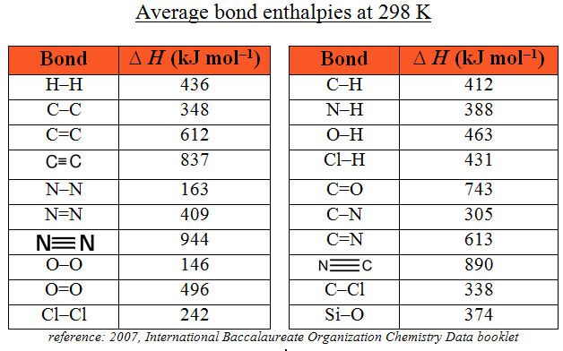

1. Calculate the energy change for this reaction: CH₂CH₂(g) + 3O₂(g) 2CO₂(g) + 2H₂O(g)

2. Use the Haber process equation to calculate the average bond enthalpy value for the N–H bond
N₂(g) + 3H₂(g) 2NH₃(g) ∆_{r}H = -92 kJmol⁻¹
3. Calculate the energy change for photosynthesis  6CO₂(g) + 6H₂O(l) C₆H₁₂O₆(s) + 6O₂(g)  The structure of glucose is shown below | 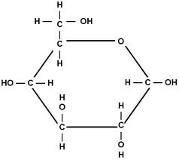

4. Hydrazine was first used as a rocket fuel during World War II. The equation below shows the combustion of hydrazine, use it and the bond enthalpy values to calculate the energy change for this reaction.
N₂H₄(l) + O₂(g) N₂(g) + 2H₂O(l)
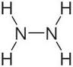

5. Calculate the heat of reaction for the combustion of butane when completely burned in oxygen

6. Carbon monoxide can be formed from the reaction of methane gas with steam. The following endothermic
reaction absorbed 206kJmol⁻¹ of energy,
Calculate the bond enthalpy for the C≡O bond in carbon monoxide.
CH₄(g) + H₂O CO(g) + 3H₂(g) ∆_{r}H = +206 kJmol⁻¹

7. Use the bond enthalpy values in the table above and these values S-S 264kJmol⁻¹ and S=S 352kJmol⁻¹ to suggest a reason why 8 sulfur atoms tend to form one S₈ molecule whereas 8 oxygen atoms tend to form four O₂ molecules.
© https://www.chemical-minds.com

