ANSWERS: Additional questions on bond enthalpy
1,
bond breaking  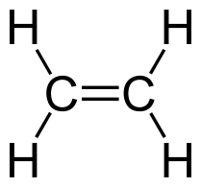 + 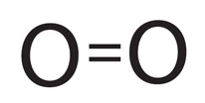  4 x C–H = 4 x 412 = 1648  1 x C=C = 612  3 x O=O = 3 x 496 = 1488  total bond breaking = 3748 |  | bond making  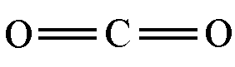 + 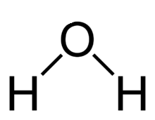  4 x C=O = 4 x 743 = 2972  4 x O-H = 4 x 463 = 1852  total bond making = 4824
difference between the two values is 1076
reaction is exothermic as bond making value is higher than bond breaking
Answer: - 1076kJmol⁻¹
2.
bond breaking  1 x = 944  3 x H-H = 3 x 436 = 1308  total bond breaking = 2252 | bond making  6 x N-H = 6 x ? | overall energy change  - 92
2252 + 6? = -92
6? = -92 – 2252
6? = - 2344
? = 2344/6
? = 390.66
Ans 391kJmol⁻¹
3.
bond breaking  6 + 6 | bond making  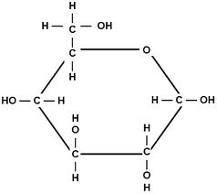 + 6
12 x 743 + 12 x 463  = 8916 + 5556  = 14472 | 7 (C – H) + 7 (C-O) + 5 (O-H) + 5 (C-C) + 6  7 x 412 + 7 x 360 + 5 x 463 + 5 x 348 + 6 x 496  2884 + 2520 + 2315 + 1740 + 2976  = 12435
reaction must be endothermic as bond breaking value is higher than bond making value, although common sense tells us this anyway as for Photosynthesis to occur light energy is required
The answer is + 2037 kJ mol⁻¹

4.
bond breaking  1 x N-N = 163  4 x N-H = 4 x 388 = 1552  1 x O=O = 496  total bond breaking = 2211 | bond making  = 944  4 x H-O = 4 x 463 = 1852  total bond making = 2796
difference between the two values is 585
reaction is exothermic as bond making value is higher than bond breaking
Answer: - 585kJmol⁻¹

5.
2C₄H₁₀(g) + 13O₂(g) → 8CO₂(g) + 10H₂O(g)
bond breaking  6 x C-C = 6 x 348 = 2088  20 x C-H = 20 x 412 = 8240  13 x O=O = 13 x 496 = 6448  total bond breaking = 16776 | bond making  16 x C=O = 16 x 743 = 11888  20 x H-O = 20 x 463 = 9260  total bond making = 21148
difference between the two values is 4372
reaction is exothermic as bond making value is higher than bond breaking
Answer: - 4373kJmol⁻¹

6.
bond breaking |  |  | bond making |  | overall energy change
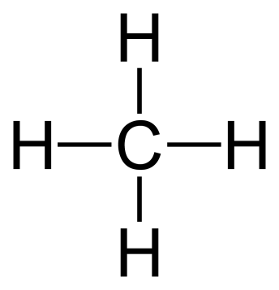 |  |  | C≡O | 3 H-H
4 C-H  4 x 412 | 2 O-H  2 x 463 |  | 1 C≡O | 3 H-H  3 x 436 | +206 kJmol⁻¹
1648 | 926 |  | ? | 1308 | +206

2574 –(1308 + ?) = +206

1266 + ? = + 206

? = +206 – 1266

? = 1060 kJmol⁻¹

7.
1 molecule of S₈ | 4 molecules of S₂ | 1 molecule of O₈ | 4 molecules of O₂
8 x S-S  = 8 x 264  = 2112 kJmol⁻¹ | 4 x S=S  = 4 x 352  = 1408 kJmol⁻¹ | 8 x O-O  = 8 x 146  = 1168 kJmol⁻¹ | 4 x O=O  = 4 x 496  = 1984 kJmol⁻¹
as can be seen from the values above, considerably more energy is required to breaks the eight single bonds between 8 sulfur atoms in S₈, 2112 kJ of energy is required, compared to 1408 kJ of energy required to break four S=S bonds in four molecules of S₂ So, sulfur tends to form 1 S₈ molecule |  | as can be seen from the values above, considerably more energy is required to breaks the four double bonds between 4 oxygen atoms in O₂, 1984 kJ of energy is required, compared to 1168 kJ of energy required to break eight O-O bonds in 1 molecule of O₈ So, oxygen tends to form O₂ molecules

© https://www.chemical-minds.com

