Additional questions on calculating and interpreting Kc

1. The diagrams below represent equilibrium mixtures for the reaction P₂ + Q ⇌ PQ + P at 25 °C and 300 °C respectively. Deduce and explain whether the reaction is exothermic or endothermic.

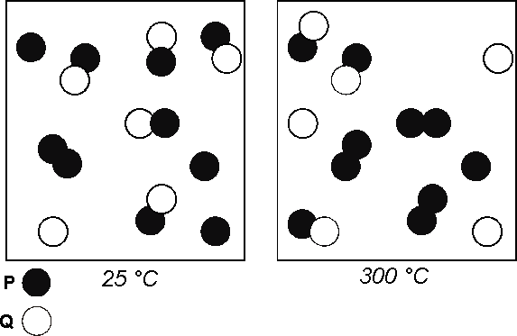
2. For the reaction

4NH₃ (g) + 5O₂ (g) ⇌ 4NO (g) + 6H₂O (g) H = - 46.2 kjmol⁻¹

a) write an expression for the equilibrium constant

b) Calculate the value of Kc given the following equilibrium concentrations at 400 °C
[NH₃] = 0.1 mol L⁻¹ [O₂] = 0.125 mol L⁻¹ [NO] = 0.1 mol L⁻¹ [H₂O] = 0.15 mol L⁻¹

c) Discuss the effect of each of the following on the value of the equilibrium constant
i) some product is removed
ii) the temperature decreases
iii) more reactant is added
iv) the volume is increased
v) a catalyst is used
vi) the pressure is increased by decreasing the volume

3. The gas-phase conversion reaction between the geometric isomers cis-2-butene and
trans-2-butene is represented by the equation below. The value of the equilibrium
constant, K_{c}, for the reaction is 3.2 at 25 °C and 1.01325 x 10⁵ Pa

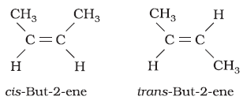
⇄

a) In a mixture of the isomers at equilibrium at 25 °C and 1.01325 x 10⁵ Pa, which is present at a
higher concentration, cis-2-butene or trans-2-butene? Justify your answer.

b) Given that K for the reaction at 127 °C has the value of 1.3, predict whether the
reaction is endothermic or exothermic. Justify your answer.

edited from reference: http://www.glimme.net/bhs/unt09/AP-Q-2-ans.pdf
© https://www.chemical-minds.com

