**Additional questions on explaining equilibrium reactions**

1. Boron trichloride reacts with hydrogen gas as shown in the equation below.

2BCl3(l) + 6H2(g)  B2H6(g) + 6HCl(g) Δr*H* = +315 kJ mol–1

What would the effect on the position of equilibrium for each of the following changes and how would the concentration of diborane (B2H6) be affected?

i) the vessel is heated

ii) HCl gas is removed

iii) more hydrogen gas is added

2.The Haber process is used for the large-scale production of ammonia to make fertilizers. The equation for the Haber process is given below.

N2(g) + 3H2  2NH3(g)

|  |  |
| --- | --- |
| The percentage of ammonia in the equilibrium mixture varies with temperature | i) Use the graph to decide whether the forward reaction is  exothermic or endothermic and explain your choice.  ii) State and explain the effect of increasing the pressure on the yield of ammonia.  iii) Explain the effect of increasing the temperature on the rate of reaction. |

3. Consider the following graph of concentration versus time for the reaction:

2SO2(g) + O2(g)  2SO3(g)

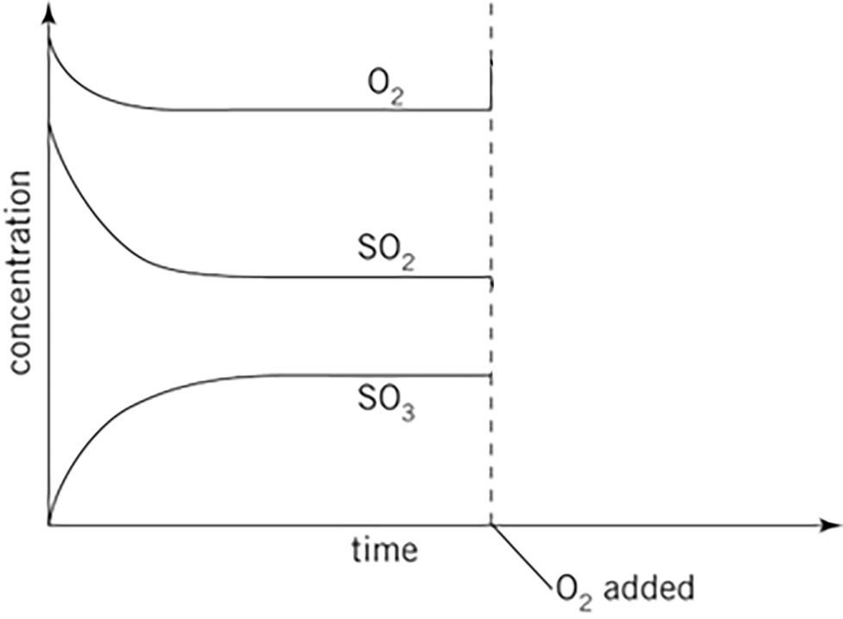

Draw onto the graph above to show changes that would occur in the concentrations of all three species

when some extra oxygen is added to the reaction vessel.

4. The diagrams below represent equilibrium mixtures for the reaction Y + X2  XY + X at 77°C and 277°C respectively. Deduce and explain whether the reaction is exothermic or endothermic.



277°C

77°C

5. A gaseous mixture of chlorine and carbon monoxide is placed into an evacuated vessel and allowed to come to equilibrium according to the equation:

CO(g) + Cl2(g)  COCl2(g) Δ*H* > 0

A series of different events occurs, and the concentrations of the gases are measured and recorded on the graph below.



i) How many times does the reaction system reach equilibrium over the period of time that the experiment is conducted?

ii) What event occurred at the 10-minute mark?

iii) In which direction was the reaction proceeding between 10 and 15 minutes?

iv) State the equilibrium expression for this reaction.

v) State what event occurred at the 30-minute mark. In which direction did the reaction proceed? Explain your answer.

reference: Derry, Connor, Jordan. IB Diploma Programme, Standard Level, Pearson, 2007

© <https://www.chemical-minds.com/>