ANSWERS: Additional questions on explaining equilibrium reactions

1i) right/forward, conc of B₂H₆ increases
ii) right/forward, conc of B₂H₆ increases
iii) right/forward, conc of B₂H₆ increases

2. i) This is an exothermic reaction because an increase in temperature favours endothermic/reverse reaction because the yield of ammonia decreases with increasing temperature
ii) an increase in pressure favours the reaction which has fewer moles of gaseous products so equilibrium moves to the right therefore the yield of ammonia increases
iii) the rate increases because there is an increase in energy of the particles and an increase in the frequency of collisions, because of the increased energy of the particles it is more likely that the collisions will be successful collisions.
3.

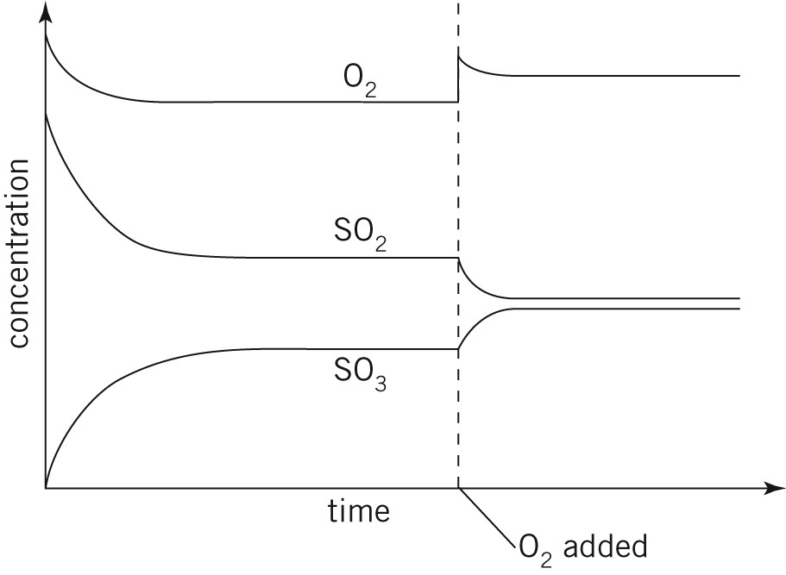
4. less product is present at higher temperatures, therefore the forward reaction is exothermic;

5. i) The reaction reaches equilibrium four times, as this is the number of occasions that the
concentrations of all three species remain unchanged for a period of time.
ii) At the 10-minute mark a quantity of COCl2 was added, as its concentration increased virtually instantaneously.
iii) Over this period of time the concentrations of CO and Cl2 were increasing and that of COCl2 was decreasing, so the reaction was proceeding to the left (backwards).
iv) Kc = mol–1 dm3
v) At the 30-minute mark the concentrations of all three species decreased almost instantaneously. To
achieve this, either a valve was opened to release some gases or the volume of the vessel was increased.

reference: Derry, Connor, Jordan. IB Diploma Programme, Standard Level, Pearson, 2007

© https://www.chemical-minds.com/

