Additional questions on describing and explaining shapes of molecules

1. Compare and contrast the bond angles and shapes of OF₂ and H₂O

2. Compare and contrast the bond angles and shapes of NH₃ and PH₃

3. Compare and contrast the bond angles and shapes of H₂CO and BCl₃

4. Compare and contrast the bond angles and shapes of ethane, ethene and ethyne
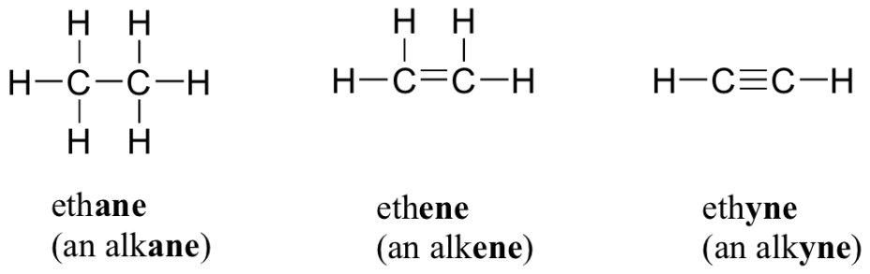

5. State the bond angles numbered 1 – 8, name the shapes of the angles numbered 1 – 8 and explain the reasons for the shapes with reference to lone pairs of electrons
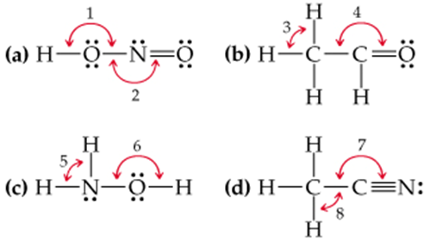
6. State the bond angles labelled below in ethanoic acid and name the shapes of the angles to which they refer. Explain fully.
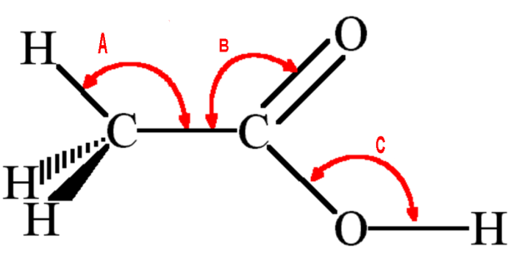

7. State the bond angles labelled below in the amino acid, glycine and name the shapes of the angles to which they refer. Explain fully.
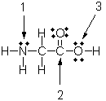
8. State the bond angles labelled below in acetonitrile CH₃CN and name the shapes of the angles to which they refer. Explain fully.
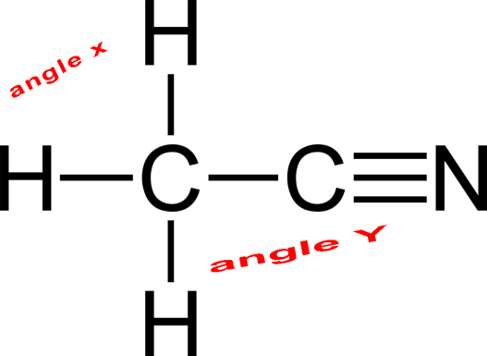

9. State the bond angles labelled below in caffeine and name the shapes of the angles to which they refer. Explain fully.
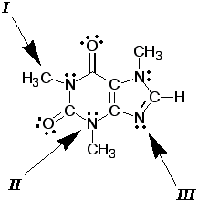

10. State the bond angles labelled below in acetylsalicylic acid, otherwise known as aspirin and name the shapes of the angles to which they refer. Explain fully
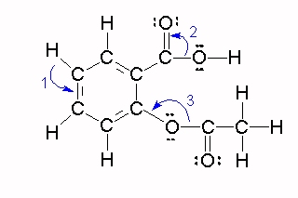

© https://www.chemical-minds.ccom

