ANSWERS: Additional questions on describing and explaining shapes of molecules
1. The central atom in H₂O has four regions of electron density around it. Two of these are bonding and two are non-bonding. These four regions repel each other as far apart as possible. The regions of electron density are arranged as far apart as possible from each other in a parent geometry of tetrahedral. The name for this molecular shape is v-shaped as there are 2 bonded pairs and 2 lone pairs around the central atom with a bond angle of less than 109.5 º due to repulsion caused by the 2 lone pair of electrons.

The central atom in OF₂ also has four regions of electron density around it. Two of these are bonding and two are non-bonding. These four regions repel each other as far apart as possible. The regions of electron density are arranged as far apart as possible from each other in a parent geometry of tetrahedral. The name for this molecular shape is v-shaped as there are 2 bonded pairs and 2 lone pairs around the central atom with and the bond angle is less than 109 ^{o.} The reason that the bond angle is smaller than in water is because the lone pairs of electrons on the F atoms reduce the angle to even smaller than that of H₂O.

2. NH₃ and PH₃
The central atom of N in NH₃ and central atom of P in PH₃ both have four regions of electron density around them. Three of these are bonding and one is non-bonding. These four regions repel each other as far apart as possible. The regions of electron density are arranged as far apart as possible from each other in a parent geometry of tetrahedral. The name for the molecular shapes of both of these molecules is trigonal pyramidal as there are 3 bonded pairs and 1 lone pairs around the central atom.

The bond angle for NH₃ is less than 109.5 º but the bond angle for PH₃ is even more so, perhaps less than 109 º.

The nitrogen atom is more electronegative that the P atom and so the electron density of nitrogen’s bonding pairs will be held closer to the nitrogen. If the bonding electrons are closer to the central atom they will exert a greater repulsive effect on each other. The bonding pair - bonding pair repulsions are larger in NH₃ than in PH₃.
In PH₃ the bonding pair electrons are relatively far from the phosphorus atom as the phosporous atoms is not very electronegative) meaning that the electrons cannot repel each other very effectively.

3. H₂CO and BCl₃
The central atom of C in H₂CO and central atom of B in BCl₃ both have three regions of electron density around them. Three of these are bonding and none are non-bonding. These three regions repel each other as far apart as possible. The regions of electron density are arranged as far apart as possible from each other in a parent geometry of trigonal planar.
Both molecules have the same molecular shape of trigonal planar and the same bond angle of 120 ^{o.}

4. All 3 molecules (ethane, ethene and ethyne) have a parent geometry and molecular shape of linear with a bond angle of 180 º
Other angles within the 3 different molecules vary.
In ethane, there are 4 regions of electron density around the C atom which repel each other as far apart as possible, the angles are 109.5 º with a shape of tetrahedral, as each C atom is bonded to 4 other atoms, with no lone pairs.
In ethene, there are 3 regions of electron density around the C atoms, these three regions repel each other as far apart as possible, the angles are 120 º with a trigonal planar shape as each C atom is bonded to 3 other atoms, with no lone pairs.
In ethyne, there are 2 regions of electron density around the C atoms, these two regions repel each other as far apart as possible, the angles are 180 º with a linear shape as there each C atom is bonded to 2 other atoms, with no lone pairs.

5.
1) There are 4 regions of electron density around the central O atom, these four regions repel each other as far apart as possible, giving a parent geometry of tetrahedral. As there are 2 lone pairs and 2 bonded pairs around the O atom so the molecular shape is bent or v-shaped with an angle of less than 109.5 º.
2) There are 3 regions of electron density around the central N atom, giving a parent geometry of trigonal planar but 2 regions are bonded and 1 is a lone pair, these three regions repel each other as far apart as possible. A lone pair exerts a greater repulsion than a bonded pair so the angle of 120 decreases slightly to 118° with a bent or v-shape as the molecular shape.
3) There are 4 regions of electron density around the central C atom, these four regions repel each other as far apart as possible, there are 4 bonding pairs so a parent geometry of tetrahedral as well as a molecular shape of tetrahedral with bond angle of 109.5 °.
4) There are 3 regions of electron density around the central C atom, these three regions repel each other as far apart as possible, there are 3 bonding pairs and no lone pairs so the parent geometry and molecular shape is trigonal planar with a bond angle of 120°.
5) There are 4 regions of electron density around the central N atom giving a parent geometry of tetrahedral. 3 are bonding pairs and 1 is a lone pair, these 4 regions will repel each other as far as possible, so there is a molecular shape of trigonal pyramid with a bond angle of less than 109.5°
6) There are 4 regions of electron density around the central O atom giving a parent geometry of tetrahedral. 2 are bonding pairs and 2 are a lone pair, these 4 regions will repel each other as far as possible to give a molecular shape of bent or v-shaped with a bond angle of less than 109.5 °.
7) There are 2 regions of electron density around the central C atom giving a parent geometry of linear. 2 are bonding pairs and there are no lone pairs, these 2 regions will repel each other as far as possible to give a linear shape with a bond angle of 180°
8) There are 4 regions of electron density around the central C atom, all 4 are bonding pairs, these 4 regions will repel each other as far as possible to give a parent geometry as well as molecular shape of tetrahedral with a bond angle of 109.5°.
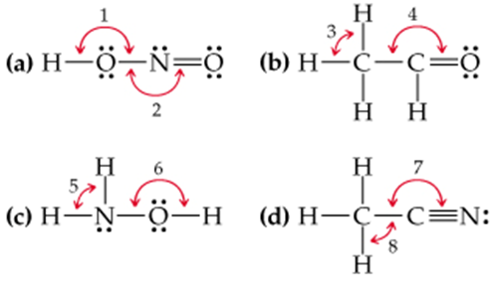

6.
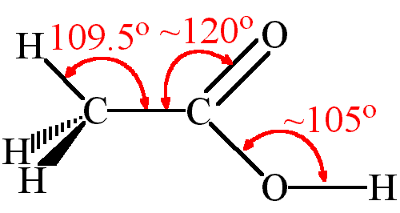 | angle A: 109.5° around the central C atom as there are 4 regions of electron density with 4 bonding pairs and no lone pairs, these four regions repel each other as far apart as possible, tetrahedral shape  angle B: trigonal planar as there are 3 regions of electron density around the central C atom, 3 are bonding pairs with no lone pairs, these 3 regions repel each other as far apart as possible to give a bond angle of 120°  angle C: bent or v-shaped as there are 4 regions of electron density around the central atom, there are 2 lone pairs and 2 bonding pairs around the central O atom, these four regions repel each other as far apart as possible to give a bond angle of less than 109.5 º
7.
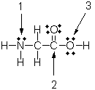 | angle 1: angle of less than 109.5 º as there are 4 regions of electron density around the central N atom, but 3 are bonding and 1 is a lone pair, these 4 regions repel each other as far apart as possible to give an overall shape of trigonal pyramidal  angle 2: 3 regions of electron density around the central C atom, all 3 are bonding regions with no lone pairs, these 3 regions repel each other as far apart as possible to give a bond angle of 120° with a trigonal planar shape  angle 3: bent or v-shaped as there are 4 regions of electron density around the central O atom, 2 are lone pairs and 2 are bonding pairs, these 4 regions repel each other as far apart as possible to give an overall shape of bent or v-shaped with a bond angle of less than 109 º

8.
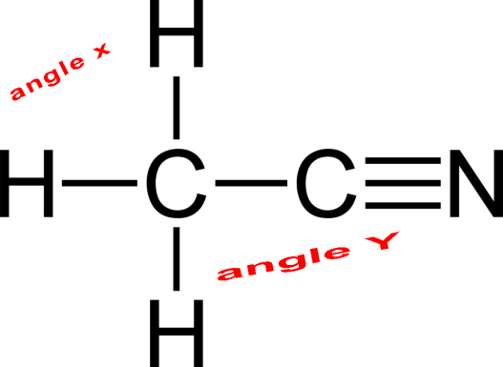 | angle X: 4 regions of electron density around the central C atom, of these 4 are bonding pairs and there are no lone pairs, these 4 regions repel each other as far apart as possible so overall the shape is tetrahedral with a bond angle of 109.5°  angle Y: 2 regions of electron density around the central C atom, 1 bonding pairs to another C atom and 3 bonding pairs (all together) to the N atom, these 2 regions repel each other as far apart as possible to give a linear shape with an angle of 180°

9.
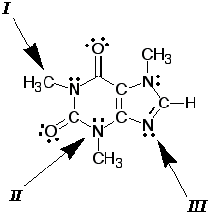 | angle i: the central atom is the C atom, there are 4 regions of electron density around the central C atom, 4 bonding pairs and no lone pairs, these 4 regions repel each other as far apart as possible to give a tetrahedral shape with an angle of 109.5°  angle II: the central atom is the N atom, there are 4 regions of electron density around the central N atom, 3 bonding pairs and 1 pairs, these 4 regions repel each other as far apart as possible to give a trigonal pyramidal shape with an angle of less than 109.5°  angle iii: there are 3 regions of electron density around the central N atom, but 2 are bonded and 1 is a lone pair, these three regions repel each other as far apart as possible, a lone pair exerts a greater repulsion than a bonded pair so the angle of 120 for trigonal planar with 3 bonding pairs decreases slightly to less than 120° with a bent or v-shape due to the 2 bonding pairs and 1 lone pair.

10.
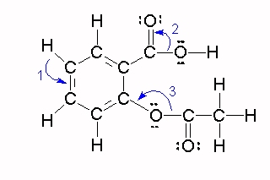 | angle 1: the central atom is the C atom, there are 3 regions of electron density around the central C atom, 3 bonding pairs and no lone pairs, these 3 regions repel each other as far apart as possible to give a trigonal planar shape with an angle of 120°  angle 2: the central atom is the C atom, there are 3 regions of electron density around the central C atom, 3 bonding pairs and no lone pairs, these 3 regions repel each other as far apart as possible to give a trigonal planar shape with an angle of 120°  angle 3: bent or v-shaped as there are 4 regions of electron density around the central O atom, 2 are lone pairs and 2 are bonding pairs, these 4 regions repel each other as far apart as possible to give an overall shape of bent or v-shaped with a bond angle of less than 109.5°

© https://www.chemical-minds.com

