Additional questions on experiments or demonstrations involving polarity

1. Describe and explain the following experiment involving a balloon and water from a tap
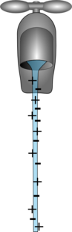 | 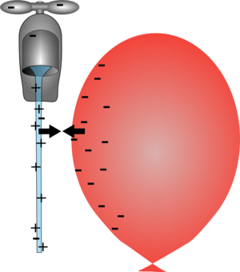 | 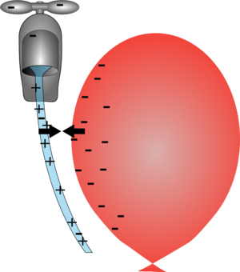

2. Isopropyl alcohol (propan-2-ol) is an everyday solvent that is used to clean dvd’s and dvd players. Describe a test to prove that isopropyl alcohol is a polar substance.

3. A thin layer of lycopodium powder is sprinkled on top of a half full beaker of water. Lycopodium powder is hydrophobic (or water hating). When a person’s fingers are placed into the beaker and then removed, their fingers are still dry. Explain why this has occurred.
4. The following demonstration is carried out in a laboratory.
1. 2 mL of 0.05 M iodine solution is diluted with 75 ml of water.  2. This iodine solution is poured into a separating funnel  3. 6 ml of dichloromethane (CH₂Cl₂) is poured slowly into the separating funnel.  4. The funnel is inverted 3 times with the stopper on.  Describe and explain your observations  (colours are not essential but may back up your explanation) | 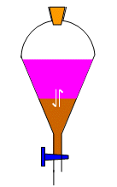

5. 10ml of water with blue food colouring is placed into a petri dish, 10ml of Propan-2-ol is added.

Describe and explain your observations

6. Bromine solution has an orange colour. When cyclohexane is added to the bromine solution, two distinct layers are formed which are purple (top layer) and colourless (bottom layer). Explain these observations in terms of the polarity of the molecules.

© https://www.chemical-minds.com

