Additional questions: Organic reaction flow charts (Level 2)
1.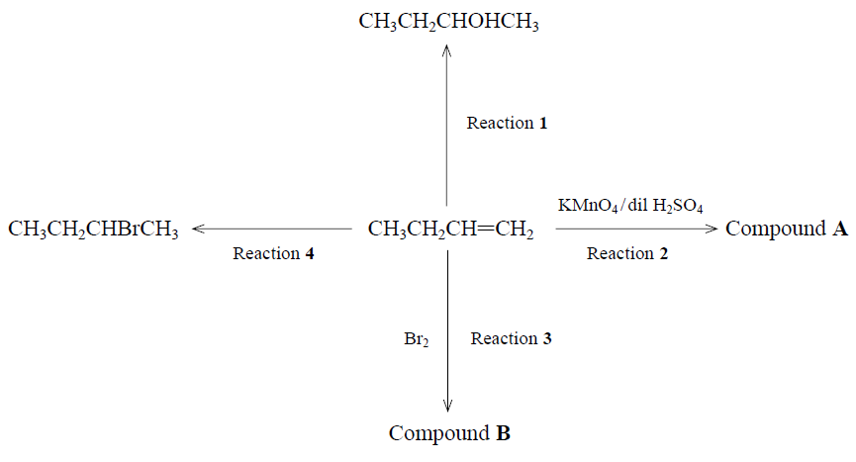
Complete the flow chart above by naming
a) i) Compounds A and B
ii) the reagents required for reactions 1 and 4
iii) state the name of the type of reaction involved for each of Reactions 1, 2, 3 and 4

2. Ethene can react to form the following organic substances.
(i) Name each substance A to F
(ii) Describe the reagents and conditions used to produce compounds A – F (not compound B)
(iii) Draw and name the polymer formed from compound B
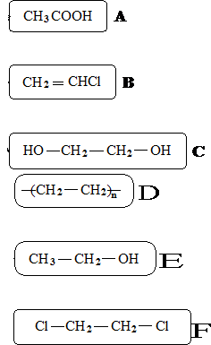

https://www.chemical-minds.com

