ANSWERS: Additional questions Organic reaction flow charts (Level 2)

1 a) i) Compound A: butan-1,2 diol
Compound B: 1,2-dibromobutane

ii) Reaction 1: warm with aqueous sulfuric acid
Reaction 4: react with HBr

iii) Reaction 1: Hydrolysis
Reaction 2: Oxidation
Reaction 3: Bromination
Reaction 4: Addition

2.
Compound letter | Name | Reagents required
A | ethanoic acid | 1st: warm with aqueous H₂SO₄ to produce ethanol  2nd: oxidise ethanol using acidified KMnO₄ or K₂Cr₂O₇
B | chloroethene | HCl
C | ethane-1,2,diol | oxidise with acidified KMnO₄
D | polyethene | high temperature and high pressure using a catalyst
E | ethanol | warm with aqueous H₂SO₄ to produce ethanol
F | 1,2-dichloroethane | react with Cl₂

Compound B forms polyvinyl chloride (PVC)

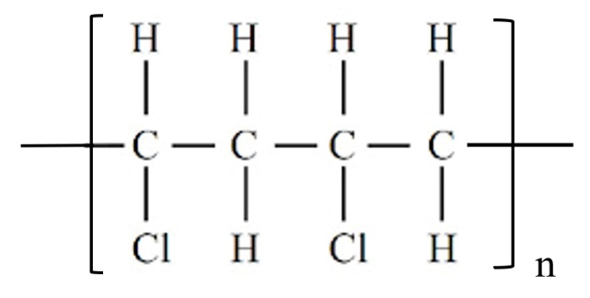

https://www.chemical-minds.com

