Additional questions on Isomers

1. The compound 1,4-dichlorobut-2-ene forms two geometrical isomers, draw and name them.
2. Which of the following are isomers of pentane?
2-methylpentane and/or methylbutane and/or dimethylpropane
3. Draw all the isomers for a compound with the molecular formula C₂H₂Cl₂?

4. Draw and name all eight isomers of pentanol

5. Shown below are four structural isomers of alcohols with molecular formula C₄H₁₀O.
State the name of each of the isomers A, B, C and D.

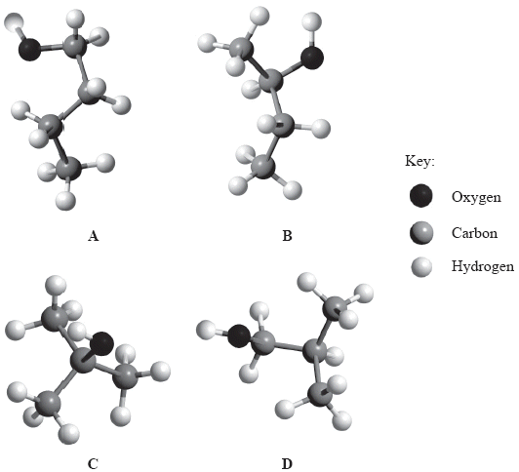

https://www.chemical-minds.com

