ANSWERS: Drawing organic molecules

octane  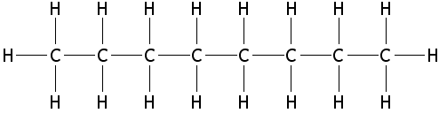 | a straight chain alkane with 16 hydrogen atoms  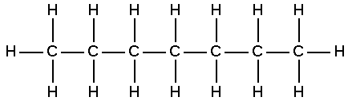 | alcohol with one 1 carbon atom  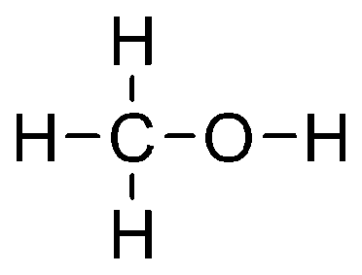
polymer containing a methyl group (CH₃) on every 2nd carbon atom  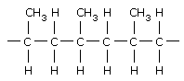  n | alkene with 3 carbon atoms  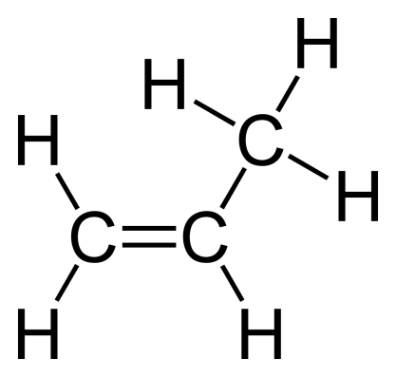 | monomer used to make polythene  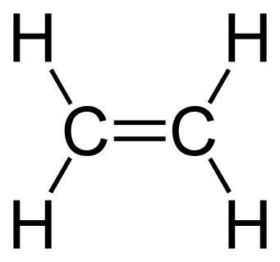
contains an OH group and 2 carbon atoms  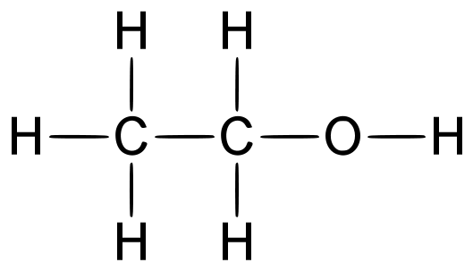 | a straight chain hydrocarbon with 7 carbon atoms  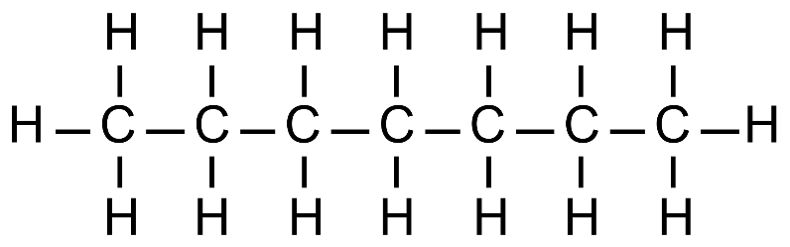 | alkane with 5 carbon atoms  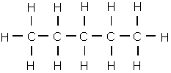

© http://www.chemical-minds.com

