Additional questions on Naming organic molecules

QUESTION: Name the following organic molecules

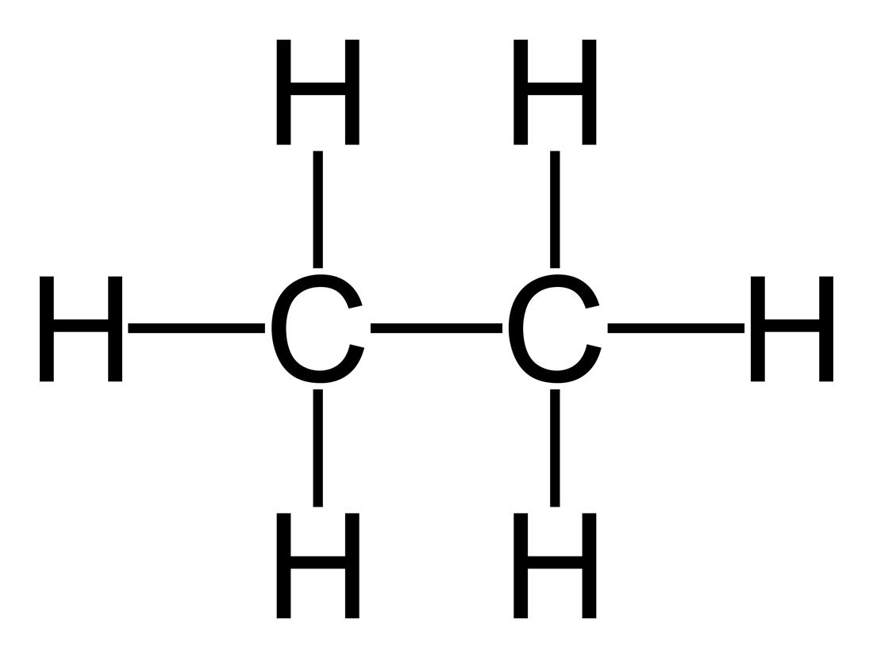 | 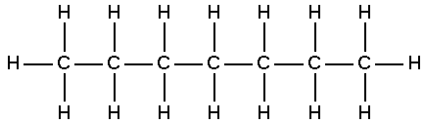 | 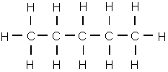
alkene with 3 carbon atoms | 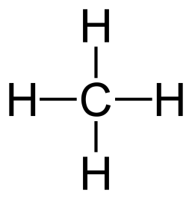 | 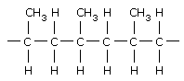  n
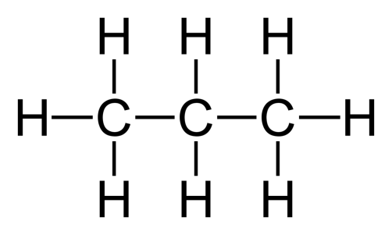 | 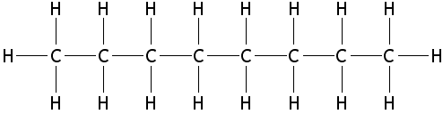 | alkene with 2 carbon atoms

© https://www.chemical-minds.com

