ANSWERS to additional questions on Properties of carbon compounds

1. (a) A hydrocarbon is a compound containing hydrogen and carbon atoms only.

(b)
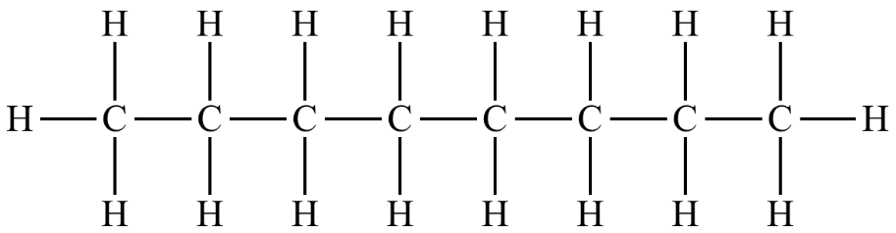

(c) Explanation: The oil or octane floats on top of the water as they are less dense. The oil is insoluble in the water.

(d) Why it is effective and what products are produced: This method is effective as it removes the oil/octane as it is burnt, so that it cannot harm the sea life.
The products produced if it is complete combustion are carbon dioxide and water which are not harmful to marine life. (However, if there is not enough oxygen then carbon dioxide, water, carbon monoxide and soot can also be produced as well. The carbon monoxide and carbon can be harmful to humans and sea life.)

2. Hydrocarbons are flammable, so if he uses a Bunsen burner the hydrocarbon might catch on fire.

© https://www.chemical-minds.com

