**Additional questions on Esters**

**1.** The molecule represented by the structural formula below is the alarm pheromone produced by honey bees: Draw and name 4 esters isomers of this molecule



**2.** The diagram below is an expanded structural diagram of a triglyceride molecule.

**i)** write the condensed structural formula of this molecule

**ii)** write the molecular formula of this molecule

**iii)** draw a square around an ester group

**iv)** write the products of this reaction of this triglyceride with NaOH

**v)** write the products of the reaction of this triglyceride with dilute HCl

**vi)** describe how to make a soap using this triglyceride molecule

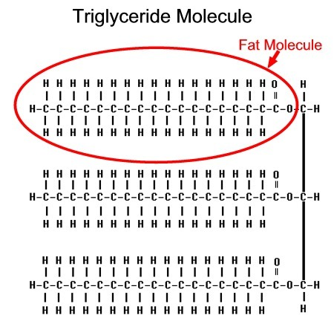

**3.** A triglyceride found in cocoa butter is made up of the following three molecules

|  |  |  |
| --- | --- | --- |
| stearic acid | oleic acid  CH3(CH2)7CH=CH(CH2)7COOH | palmitic acid  CH3(CH2)14CO2H |

**i)** Draw the expanded structural formula of the triglyceride

**ii)** Compare and contrast hydrolysis reactions of this triglyceride in acidic and basic conditions

**iii)** describe the observations of the reaction of this tryglyceride with bromine water

**iv)** describe the observations of the reaction of this tryglyceride with an oxidising agent (named example in your answer)

© <https://www.chemical-minds.com>