**ANSWERS: Additional questions on Esters**

**1.**

|  |  |
| --- | --- |
| http://www.ivy-rose.co.uk/Chemistry/Organic/molecules/methyl-esters/methyl-hexanoate_structure.gif  methyl hexanoate | 3-methylbutyl ethanoate |
| butyl propanoate | 2-methylbutyl ethanoate |
| some of the other possibilities are...  ethyl pentanoate  propyl butanoate  pentyl ethanoate  ethyl 2-methylbutanoate  ethyl 2,2-dimethylpropanoate | |

**2. i)**

|  |
| --- |
| CH3(CH2)16COOCH2  CH3(CH2)16COOCH2  CH3(CH2)16COOCH2 |

**ii)** C57H102O6

**iii)** *a square drawn around any of the three ester groups*

**iv)** products of reaction of this triglyceride with NaOH

CH3(CH2)16COONa  **and** CH2(OH)CH(OH)CH2(OH) - propan-1,2,3-triol -



**v)** products of reaction of this triglyceride with dilute HCl (or H2SO4)

CH3(CH2)16COOH and CH2(OH)CH(OH)CH2(OH) - propan-1,2,3-triol - 

**vi)** a soap can be made by carrying out a base hydrolysis reaction of the triglyceride with NaOH, the two products of the reaction have already been shown for answer iv). The soap formed is the salt

CH3(CH2)16COONa which can also be written as CH3(CH2)16COO- Na+ because the soap has a

polar end and a non-polar end

CH3(CH2)16COO- Na+

**3.** **i)**

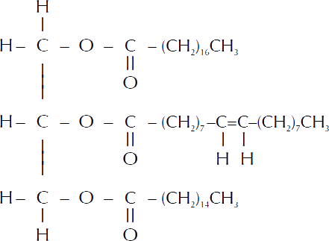

**ii)** A comparison of the reaction of this triglyceride with both dilute acid and dilute base is that two different products are formed and that they are both hydrolysis reactions. Another comparison is that glycerol is a common product of both reactions.

A contrast is that for the reaction of the triglyceride with dilute acid is that the carboxylic acids formed are stearic acid, oleic acid and palmitic acid (their structural formula is shown in the question)

Another contrast is that for the reaction of the triglyceride with dilute base is that sodium salts of the carboxylic acid(s), which are shown below

|  |  |  |
| --- | --- | --- |
|  | CH3(CH2)7CH=CH(CH2)7COONa | CH3(CH2)14COONa |

**iii)** Bromine water will be immediately decolourised on addition to this triglyceride, the colour change observed will be orange to colourless (NOT clear!!!).

This is because there is a double bond in the middle of the oleic acid, the double bond will break immediately, an addition reaction will occur and two Br atoms will add on to the carbon atoms at either end of the double bond.

**iv)** An oxidising agent such as potassium permanganate will change colour from purple to colourless. Another oxidising agent such as potassium dichromate will change colour from orange to green.

This is because there is a double bond in the middle of the oleic acid, the double bond will break immediately, an oxidation reaction will occur and two –OH (hydroxy’s) will add on to the carbon atoms at either end.

© <https://www.chemcial-minds.com>