**ANSWERS: Additional questions on Level 3 Isomers**

**1. i)** The lactate ion is

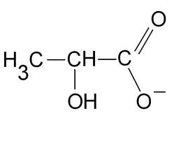

**ii)** The two enantiomers of lactic acid are

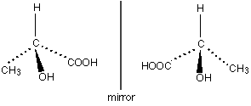

**iii)** The two enantiomers of lactic acid have the same molecular formula which is C3H6O3, therefore they both have the same molar mass and density. Both enantiomers have the same functional groups bonded to the chiral carbon atom, the functional groups are carboxylic acid and alcohol so the two isomers will have the same chemical reactions (except with other enantiomers). The 4 different groups of atoms or atoms are arranged around the central chiral carbon, both molecules have a tetrahedral shape with a bond angle of 109°.

Due to reasons stated above the two enantiomers will have the same melting and boiling points.

The differences between the two enantiomers are that they cannot be superimposed on each other as they are mirror images of each other. If plane polarised light is passed through the two enantiomers of lactic acid, one isomer will rotate the light clockwise and the other will rotate light anti-clockwise (another similarity is that the two enatiomers will rotate light either clockwise or anticlockwise by the same number of degrees). The two enantiomers will have different chemical reactions with other optically active molecules.

**2. i)**

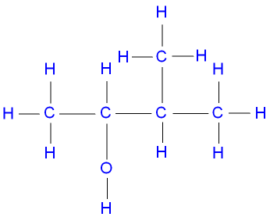

3-methylbutan-2-ol

**ii)**

**images**

**iii)** 3-methylbutan-2-ol is a stereoisomer because it has a chiral carbon atom, this means that there are 4 different groups positioned around the chiral carbon (which has been circled in the diagram)

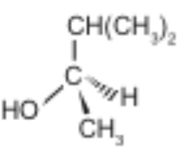

The two isomers of 3-methylbutan-2-ol rotate plane polarised light either to the left or the right by the same number of degrees. The levorotatory isomer rotates plane polarised light in a clockwise direction and the dextrorotatory isomer rotates plane polarised light in an anti-clockwise direction.

**iv)** A racemic mixture contains a 50/50 mix of each of the two stereoisomers, the mixture has no effect on plane polarised light.

**3.**

**i)** 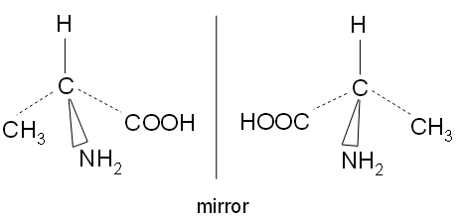

*(It doesn't matter where you put the various groups in the first isomer, but the COOH group must be*

*attached to the central carbon atom via the C and not the H. The second isomer should be a*

*reflection of the first in the mirror.)*

The second isomer is a mirror image of the first. If you removed the image from the mirror,

however much you rotated it, you would never be able to get it to align exactly with the structure on

the left. The mirror images are therefore non-superimposable – they can't be superimposed on each

other.

**ii)** A chiral molecule is one that has no plane of symmetry. An asymmetric carbon atom is one

which has four different groups attached.

**iii)** It is a 50/50 mixture of the two enantiomers (optical isomers). One of these is rotating the plane

of polarisation anti-clockwise, and the other is rotating it by exactly the same amount clockwise.

They cancel each other out, so there is no overall effect on the light.

*question 3 answer referenced from chemguide* [*http://www.chemguide.co.uk/basicorg/questions/q-optisomerism.pdf*](http://www.chemguide.co.uk/basicorg/questions/q-optisomerism.pdf)

© <https://www.chemical-minds.com>