ANSWERS: Additional questions on Level 3 Polymers

1. Teflon is a polymer formed by addition polymerisation of the monomer 1,2,3,4-tetrafluroethene under conditions of high temperature and pressure.
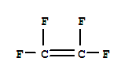
During the additional polymerisation reaction the carbon to carbon double bond in each monomer breaks and new single carbon to carbon single covalent bonds form (or making new bond spaces available) thus allowing the monomers to bond together in a long chain. Polymers are not a discrete molecule, their infinite length is indicated by brackets and the subscript “n”.

2. Perspex is formed from the monomer which is drawn below (methyl 2-methylpropenoate). In addition polymerisation under conditions of high temperature and pressure the double bond between the carbon atoms will break and new carbon to carbon single covalent bonds form (or making new bond spaces available) thus allowing the monomers to bond together in a long chain forming a continuous chain of perspex.
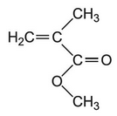
3. In condensation polymerisation, two functional groups react and a small molecule (usually H₂O or HCl) is eliminated. Condensation polymerisation can involve the reaction of identical monomers of which there are both hydroxyl (-OH) and carboxylic acid groups (-COOH) present.

In forming polyesters, monomers such as a diacid (containing two carboxyl groups) or diacid chloride (containing two acyl chloride groups) and a dialcohol (containing two hydroxyl groups) .

In forming polyamides, monomers such as a diacid or diacid chloride and a diamine will react together.
ester bond

4.

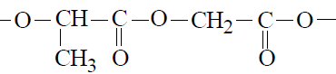n

Lactomer is a condensation polymer, formed by condensation polymerisation which means the loss of a small molecule, in this case water, to form a larger molecule. The repeating unit (shown in the blue box above) has an ester bond (shown in the diagram) between the carboxylic acid side of the lactic acid and the alcohol side of the glycolic acid
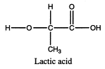 | 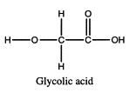

Lactomer is a polyester because when a carboxylic acid and an alcohol react they form an ester. In this example of forming lactomer the OH from the carboxylic end of lactic acid is removed along with the H from the hydroxy end of glycolic acid and and ester link forms between the two monomers.

Lactomer is used for internal stitches as after a number of weeks the internal tissue has healed and the stitches dissolve due to the lactomer hydrolysing to form the two monomers lactic acid and glycolic acid, these monomers are not toxic in low doses, the body will metabolise and excrete these monomers.

5. Dacron
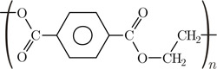

Polyesters are not hydrolysed by water alone so are safe for everyday clothing as they won’t deteriorate in the rain.
However, if you spill dilute alkali on a fabric made from polyester, the ester linkages are broken. Ethane-1,2-diol is formed together with the salt of the carboxylic acid.
Because you produce small molecules rather than the original polymer, the fibres are destroyed, and you end up with a hole in the container, therefore the dilute acid or alkali will spill out of the bottle
reaction with NaOH
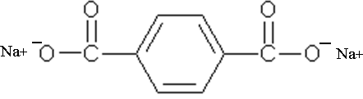 + 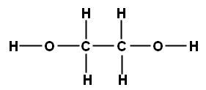
reaction with dilute HCl
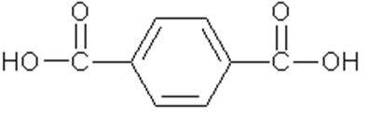 +
6.
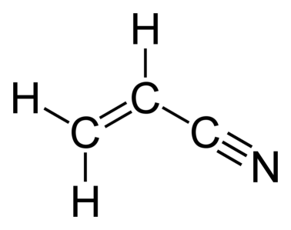
When polyacrylonitrile burns poisonous fumes of hydrogen cyanide (HCN) are given off.

© http://www.chemical-minds.com

