ANSWERS: Additional questions on Level 3 Organic practical

1. Ethyl ethanoate is an ester and is formed from ethanol and ethanoic acid.

Firstly, the ethanol has to be oxidised using an oxidising agent to form the ethanoic acid. Place 1mL of the ethanol into a test tube and add 2mL of dilute H₂SO₄ followed by 1mL of either KMnO₄ or K₂Cr₂O₇. Place the test tube into a water bath and heat for approx 5 minutes. A colour change will occur of either purple to colourless (with the KMnO₄) or orange to green (with the K₂Cr₂O₇).

The general equation for the oxidation reaction of alcohol carboxylic acid is
[O]
C₂H₅OH CH₃COOH

The Redox equation for the reaction is:
Please note that for the organic chemistry exam is will not be necessary to write the balanced redox equation for the oxidation of ethanol

Using Potassium permanganate
reduction half equation: MnO₄⁻ + 8H⁺ + 5e Mn²⁺ + 4H₂O
oxidation half equation: CH₃CH₂OH + H₂O CH₃COOH + 4H⁺ + 4e
(easiest to balance the oxidation equation using charges as opposed to oxidation numbers)

20 electrons is the lowest common number for 5e and 4e
so, multiply/times reduction half equation x 4: 4MnO₄⁻ + 32H⁺ + 20e 4Mn²⁺ + 16H₂O
and multiply/times oxidation half equation by 5: 5CH₃CH₂OH + 5H₂O 5CH₃COOH + 20H⁺ + 20e

So, the overall balanced redox equation is 4MnO₄⁻ + 12H⁺ + 5CH₃CH₂OH 4Mn²⁺ + 5CH₃COOH + 11H₂O

Using Potassium dichromate
reduction half equation: Cr₂O₇2²⁻ + 14H⁺ + 6e 2Cr³⁺ + 7H₂O
oxidation half equation: CH₃CH₂OH + H₂O CH₃COOH + 4H⁺ + 4e

12 electrons is the lowest common number for 6e and 4e
so, multiply/times reduction half equation by 2: 2Cr₂O₇2²⁻ + 28H⁺ + 12e 4Cr³⁺ + 14H₂O
and multiply/times oxidation half equation by 3: 3CH₃CH₂OH + 3H₂O 3CH₃COOH + 12H⁺ + 12e

So, the overall balanced redox equation is 2Cr₂O₇²⁻ + 16H⁺ + 3CH₃CH₂OH 4Cr³⁺ + 3CH₃COOH + 11H₂O

The structural formula for ethanol is
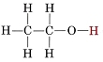
The structural formula for ethanoic acid is
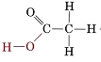

So, now with samples of ethanol and ethanoic acid, the ester; ethyl ethanoate can be produced.
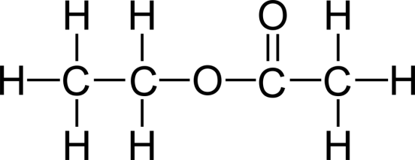

The equation for the condensation reaction to form ethyl ethanoate is

C₂H₅OH + CH₃COOH C₂H₅COOCCH₃

This is a condensation reaction which is catalysed by H⁺ ions. Concentrated H₂SO₄ is both a dehydrating agent and provides the H⁺ ions for the reaction. Place 2mL of ethanol in a test tube, add 1mL of pure ethanoic acid followed by a couple of drops of concentrated H₂SO_{4.} Warm the mixture in a water bath for a few minutes. Then, add the mixture to 15mL of Na₂CO₃ solution, this is to neutralise any excess acid. Once the bubbling of carbon dioxide stops, pour the solution into a boiling tube, the ester layer will be visible on top of the aqueous layer and should have a sweet pear smell.

2. Ethyl ethanoate is an ester and formed from ethanol and ethanoic acid.

The general equations and structural formula have all been provided in answer 1 (above)

Firstly, set up the Liebig condensor for reflux. Make sure that the cold water tap is on.
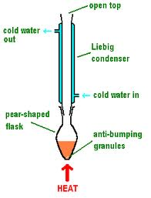
Place 10mL of ethanol into a pear shaped flask, add 10mL of acidified KMnO₄ or K₂Cr₂O₇. Ideally KMnO₄ as the colour change is from purple to colourless, resulting in a colourless solution. Add in a couple of anti-bumping granules. Heat the pear shaped flask by either moving a bunsen burner to and fro or allowing the pear shaped flask to rest in a tray of sand placed on a hot plate or a water bath. Allow the mixture to boil and reflux thus fully oxidising the primary alcohol, in this case ethanol to a carboxylic acid, in this case ethanoic acid. Reflux means that as the warm vapours from the ethanol rise into the cold condensor they will condense and fall back into the pear shaped flask, the oxidising agent will cause the ethanol to be oxidised firstly to the aldehyde, ethanal and then full oxidised to the carboxylic acid, ethanoic acid. Because the reaction mixture is continually refluxing then end result will ensure that full oxidation to a carboxylic acid has occured. A change in colour (colours given in answer 1) will indicate that oxidation is complete.
Carry out simple distillation of the reaction mixture and at 118’C collect the distillate, which is ethanoic acid, pour into a conical flask, add 10mL of ethanol and then 1mL of conc H₂SO₄ as a dehydrating agent (see equation in answer 1). Warm the conical flask in a water bath for a few minutes. Pour the resulting mixture into a beaker of aqueous sodium carbonate to neutralise any excess acid. Once the mixture stops bubbling, pour into a separating funnel.
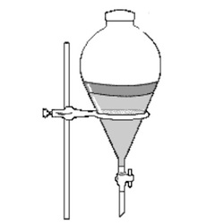
Allow to settle and carefully separate out the top organic layer which is the ester, ethyl ethanoate.

3.

The chart below summaries the oxidation of butanol (primary, secondary and tertiary alcohols)

primary alcohol carboxylic acid
butan-1-ol butanoic acid
or aldehyde
2-methylpropan-1-ol butanal

secondary alcohol ketone
butan-2-ol butanone

tertiary alcohol no reaction
2-methylpropan-2-ol

Suitable oxidising agents to use are acidified KMnO₄ or K₂Cr₂O₇

A suggested procedure is to place 0.5 mL of KMnO₄ or K₂Cr₂O₇ and 1mL of dilute sulfuric acid into a test tube. Add 1mL of butan-1-ol. Swirl and if necessary heat in a water bath for a few minutes until a colour change occurs; purple colourless with KMnO₄ or orange green with K₂Cr₂O₇

Repeat the procedure for each isomer of butan-1-ol.

The structural formula of reactants and products are

butan-1-ol  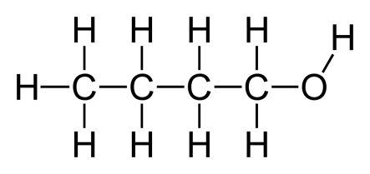 | butanal  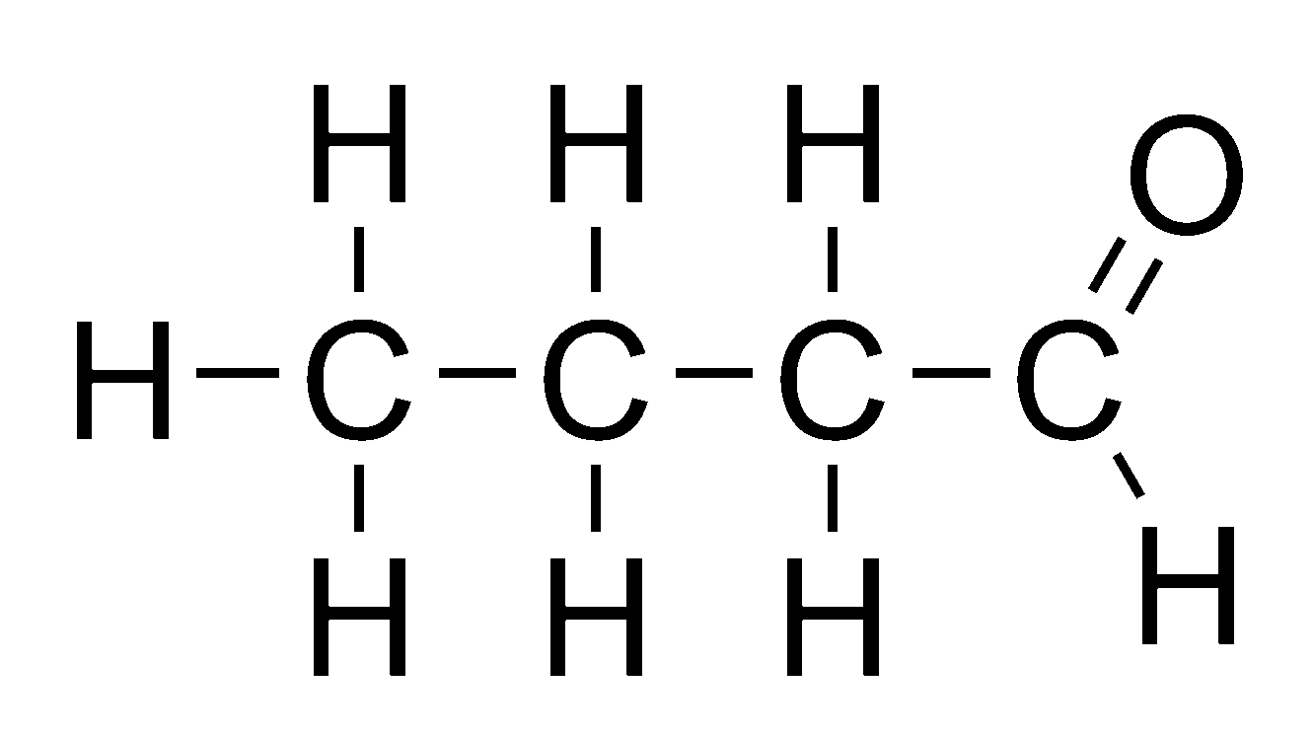 | butanoic acid  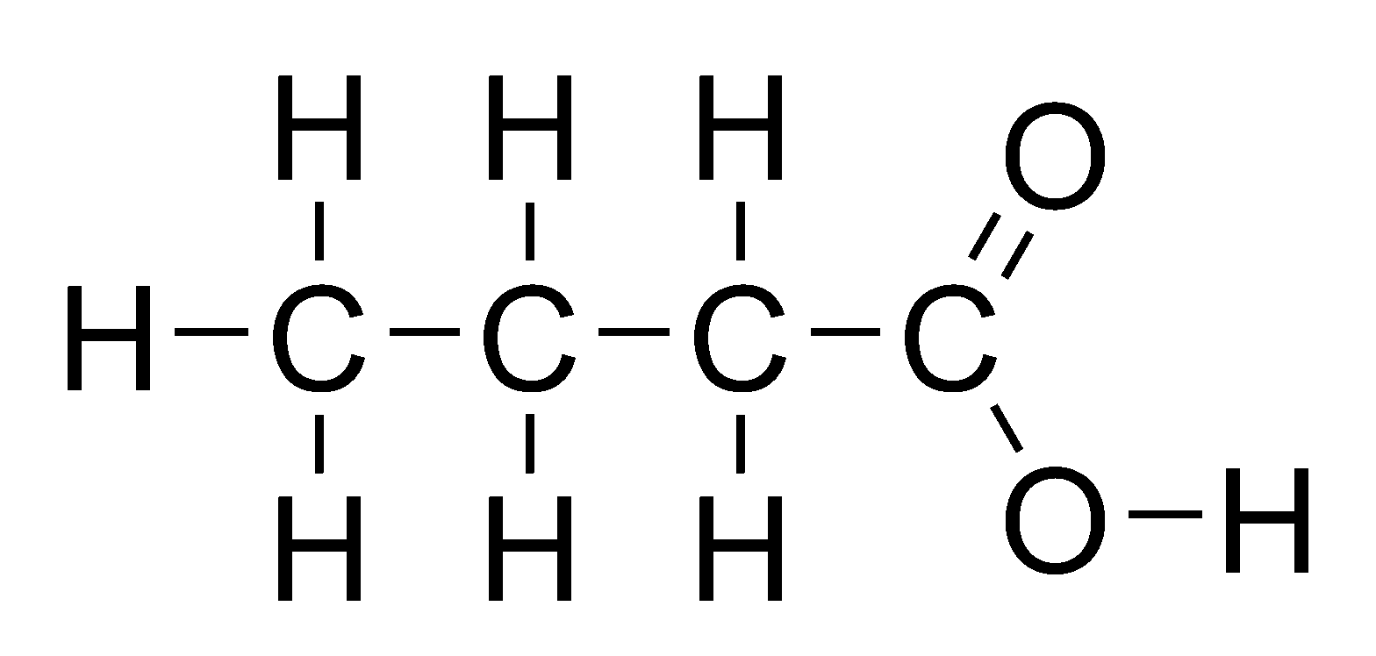

butan-2-ol  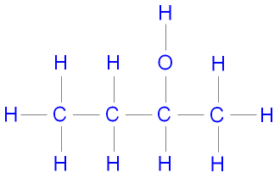 | butanone  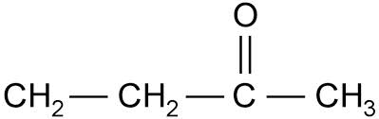 | 2-methylpropan-2-ol  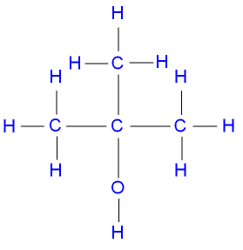
2-methylpropan-1-ol
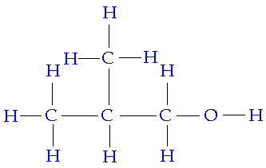

4. There are different uses for a Liebig condensor, one is distillation, another is reflux.

Distillation
Distillation is a liebig condensor arranged horizontally on a pearshaped flask using quickfit apparatus. Distillation is a process used to separate miscible liquid which have different boiling points.
Partial oxidation of a primary alcohol such as propanol will result in the formation of an aldehyde, propanal. The aldehyde must be distilled from the solution at its boiling point or the aldehyde will continue to be further oxidised and form propanoic acid.

The equation for the reaction is [partial O]
C₃H₇OH C₃H₆O

Reagents required are an oxidising agent such as acidified KMnO₄ or acidified K₂Cr₂O₇
Conditions required are gentle heat for approx 5 mins, this is achieved by having the bunsen on a medium heat and moving it to and fro under the pear shaped flask.
Anti-bumping granules or porcelain chips should be added to the pear shaped flask at the start of the reaction to prevent the reaction mixture boiling over into the Liebig condensor.

See the distillation apparatus below
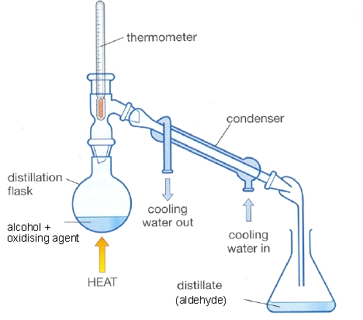
The way the Liebig condensor works is that it is made up of two tubes, an inner and outer tube. The outer tube is connected to the cold water tap (water in at the bottom and out at the top), therefore the inner tube is kept cool. The warm aldehyde vapour rises from the pear shaped flask and though the condensor, because the inner tube of the condensor is cool the warm aldehyde vapours will condense to form aldehyde liquid which drips down and out of the Liebig condensor and into the conical flask.

Reflux
Reflux is a process whereby a Liebig condensor is arranged vertically on a pearshaped flask using quickfit apparatus, as shown below.
The process of reflux can be used for the full/total oxidation of a primary alcohol eg propanol to a carboxylic acid eg propanoic acid. Reflux is a distillation technique involving the condensation of vapours and the return of this condensate to the pear shaped flask from which it originated. Heating under reflux prevents the aldehyde formed escaping before it has time to be oxidised to the carboxylic acid. This is because the cold water in the outer tube of the Liebig condensor causes the aldehyde vapours in the inner tube to condense and fall back into the pear shaped flask where they will continue to be oxidised.

The equation for the reaction is [total O]
C₃H₇OH C₂H₅COOH

Reagents required are an excess of an oxidising agent such as acidified KMnO₄ or acidified K₂Cr₂O₇
Conditions required are gentle heat for approx 5 mins, this is achieved by having the bunsen on a medium heat and moving it to and fro under the pear shaped flask.
Anti-bumping granules or porcelain chips should be added to the pear shaped flask at the start of the reaction to prevent the reaction mixture boiling over into the Liebig condensor.

The process of reflux should continue until the oxidising agent has changed colour ie purple to colourless for KMnO₄ or orange to green for K₂Cr₂O₇. Then the apparatus needs to be rearranged for distillation so the the carboxylic acid can be distilled off at the appropriate boiling point.

5. i) ethanamide from chloroethane
Firstly, form ethanol by carrying out a substitution reaction using heat, of the chloroethane and NaOH
NaOH
C₂H₅Cl C₂H₅OH
Then, totally oxidise the ethanol to ethanoic acid using an oxidising agent such as acidified KMnO₄ or K₂Cr₂O₇
[O]
C₂H₅OH CH₃COOH
Finally, carry out a substitution reaction of ethanoic acid with NH₃ to form the amide
NH₃
CH₃COOH CH₃CONH₂

ii) ethanoyl chloride from propene
Firstly, add water (and some dilute H₂SO₄) to form propanol

C₂H₄ + H₂O C₂H₅OH
Then, totally oxidise the ethanol to ethanoic acid using an oxidising agent such as acidified KMnO₄ or K₂Cr₂O₇
[O]
C₂H₅OH CH₃COOH
Finally, carry out a substitution reaction with PCl₃, PCl₅ or SOCl₂ to form the ethanoyl chloride
C₂H₅COOH C₂H₅COCl
© 2018 http://www.chemical-minds.com

