Additional questions on addition reactions

1. Draw the major and minor products from this reaction
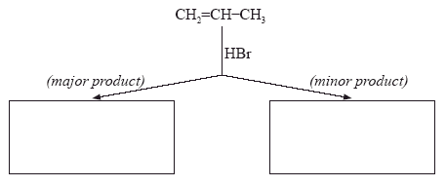

2. Draw and explain the major and minor products of 3-hydroxybut-1-ene with HBr

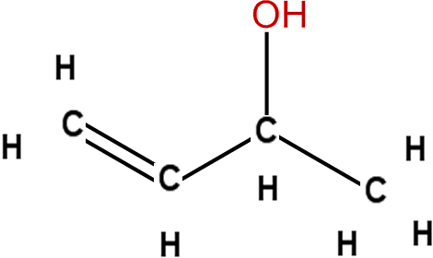

3. Draw and explain the structures of the major and minor products when hydrogen chloride is added to 2-methylbut-2-ene, (CH3)2CCHCH3.

4. Draw, identify and name the 2 products of propene with HCl

https://www.chemical-minds.com

