ANSWERS: Additional questions on addition reactions

1.

2. with clear labelled structural diagram and explanation
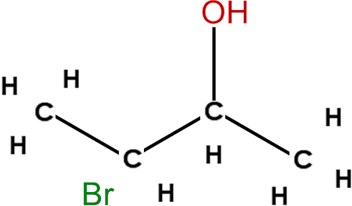  MAJOR product | 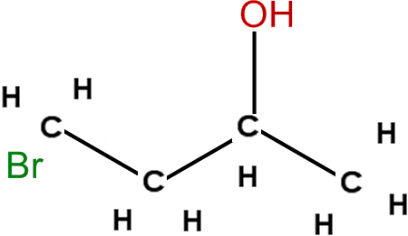  Minor product

3. major product:
(CH3)2CBrCH2CH3/2-bromo-2-methylbutane;

minor product:
(CH3)2CHCHBrCH3/2-bromo-3-methylbutane;
with clear labelled sketch and an explanation

4.
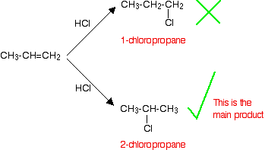
aka major product

https://www.chemical-minds.com

