Additional questions on bond dipole and polarity of molecules

bond dipoles present within the molecule?
HF
H₂
HBr
O₂
C = O

Are the following molecules polar or non-polar?
CS₂ | N₂ | CH₃OH
HCN | PCl₃ | O₂
CH₃COCH₃  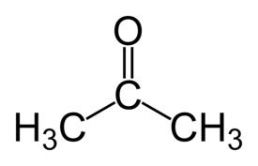 | CH₄ | C₂H₄
PH₃ | SF₂ | O₃  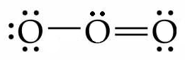

© https://www.chemical-minds.com

