ANSWERS: Additional questions on bond dipoles and polar of molecules

 | bond dipoles present within the molecule?
HF | yes
H₂ | no
HBr | yes
O₂ | no
C = O | yes

CS₂  non-polar | N₂  non-polar | CH₃OH  polar
HCN  polar | PCl₃  polar | O₂  non-polar
CH₃COCH₃  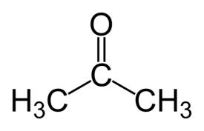  polar | CH₄  non-polar | C₂H₄  non-polar
PH₃  polar | SF₂  polar | O₃  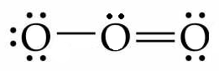  polar

© http://www.chemical-minds.com

