Additional questions on Polymers
The questions below are all unusual example of monomers

Complete the table
monomer | polymer  (draw at least 2 repeating units) | common name
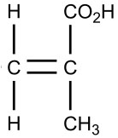  methacrylic acid | polymethacrylic acid | polymethacrylic acid  (gene therapy)
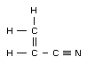  acrylonitrile | polyacrylonitrile | acrylics  (sails for yachts)
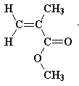  methyl methacrylate | poly methyl methacrylate | PMMA  (hard contact lenses)
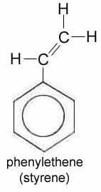  phenylethene  (no, you are not expected to know benzene rings for NCEA Level 2 and 3) | polyphenylethene | polystyrene  (bean bag balls)
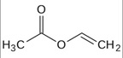  vinyl acetate  (no, you are not expected to know skeletal structures for NCEA Level 2 and 3) | polyvinyl acetate | PVA  (craft glue)

https://www.chemical-minds.com

