Additional questions on Level 3 polymers

1. Discuss polymerisation using Teflon (shown below)
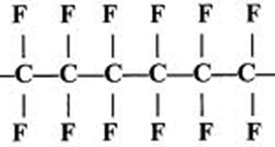n

2. Part of the structure of the polymer commonly known as perspex is shown below. Discuss addition polymerisation using perspex in your answer

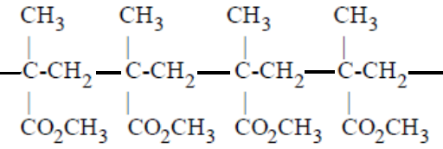n

3. What structural features must a monomer possess to undergo condensation polymerisation?

4. Surgical staples are made of a polymer called lactomer.
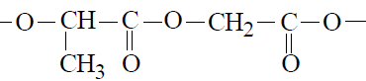
n
Lactomer is a polymer of lactic acid and glycolic acid.
i) Discuss polymerisation using lactomer, include the monomer structure in your answer.
ii) Explain why lactomer is suitable for internal stitches

5. Dacron or Terylene (Polyethylene terephthalate) also known as PET is used for food and drink containers, it is made from terephthalic acid
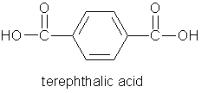
and 1,2-dihydroxyethane.

i) Draw the repeating unit for Dacron.
ii) Explain using chemical equations why polyesters cannot be used for storing dilute acids (eg HCl) or alkalis (eg NaOH) but can be used for everyday clothing items.

6. Polyacrylonitrile is used in making fibres for rugs and upholstery. Polyacrylonitrile is made from the monomer acrylonitrile CH₂CHCN.
i) draw the monomer
ii) explain the dangers of a fire in a house containing polyacrylonitrile rugs.

© https://www.chemical-minds.com

