ANSWERS: Additional questions on shapes of molecules

BCl₃  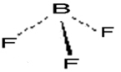  trigonal planar  120° |  | H₂O₂  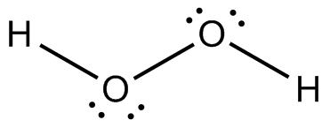  bent/v-shaped  less than 109.5 ° | SCl₂  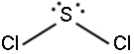  less than 109.5°  bent or v-shaped | CF₄  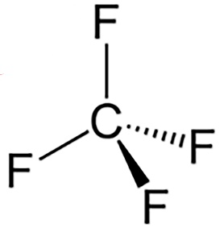  tetrahedral  109°
CO  linear  180° |  | BeCl₂  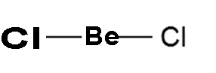  180 °  linear | SiH₄  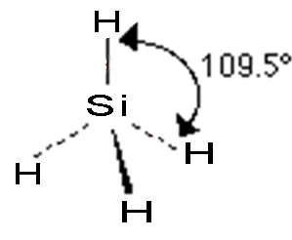  tetrahedral | Br₂  linear  180°
NH₂OH  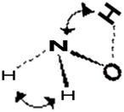  trigonal pyramidal  as well as  bent or v-shaped  both angles less than 109.5 ° | O₃  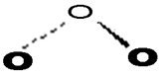  bent or v-shaped  less than 120° |  | HNO₂  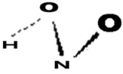  bent or v-shaped  less than 109.5 ° | P₄  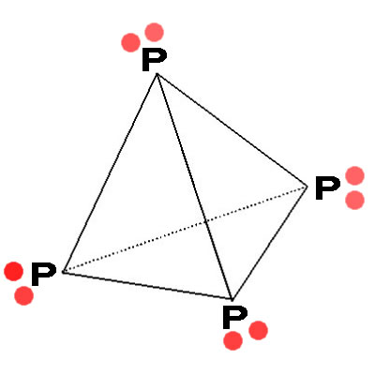  trigonal pyramidal shape around each P atom  109.5 °  but with a  tetrahedral shape overall
SiH₂F₂  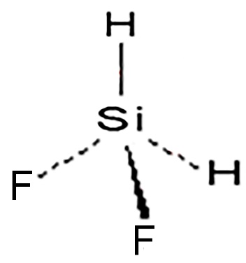  tetrahedral  109° | COCl₂  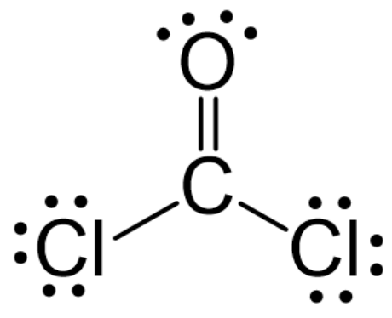  120°  trigonal planar |  | HOCl  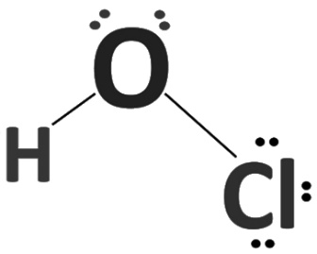  less than 109.5°  bent or v-shaped |  | SO₃  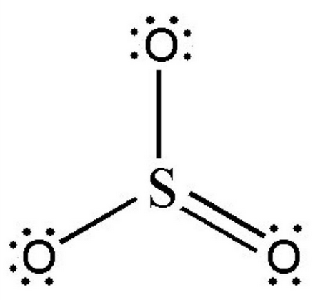  120°  trigonal planar

© https://www.chemical-minds.com/

