ANSWERS: Additional questions on Structural formula (aka displayed, expanded structural formula)

hexane  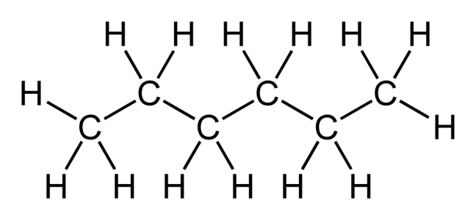  alkane  (all single bonds) | cis pent-2-ene  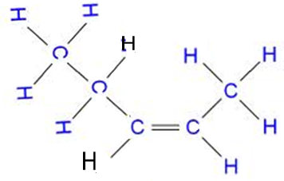  alkene | trans pent-2-ene  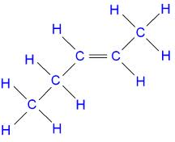  alkene
1,1,2,2-tetrafluoroethene  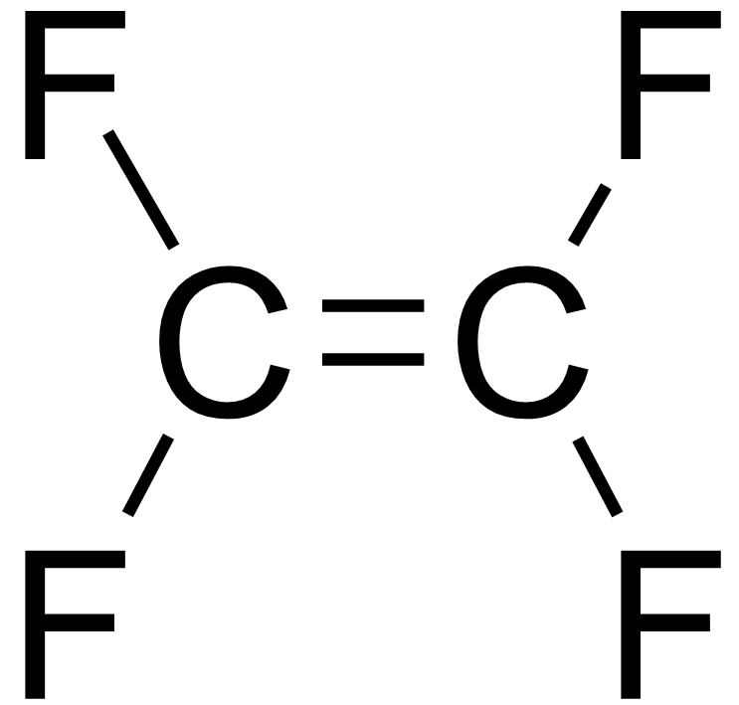  alkene | polybutene  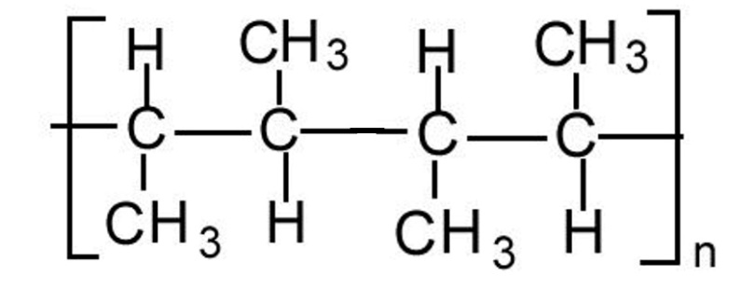  polymer | 4-methylpentan-1-ol  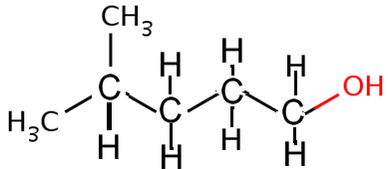  alcohol
methylamine  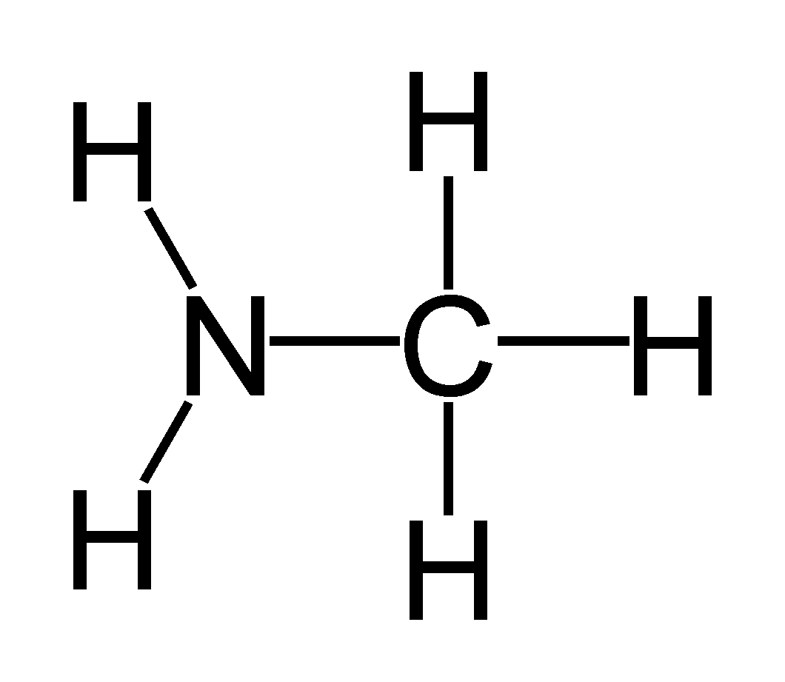  amine | 4-methylhexanoic acid  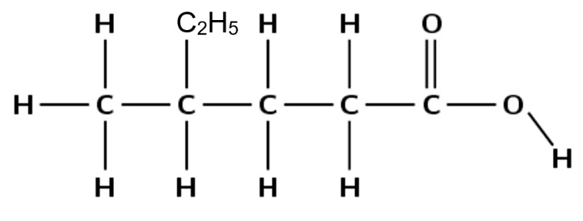  carboxylic acid | 2,2,3,3-tetramethylbutane  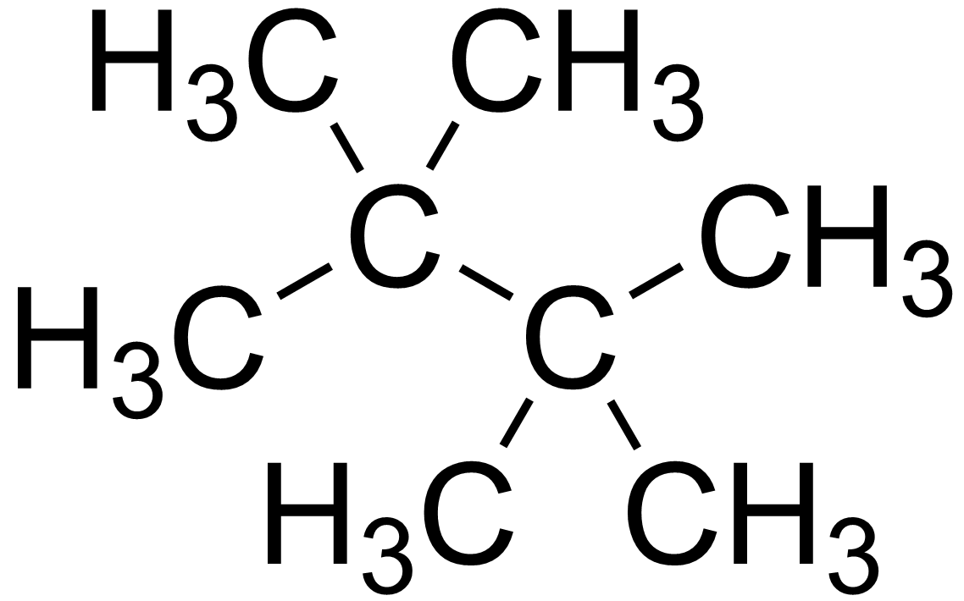  alkane  (all single bonds)

2,2-dimethylbutan-1-ol  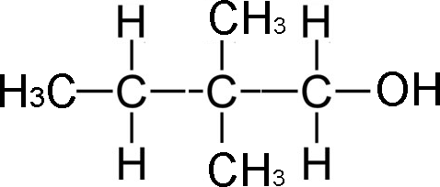  alcohol | pentan-3-ol  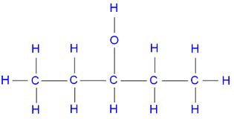  alcohol | ethylpropylamine  (also known as N-ethylpropylamine)  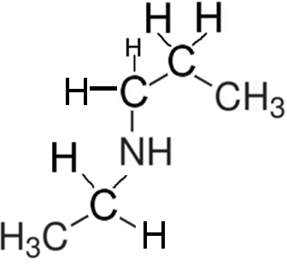  amine
cis 1,2-dichloropropene  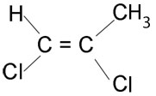  alkene | trans 1,2-dichloropropene  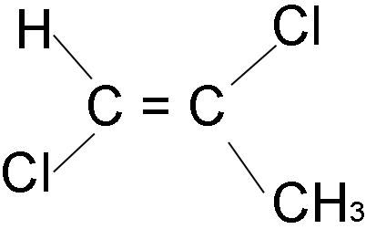  alkene | 2-chloro-3-methylbutan-1-ol  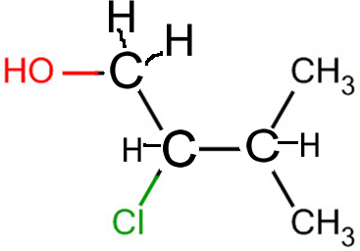  alcohol
dimethylamine  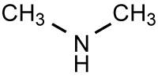  amine | 1-bromo-4-ethylhexane  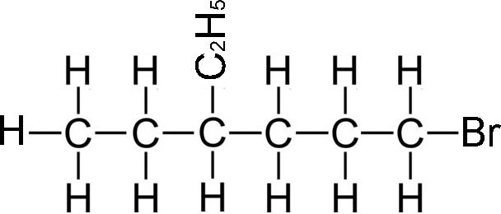  alkane  (all single bonds) | propan-1,2,3-triol  alcohol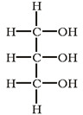
4-amino-2-methylbutanoic acid  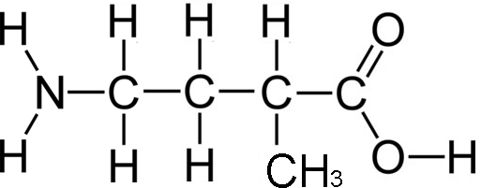  carboxylic acid | 3-ethyl-2,4-dimethylpentane  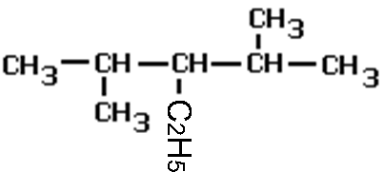  alkane (all single bonds) | cis 1,2-dibromopropene  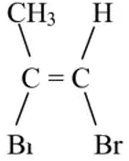  alkene
https://www.chemical-minds.com

