ANSWERS: Esters and triglycerides

2019 | Evidence | Achievement | Merit | Excellence
(i)  (ii) | Circle around – COO –  A hydrolysis reaction uses water to split a large organic molecule  into smaller organic molecules. Hydrolysis occurs in both acidic  and basic conditions (using dilute acid or base).  Both acidic and basic hydrolysis require heat under reflux. Both hydrolysis reactions produce the alcohol, glycerol. However, basic hydrolysis will produce the salt of the carboxylic acid, whereas acidic hydrolysis will produce the carboxylic acid.  Products from acidic hydrolysis:  CH₂(OH) – CH(OH) – CH₂(OH)  3CH₃ – (CH₂)₁₄ – COOH  Products from basic hydrolysis:  CH₂(OH) – CH(OH) – CH₂(OH)  3CH₃ – (CH₂)₁₄ – COO– | Correctly circles ester group.  Describes the hydrolysis reaction.  One correct product. | Links acidic OR basic hydrolysis reaction to correct products with structural formulae. | Compares and contrasts acidic and  basic hydrolysis, including ALL  correct structural formulae of  products.

2018 | Evidence |  | Achievement |  | Merit |  | Excellence
(i)  (ii)  (iii)  (iv) | ethyl butanoate  CH₃–CH₂–CH₂–COO–CH₂–CH₃  Heat under reflux: Diagram 2  Increases rate because it is able to be heated  No loss of products / reactants because they are condensed back into the mixture  Increases the amount of products / yield because reactants/products are prevented from escaping  Distillation could be used to purify the ester (diagram 1).  The reaction mixture is heated to the boiling point of the ester which is different from both the alcohol and carboxylic acid reactants. The ester will evaporate from the mixture and enter the condenser where it is cooled back to the liquid to be collected. The ester has therefore  been separated from the reaction mixture. |  | • Correct name or structural formula of  ethyl butanoate.  • Correctly identifies apparatus for BOTH  reflux and distillation  • Recognises heating under reflux prevents  loss of volatile organic compounds / speeds up rate of reaction / increases yield.  • Identifies distillation separates ester from  reaction mixture based on its boiling point.  OR  Description of distillation process. |  | Correct diagram for heating  under reflux TWO advantages and ONE explanation.  Correct diagram for  distillation plus process based on different boiling points and separation / purification explained by evaporating, cooling, condensing and collecting. |  | Fully explains the  advantages of heating under reflux  AND  Fully explains the use of distillation to purify the ester from reaction mixture.
2016 | Evidence | Achievement |  | Merit |  | Excellence
(i)  (ii) | One of these groups circled:  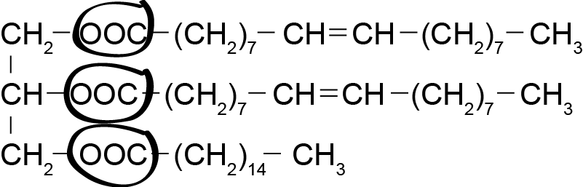  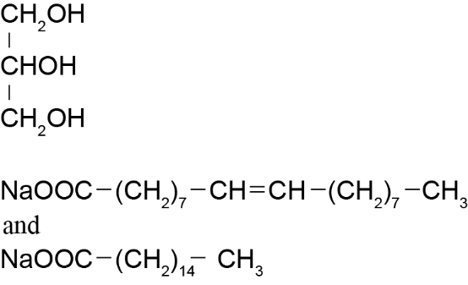 | - Ester functional group indicated.  - ONE correct product for hydrolysis reaction. |  | - All THREE products correct.

2015 | Evidence | Achievement | Achievement with Merit | Achievement with Excellence
(a)(i) | Any one of these groups circled:  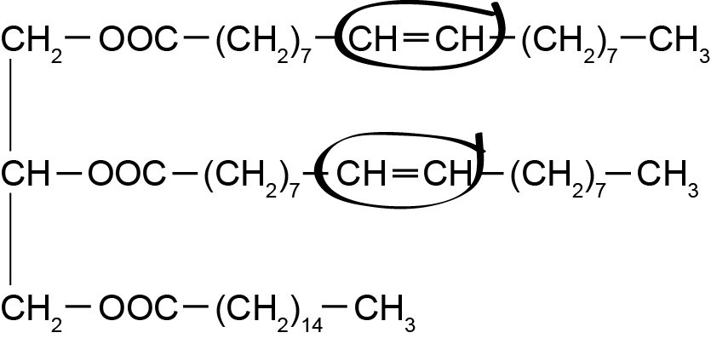 | - Functional group correct.
(ii) | Bromine water rapidly decolourised from red or orange to colourless in an addition reaction.  OR  Acidified permanganate rapidly decolourised from purple to colourless in a redox or oxidation or reduction reaction. | - Incomplete description. | - Links the observation to the reaction type.
(iii) | 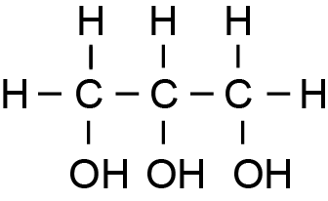  NaOOC(CH₂)₇CH=CH(CH₂)₇CH₃  NaOOC(CH₂)₁₄CH₃ | - ONE product correct. | - ALL products correct.

Evidence | Achievement | Merit | Excellence
Ester group:  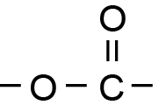  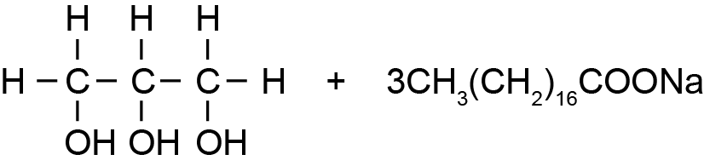  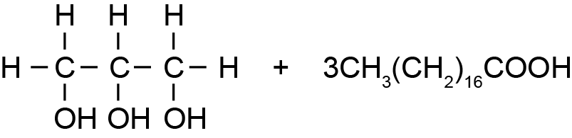  Both acidic and basic hydrolysis produce the same alcohol  propan-1,2,3-triol.  In addition, they both require heat / reflux  In contrast, acidic hydrolysis requires H₂O / H⁺ or HCl(aq) and produces the carboxylic acid, whereas basic hydrolysis requires H₂O / OH– or NaOH(aq) and produces the carboxylate ion/salt. | - Correct functional group circled AND named.  - One correct structure.  OR  Partial discussion. | - Two unique products linked to the type of hydrolysis.  OR  Products of one reaction correctly linked to the type of hydrolysis and reagent or conditions. | - Comparison and contrast of hydrolysis to give salt / acid and alcohol.  Reagents with conditions and structures correct.

2013 | Evidence | Achievement | Achievement with Merit | Achievement with Excellence
 | 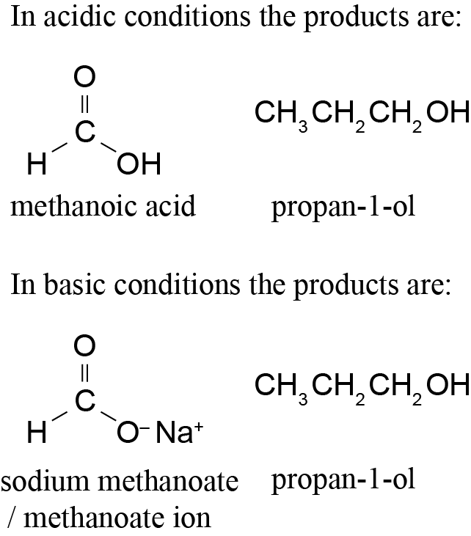  - The ester link is hydrolysed in both acid and basic conditions.  - Both produce an alcohol.  Acidic hydrolysis produces an acid and basic hydrolysis produces a base or salt / following hydrolysis in sodium hydroxide, an acid-base reaction occurs to form the sodium salt and water. (No further reaction occurs in acid.) | TWO correct products (name or formula).  Identifies hydrolysis. | TWO correct products (name and formula).  AND  Identifies hydrolysis. | ALL products correct (name AND formula).  AND  acidic hydrolysis compared and contrasted against basic hydrolysis.

© https://www.chemical-minds.com
NCEA questions and answers reproduced with permission from NZQA

