ANSWERS Trends in the Periodic table.

2022
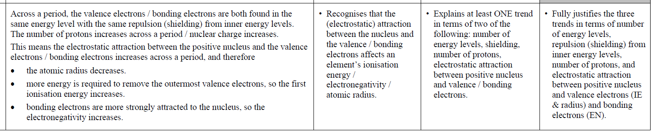

© https://www.chemical-minds.com

