Atomic structure extra help and questions

Atoms are the basic building blocks of matter that make up everyday objects. A desk, the air, even you are made up of atoms! Atoms are made up sub-atomic particles which are called electrons, protons and neutrons.
The centre of an atom is known as the nucleus. The nucleus is where protons and neutrons are found. Electrons are extremely light, they move extremely fast, orbiting the nucleus of an atom in electron shells or clouds. The closest shell/cloud to the nucleus is called the first shell/cloud and holds a maximum of two electrons. For now, you will learn that there are eight electrons orbiting within the other electron shells/clouds.

The numbers of sub-atomic particles for each element are shown on the Periodic table.
Atomic Number (the smallest number)
the number of protons
which is the same as
the number of electrons

2

He

4

Mass Number (the largest number)
the total number of particles in the nucleus; the number of protons
plus
the number of neutrons

Use the information above to answer the following questions
1. How many electrons, protons and neutrons does an atom of helium have? ____________________

___________________________________________________________________________________

___________________________________________________________________________________

2. Draw a neat, labelled sketch of an atom of helium

please note: You will be provided with a Periodic table in your NCEA Level 1 Science exam. Atomic numbers will be typed on that table. If the mass number is required for a question, then the mass number will be typed within that particular question.

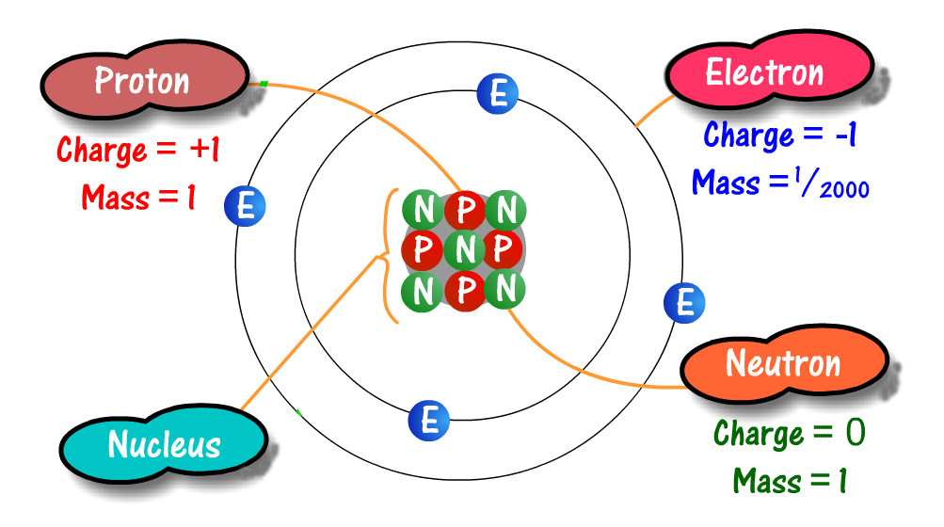

3 (i) Use at the image above to state the number of protons, electrons and neutrons in this atom

___________________________________________________________________________________

___________________________________________________________________________________

(ii) Use the numbers of protons and neutrons to state the Atomic number and Mass number for this element ____________________________________________________________________________

___________________________________________________________________________________

(iii) Use both your Periodic table and the image of the atom shown above to write out the name and chemical symbol of this element. ________________________________________________________
4 (i) The diagram below is of an atom, label the atom with the following words
electron  electron shell  nucleus  proton  neutron | 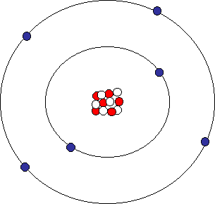

(ii) Look at your Periodic table and find out the name and chemical symbol of the element shown above

___________________________________________________________________________________

5. Use the periodic table provided in your NCEA Resource booklet to state the number of electrons, and protons in a potassium atom. Also, draw a labelled sketch of the atom

_______________________________________________

_______________________________________________

_______________________________________________

_______________________________________________

_______________________________________________
6. i) What is the chemical symbol for aluminium?  ii) What is the name given to the number next to the letters Al?  iii) What does the number tell us?  iv) Aluminium is a “neutral” atom, what does neutral mean? |  | 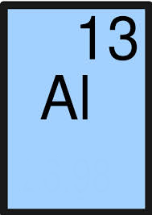

7. The Atomic number for a carbon atom is provided on the periodic table in your resource booklet (it is 6). An exam question may tell you that the Mass number for a carbon atom is 14. Use this information to complete the missing words below using your knowledge of atoms
A carbon atom has an Atomic number of six, so the carbon atom has _____ electrons orbiting the nucleus and _______ protons in the nucleus.
The mass number is the total number of particles in the nucleus, so carbon has a total of _____ particles in its nucleus. The particles in the nucleus are known as _______________ and ________________. As a carbon atom has 14 particles in the nucleus and 6 of these particles are called protons, then the other _____ particles must be neutrons.
Protons have a _______________ charge, neutrons have _______________ charge and electrons have a _________________ charge. Electrons are extremely light and move very quickly around the nucleus in ___________. Only ______ electrons fit in the first shell/cloud and we have learned (in Year 11) that all of the other shells/clouds fit up to _______ electrons.
8. Overleaf is a blank Periodic table (the middle section “Transition metals” is missing) complete each of the following activities on the Periodic table overleaf.
i) Label each group of the Periodic table with its correct name or number
ii) Label each period of the Periodic table with its correct number
iii) Choose 1 group and draw the electrons on the shells for each atom (get the Atomic numbers from your Periodic table)
iv) Now write the number of neutrons and protons in the nucleus for the group that you used in ques iii)
v) Complete the missing gaps in the following paragraph
Vertical columns of the Periodic table are known as ____________ Horizontal rows of the Periodic table are known as _____________ Elements in the same group all have the same number of ____________ in their outer shell eg I drew the atoms of group ________ and noticed that they all have ____ electron(s) in their outer shell. Elements in the same period all have the same number of ____________ eg I drew the atoms of period ____ and noticed that they all have ___ shells.

© https://www.chemical-minds.com

1 | 2 | 13 | 14 | 15 | 16 | 17 | 18
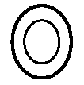

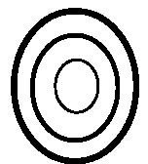

ANSWERS
6. (i) Al (ii) Atomic number (iii) the number of protons which is the same as the number of electrons
(iv) “neutral” means that an atom does not have an overall charge because the atom has the same number of positively charged protons (13 protons for aluminium) and negatively charged electrons (13 electrons for aluminium)
7. 6, 6, 14, protons, neutrons, 6, 6, 8, positive, neutral (or no), negative, electron shells, 2, 8
8 (v) groups, periods, electrons, eg... one, one eg…shells, eg…two, two

