ANSWERS: Atomic and Ionic Radii

2022
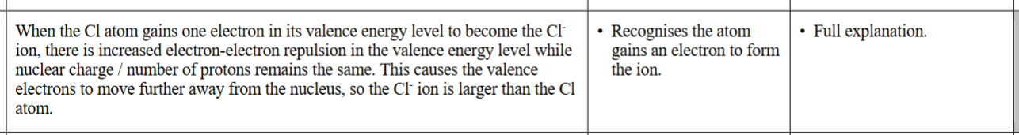

2021
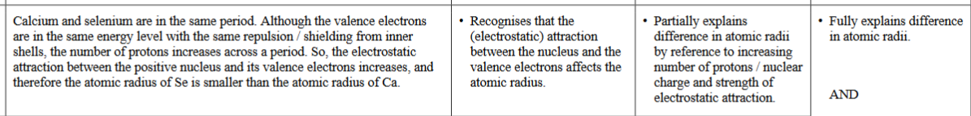

2020

2019 | Evidence | Achievement | Achievement with Merit | Achievement with Excellence
 | Sulfur and the sulfur ion have the same number of proton/nuclear charge but when the sulfur atom gains two electrons to form the sulfur ion, there is increased electron-electron repulsion in the valence energy level. As a result, the electrons move further apart, and therefore the S^{2–} ion has a larger radius than the S atom. | Recognises the atom gains  electrons to form ion / repulsion increases | Full explanation.

2016 | Evidence | Achievement | Achievement with Merit | Achievement with Excellence
 | The Cl atom gains one electron to complete its valence shell to form the Cl– ion, the nuclear charge remains the same. The increased inter-electron repulsion in the outer energy level causes the valence electrons to move further from the nucleus, so the Cl– ion is larger than the Cl atom. | - Cl– is larger as it gained an electron when formed / more repulsion. | - Full explanation.
2014 | Evidence | Achievement | Achievement with Merit | Achievement with Excellence
 | The K⁺ ion has a smaller radius than the K atom, as the ion has lost an electron from the valence/outer energy level, and therefore has fewer shells. This results in greater attraction between the nucleus and the valence electrons, as the outer electrons are now closer to the nucleus. There is less repulsion between the remaining electrons. Both species have the same number of protons / amount of nuclear charge. | - K⁺ is smaller, as it has lost a shell / or other correct statement. | - K⁺ is smaller, both species have the same number of protons / charge AND lost a shell  OR less electron-electron repulsion linked to a greater attraction in the ion. | - Full explanation

2013 | Cl– has an extra electron in its outermost/same energy level. This causes increased repulsion between electrons in the valence shell, so the electrons move further apart. This makes Cl– bigger than Cl. Both Cl and Cl– have the same number of protons/attractive force of the nucleus remains the same.

2012 | Ge = 123 pm  Cu = 128 pm  Cu⁺ = 77 pm  Both atoms have the same number of electron shells / energy levels / shielding of outer electrons by inner electrons / valence electrons in same energy level. Ge, however, has a greater nuclear charge / number of protons, compared to Cu, so there is a stronger attraction for the valence electrons, bringing them in closer, resulting in a smaller radius.  Cu⁺ has fewer electron shells than the Cu/Ge atoms (only 3 vs 4) and hence the electrons are closer to the nucleus meaning it is the smallest of the three particles.  Cu> Ge > Cu⁺ | - Cu =128pm or Cu⁺ = 77pm.  - All radii in correct order.  - Loss of energy level / loss of electron from 4s orbital for Cu to form Cu⁺ hence valence electrons much closer to the nucleus.  Recognises smaller radius for Ge, compared to Cu, due to greater electrostatic attraction between nucleus and valence electrons due to fact that:  - Ge has greater charge / more protons on the nucleus. Both Ge and Cu have valence electrons in the same energy level.

2011 | Evidence | Achievement | Achievement with Merit | Achievement with Excellence
 | Al has the larger radius.  Al³⁺ has lost 3 electrons / valence shell.  This means that there is one less energy level than in Al.  The remaining electrons are drawn closer by nuclear charge / nuclear attraction greater causing smaller size. | Correct radii identified to be largest.  With one of first two bullet points. | Correct radii identified to be largest.  With fully correct explanation.

© http://www.chemical-minds.com
NCEA questions and answers reproduced with permission from NZQA

