Question: What is the correct balanced equation for the reaction of potassium hydroxide with sulfuric acid?

Take your time, do this carefully in THREE stages…

Firstly, write the word equation potassium hydroxide + sulfuric acid potassium sulfate + water

Secondly, use the ions table in your resource booklet to write the chemical formula for the reactants and products

potassium hydroxide | sulphuric acid |  | potassium sulfate | water
K⁺ OH⁻  scribble down your rough notes on paper | H₂SO₄ learn this!  the other less common name is hydrogen sulfate  H⁺ SO₄²⁻  H⁺ |  | K⁺ SO₄²⁻  K⁺ | H₂O  you KNOW this, don’t you!!!???
KOH | H₂SO₄ |  | K₂SO₄ | H₂O

Finally, count the atoms on each side of the equation (use numbers or draw circles/shapes)

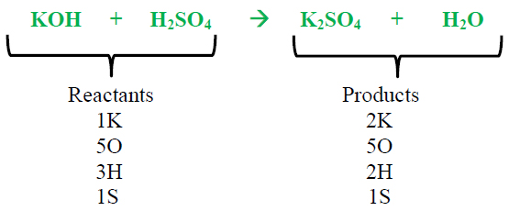 | 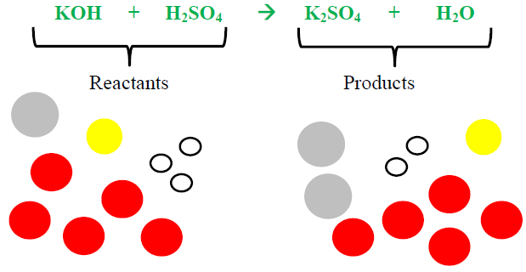

and if needed adjust the number molecules or compounds by writing a BIG number in front

2KOH + H₂SO₄ K₂SO₄ + 2H₂O

This is the correct balanced equation.

© https://www.chemical-minds.com/

