Bromine test (Level 2) examiners tips

A common laboratory procedure to distinguish between an alkane and alkene is to use bromine water, Br₂ (aq)

Name of substance | 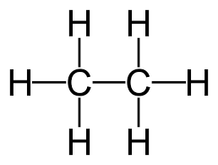  Ethane | 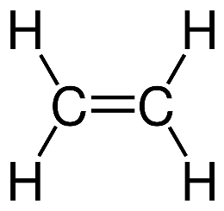  Ethene
Homologous series | Alkanes | Alkenes
Functional group | Single bond between the carbon atoms | Double bond between the carbon atoms
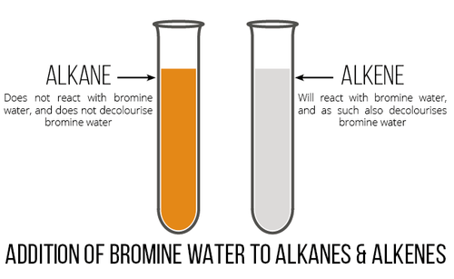
https://socratic.org/questions/what-are-the-tests-for-alkanes

Reaction of bromine water with an alkane and an alkene
Name of alkane/alkene | Ethane | Ethene
Type of reaction | Substitution | Addition
Catalyst | light is required | none required
Speed of reaction | approx. 10 minutes | immediate
Number of products formed | 2 | 1
Name of products | bromoethane and hydrogen bromide | 1,2-dibromoethane

Many exam questions regarding the bromine test for unsaturation ask you to compare and contrast.
First, use a double/bubble to write down your thoughts as you prepare your answer

To achieve with Excellence
When composing your compare/contrast (similarities/differences) answer, you MUST use linking words

Sentence starter | linking words |  | Sentence starter | linking words
A similarity is….  Another similarity is… | similarly  as with  in the same way  likewise  equally |  | A difference is…  Another difference is… | whereas  alternatively  otherwise  conversely  however  on the other hand  although
© https://www.chemical-minds.com

