ANSWERS: Calculating and interpreting Kc

**2022**

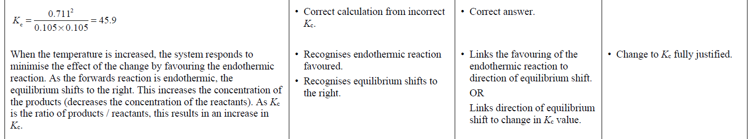 **2021**

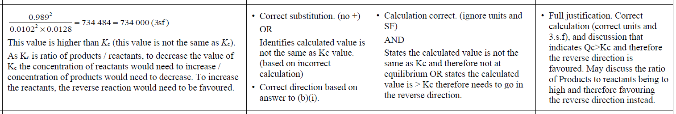

**2020**

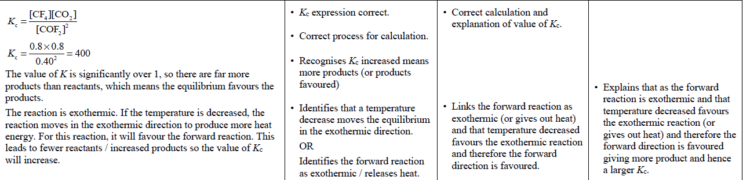

|  |  |  |  |  |
| --- | --- | --- | --- | --- |
| **2019** | **Evidence** | **Achievement** | **Merit** | **Excellence** |
| **1.** | As the temperature increases, the system will act to reduce the  temperature by favouring the endothermic direction to absorb some of the extra heat energy. Since the reaction has a negative Δr*H*, this means that the forward reaction is exothermic and produces heat energy. So, an increase in temperature will cause the equilibrium to shift towards the reactants and therefore the concentration of reactants will increase. A higher concentration of reactants (compared to products) will cause the *K*c value to decrease. | Recognises that an  increase in temperature  moves the equilibrium in  the endothermic  direction. | • Links temperature increase to the equilibrium shifting towards reactants, and therefore an increase in  **concentration** of reactants.  OR  • Links increase in amount /  concentration of reactants to decrease in *K*c. | Justifies the decrease in *K*c by linking to equilibrium principles and relative  amount / concentration of reactants (and products). |
| **2. (i)**  **(ii)** | When N2(*g*) is added, the system will oppose the change (increase in concentration of N2(*g*)) and therefore the position of the equilibrium will shift in the forward direction to use up some of the added N2(*g*). This means more NO2(*g*) will be produced.  However, the ratio of the concentrations of the reactants and products will remain the same, consequently the value of *K*c remains unchanged. Only a change in temperature will affect the value of *K*c. | One step of calculation is  correct, e.g. correct substitution.  *K*c is unchanged. | Calculation correct.  *K*c is unchanged with reason, e.g.  *K*c is a constant at a given temperature  OR  Change in concentration does not affect Kc  OR  the ratio of the concentrations of the  reactants and products will remain the same. | Calculation correct with unit and 2–4  significant figures.  **AND**  Effect on *K*c when more N2(*g*) is added is explained, e.g. The value of *K*c is unchanged by a change in concentration since *K*c is a constant at a given temperature. |

|  |  |  |  |  |
| --- | --- | --- | --- | --- |
| **2018** | **Evidence** | **Achievement** | **Merit** | **Excellence** |
| **(i)**  **(ii)** | The Kc value is larger than 1 so there are more products than reactants at equilibrium. | One step of calculation correct (correct substitution).  Identifies products are favoured.  Allow error carried forward. | Correct calculation. No penalty for significant figures.  Links the *K*c value being larger than 1 to more products than  reactants. **Do not accept generic statements.** |  |

|  |  |  |  |  |
| --- | --- | --- | --- | --- |
| **2017** | **Evidence** | **Achievement** | **Merit** | **Excellence** |
| **(i)** | No, the reaction is not at equilibrium because 677 > 640 (values must be equal for a reaction to be at equilibrium).  *Accept answers between 676 – 678.* | One correct step of the calculation (correct substitution)  OR  Correctly compares incorrect *K*c to 640. | Correct calculation and explanation. |  |

|  |  |  |  |  |
| --- | --- | --- | --- | --- |
| **(ii)** | When temperature increases, the reaction moves in the endothermic direction to absorb the added heat. In this reaction, the value of *K* decreased, indicating the ratio of products to reactants decreased. Since there will be fewer products and more reactants, the equilibrium is favouring the reactants, so adding heat favours the reverse reaction / the position of equilibrium shifts left. Hence, the formation of ammonia gas / forward reaction, is exothermic.  (Temperature is the only factor that can change the *K* value in an equilibrium). | Identifies that a temperature increase shifts equilibrium in  endothermic direction. | Links change in *K*c value to  changes in the relative  concentrations of reactants or  products. | Justifies forward direction as exothermic by linking the effect of increasing temperature to the change  in *K* value and relative amounts of reactants / products. |

|  |  |  |  |  |
| --- | --- | --- | --- | --- |
| **2016** | **Evidence** | **Achievement** | **Merit** | **Excellence** |
| **(i)**  **(ii)**  **(iii)** | There would be no effect on the equilibrium if pressure was increased because there are equal numbers of moles of gas on either side of the equilibrium / in the reactants and products.  (Temperature is the only factor that can change the *K* value of an equilibrium).  When the temperature increases, the reaction moves in the endothermic direction to absorb the added heat. In this reaction, the value of *K* decreased, indicating the ratio of products to reactants (numerator to denominator) decreased. Since there will be fewer products and more reactants, adding heat is favouring the backwards reaction. Therefore, the forward reaction is exothermic. | * One correct step of the calculation (correct substitution). * Recognises change in pressure has no effect.   • Identifies increase in temperature favours the endothermic reaction. | * Calculates correct concentration of HI with unit (accept 2-4 sig. figs). * Explains effect of pressure in terms of moles of **gaseous** particles.   • Links decrease in *K*c value  to changes in the relative  concentrations of reactants  or products. | • Justifies the forward reaction as exothermic by explaining how the increase in temperature favours the endothermic reaction, and the decreasing *K*c value results in a change in relative concentrations of reactants or products |

© <https://www.chemical-minds.com>

NCEA questions and answers reproduced with permission from NZQA

|  |  |  |  |  |
| --- | --- | --- | --- | --- |
| **2015** | **Evidence** | **Achievement** | **Merit** | **Excellence** |
| **(i)**  **(ii)** | Since *K*c = 4.32, *Q* ≠ *K*c, so this reaction mixture is not at equilibrium.  This number is greater than the *K*c value, 4.32, which indicates that the reaction lies to the products side as the larger the *K*c or *Q* value, the greater the numerator (products).  At 450**°**C, the temperature has decreased. This reaction is exothermic, as shown by the negative enthalpy. This means that if the temperature is decreased, the reaction will move in the direction that produces more heat. Because this is an exothermic reaction, the exothermic direction is forwards. This will lead to more products and an increase in *K*c. | One correct step of the calculation*.*   * Identifies the forward reaction as exothermic   OR  That the forward reaction is  favoured / moves to right. | Correct calculation.  Links reaction favoured to the production of heat / or increasing *K*c. | Calculation correct and links to  *Q* ≠ *K*c (4.32), or similar. (If correct, accept if something other than *Q* is used).  Explains the effect of decreasing temperature on *K*c, in terms of relevant equilibrium principles and links this to product formation. |