Chemical Bonding
useful additional info…

Coulomb's law
describes the electrostatic interaction between electrically charged particles
which states that…
the force between two charged particles
is directly proportional to the product of the charges
and
is inversely proportional to the square of the distance between them.
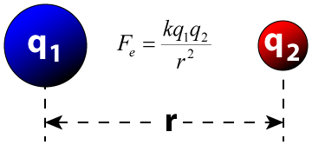
All chemical bonding is an electrostatic force of attraction
Electrostatic force means the force between two charges
“like charges repel
unlike charges attract”
Electrostatic attraction means an attraction between oppositely charged particles

In Chemistry, the attraction is between the electrons and nucleus

because electrons are negatively charged and positive protons are found in the nucleus

Type of bond | 1) Metallic | 2) Ionic | 3) Covalent
type of substance | 3D metallic | 3D ionic | molecular | network covalent  giant covalent
examples | eg Na, Cu, Mg, Fe | eg NaCl, MgF₂, Li₂O | eg. H₂, Cl₂, O₂ | eg 2D graphite, 3D diamond,  3D buckyball, 3D SiO₂
particles | metal cations and electrons | cations and anions | molecules | atoms
strength | strong | strong | strong covalent bond between atoms  weak force between molecules | very strong covalent bond
image | 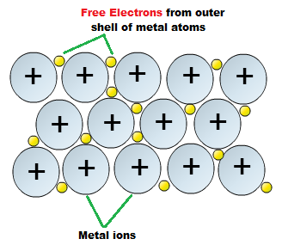 | 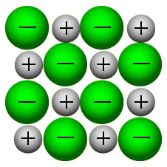 | 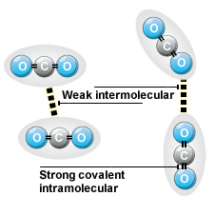 | 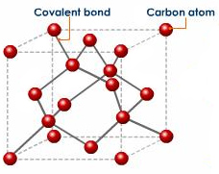
Let’s look at Ionic bonding and Covalent bonding (specifically molecular substances) in more detail

Molecular substances contain covalent bonds between atoms, INside the molecule (INTRAmolecular force)
the covalent bond(s) will be either pure covalent or polar covalent
useful additional info…

Ionic bonds, polar covalent bonds and pure covalent bonds all sit along a continuum
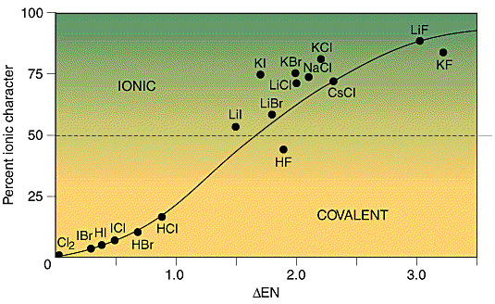
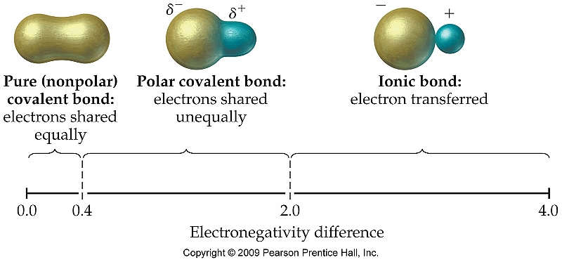

Molecular substances also contain weak forces BETWEEN molecules (INTERmolecular forces)

There are THREE different types of Intermolecular force /van der Waals force

A Hydrogen bond forms between a H atom (which is directly bonded to a N, O, F atom within the same molecule) and N. O. F (also directly bonded to a H atom) of another molecule. | Permanent dipole/Dipole-dipole forms between dipole positive end of one molecule and dipole negative end of another | Temporary dipole/London force  Covalent Bond  (strong)  Instantaneous dipole/Dispersion force
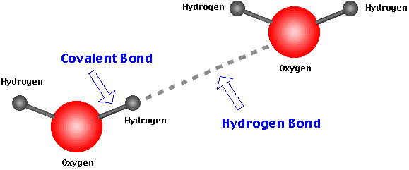  >  Hydrogen Bond  which is a weak intermolecular force  Covalent Bond  (strong) | 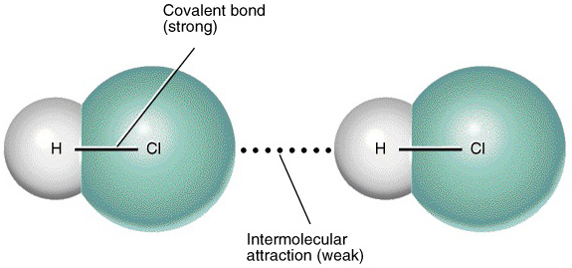  Permanent dipole/ dipole –dipole  which is a weak-intermolecular force | 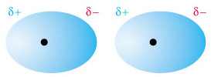  >  Temporary dipole/ instantaneous dipole/ dispersion force/ London force  which is a weak intermolecular force  H H  H H  - - - - - -
© https://www.chemical-minds.com

