ANSWERS: Cracking

2019 | Evidence | Achievement | Merit | Excellence
(i)  (ii)  (iii) | Cracking. It is necessary to provide alkenes that can be used to make polymers  C₇H₁₆ --> C₅H₁₂ + C₂H₄  (accept condensed or expanded)  C₁₅H₃₂ --> C₈H₁₈ + 2C₂H₄ + C₃H₆ | • Cracking or produce alkenes. | • Links cracking to producing an alkene.  • One Correct equation. | • Both correct balanced  equations.

2018 | Evidence | Achievement | Merit | Excellence
 | C₆H₁₄ --> C₄H₁₀ + C₂H₄

2017 | Evidence | Achievement | Merit | Excellence
(i)  (ii) | Decane → Pentane + Propene + Ethene  C₁₀H₂₂ → C₅H₁₂ + C₃H₆ + C₂H₄  Cracking is a chemical reaction in which carbon to carbon bonds within the molecule are broken to form smaller hydrocarbons. This requires either high temperatures and pressures, or the use of a catalyst to break the carbon to carbon bonds. New products are formed, so this is a chemical process.  Fractional distillation is a physical process where hydrocarbons are separated based on their physical properties (boiling points). No new substances are formed – the mixture is separated into different fractions based on mass / boiling point, therefore the process is physical.  The two processes are different as cracking produces new products while fractional distillation is used to separate a mixture. | • One product correct.  • States that cracking is a chemical process and fractional distillation is a physical process.  • Describes what cracking /fractional distillation is. | • All products correct.  • Explains why one process is a  chemical or physical process. | • Contrasts both processes; including reference to the  physical / chemical properties of the hydrocarbons involved.

2016 | Evidence | Achievement | Merit | Excellence
 | 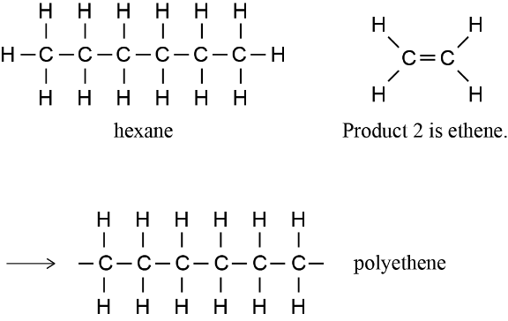  Reaction 1 is cracking. The conditions required are heat, pressure, catalyst. | - THREE out of four names / structures correct.

2015 | Evidence | Achievement | Merit | Excellence
(i)  (ii) | Catalyst, heat, pressure.  C₁₂H₂₆ → 2C₂H₄ + C₈H₁₈ | - States one condition required.  • Gives correct formulae of products.

© https://www.chemical-minds.com
NCEA questions and answers reproduced with permission from NZQA

