ANSWERS: Electronegativity

2021
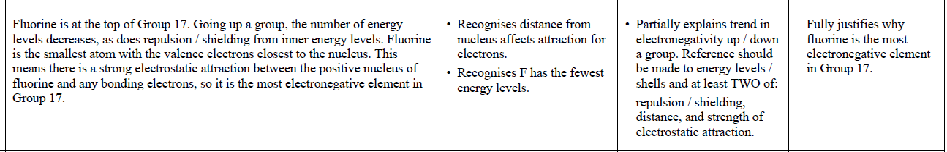

2019 | Evidence | Achievement | Achievement with Merit | Achievement with Excellence
 | Electronegativity increases across a period, i.e. from Na to S. Both Na and S have the same number of energy levels and therefore the same shielding/electron-electron repulsion from inner levels. S has more protons/greater nuclear charge and therefore a greater attraction for valence/bonding electrons therefore greater electronegativity than Na.  Electronegativity decreases down a group. Sulfur has one more energy level and therefore increased shielding/electron-electron repulsion. Even though S has greater nuclear charge/more protons than O, because the valence electrons are further from the nucleus,  electronegativity is lower. | States that electronegativity increases  across a period  OR  up a group.  OR  One correct statement relating to  electronegativity. | Explains difference in  electronegativity EITHER across a  period OR up / down a group  OR  Partial explanation for both with some linking of ideas. | Fully accounts for difference in electronegativity for ALL  three elements.

2017 | Evidence | Achievement | Achievement with Merit | Achievement with Excellence
(i)  (ii) | Electronegativity is the ability of an atom to attract a bonding pair of electrons to itself.  Electronegativity increases as you go across a period.  Both Cl and P are row 3 elements and have valence electrons in their 3rd shell. The electrons are in the same shell so experience the same shielding effect. Chlorine has more protons in its nucleus than phosphorus so its nuclear charge is greater. This means that chlorine will have more attraction for the bonding pair of electrons so its electronegativity is greater. | • Correct definition.  • ONE correct statement. | • Links nuclear charge to chlorine’s greater electronegativity. | • Full and correct explanation of  nuclear charge and electrons.

2016 | Evidence | Achievement | Achievement with Merit | Achievement with Excellence
 | Electronegativity decreases down a group. Electronegativity is a measure of how strongly an atom attracts bonding electrons. Although the nucleus will become increasingly positive down a group (number of protons increases), the atomic radius increases down a group as more energy levels are added and shielding / repulsion from inner shells increases. Therefore, the bonding electrons in the valence shell will be further from the positive nucleus, resulting in a weaker electrostatic attraction between the nucleus and the bonding electrons.  First ionisation energy is a measure of how easily the first mole of electrons is removed from one mole of gaseous atoms. It becomes easier to remove an electron down a group / first IE decreases down a group as the valence electrons are further from nucleus with greater repulsion / shielding from inner shells, so there is less electrostatic attraction between protons in the nucleus and valence electron to be removed.  For both EN and first IE, the attraction between the positive nucleus and bonding / valence electrons in the outer shell is decreasing down a group, so both EN and first IE decrease down a group. | - Trend in electronegativity and first ionisation energy correctly identified.  OR  Correct definitions for electronegativity and first ionisation energy.  OR  Both the definition AND the trend are correct for either electronegativity or first ionisation energy. | - Links trend in electronegativity  AND ionisation energy to  EITHER  the size of atom / shielding  OR  to the electrostatic attraction between the nucleus and bonding electrons. | - Full explanation, including the relationship between electronegativity and first ionisation energy.

2015 | Evidence | Achievement | Merit | Excellence
 | Electronegativity is the ability of an atom in a compound to attract electrons to itself.

2013 | Evidence | Achievement | Merit | Excellence
 | Se has more shells/electrons in energy levels further from the nucleus than O, with increased shielding from inner shells. This means there is a weaker electrostatic attraction between the nucleus and the bonded electrons, so Se has a lower electronegativity than O.

© https://www.chemical-minds.com
NCEA questions and answers reproduced with permission from NZ

