Major and minor products of elimination reactions examiner’s tips
Zaitsev’s (or Saytzeff’s) rule is used to predict the major and minor products of an elimination reaction of secondary alcohols or haloalkanes.

1. Look at the 2 carbon atoms on either side of the carbon atom which is directly attached to the hydroxyl
group or halogen atom.
2. Count the hydrogen atoms directly bonded to each of the carbon atoms, one of those carbon atoms has
least number hydrogen atoms directly bonded to it, so, this is known as the "poorer" carbon atom
3. Therefore the major product will result in the “poorer” carbon atom losing a hydrogen atom during the
elimination reaction, when the hydroxyl or halogen atom is also removed.
4. So, the minor product will form with the “richer” carbon atom losing a hydrogen atom during the
elimination reaction, when the hydroxyl or halogen atom is also removed

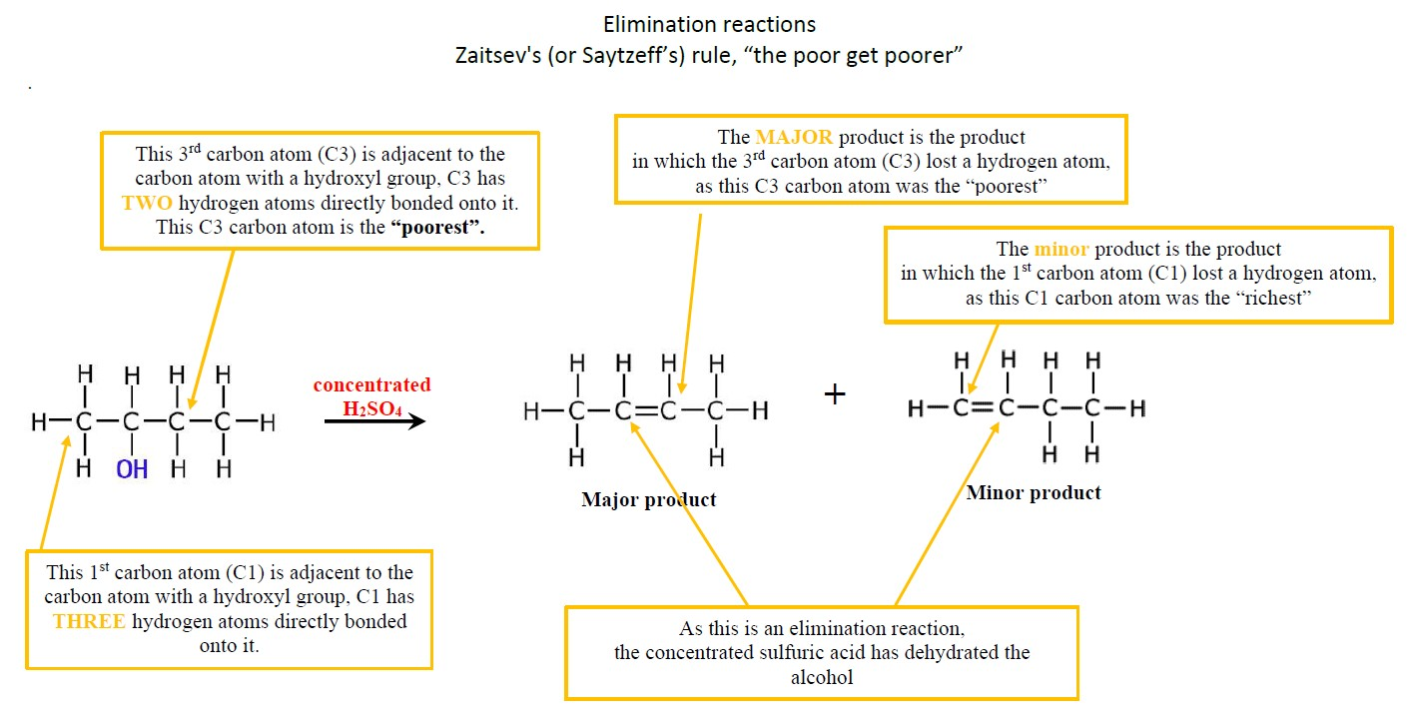

Structure your exam answer carefully
What type of reaction is this and why?
This is an elimination reaction because atoms (name them!) have been removed and a double bond is formed.
Describe and explain formation of both the major…
There are two unique positions the double bond can form, so there are two possible products.
The carbon atom adjacent to the carbon atom with the hydroxy group, that has the least hydrogen atoms attached is where the double bond forms as the major product.
This means that but-2-ene will be the major product, since C3 has only two hydrogen atoms directly bonded to it whereas C1 has three hydrogen atoms directly bonded to it, therefore a double bond forms from the C3 atom.
and minor products
The carbon atom adjacent to the carbon atom with the hydroxy group, that has the most hydrogen atoms attached is where the double bond forms as the minor product.
This means that but-1-ene will be the minor product, since C1 has three hydrogen atoms directly bonded to it whereas C3 has two hydrogen atoms directly bonded to it, therefore a double bond forms from the C1 atom.
Be sure to draw the structural formula and name the products

Also…”don’t be daft”
"the poor get poorer" means NOTHING! see explanation above and use something similar in your answers
Ensure you describe your reasons for formation of both “major” and “minor” products.
© https://www.chemical-minds.com

