**ANSWERS: Enthalpy change calculations**

**2022**

**(a)**

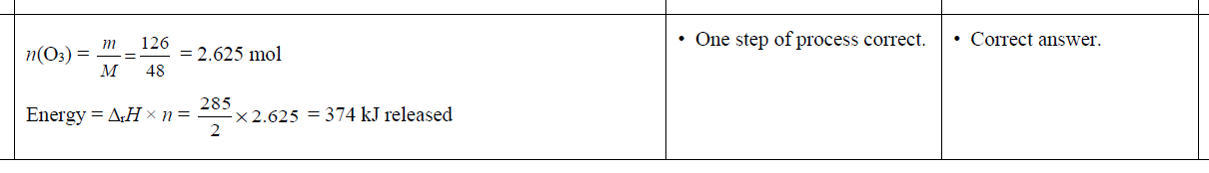

**(b)**

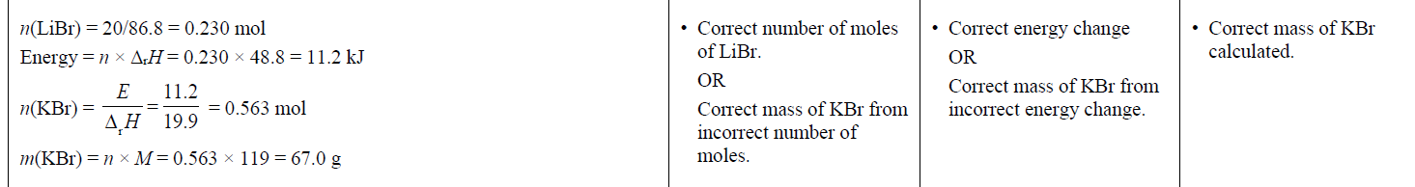

**2021**

**(a)**

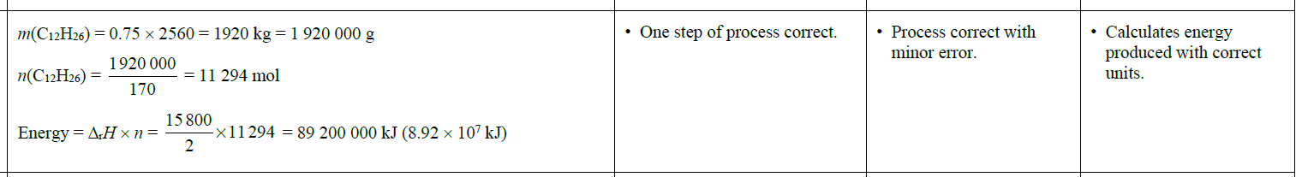

**(b)**



**2020**

**(a)**

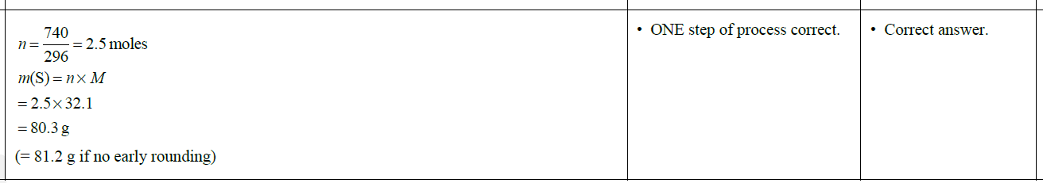

**(b)**

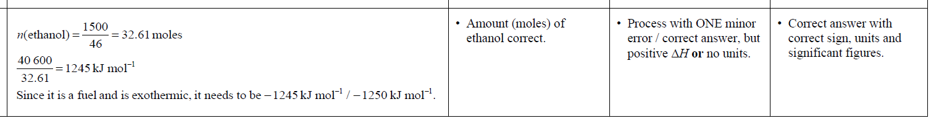

|  |  |  |  |  |
| --- | --- | --- | --- | --- |
| **2019** | **Evidence** | **Achievement** | **Merit** | **Excellence** |
| **(a) (i)**  **(ii)**  **(b)** |  | • ONE step of calculation correct.  • ONE step of calculation correct. | • Correct answer.  • Correct answer.  • ONE step of process correct. | BOTH correct answers with units.  • Process correct with minor error. |

|  |  |  |  |  |
| --- | --- | --- | --- | --- |
| **2018** | **Evidence** | **Achievement** | **Merit** | **Excellence** |
|  |  | • One step of calculation correct. | • Two steps of calculation are correct. | • Correct answer with unit. |

|  |  |  |  |  |  |  |  |
| --- | --- | --- | --- | --- | --- | --- | --- |
| **2017** | **Evidence** | | | **Achievement** | | **Merit** | **Excellence** |
|  | **Reaction 1:** If 1 mole of Fe2O3 releases 852 kJ energy 0.313 mol × 852 kJ mol–1 = 266 kJ energy released  **Reaction 2:** If 3 mole of CuO releases 1520 kJ energy. Then 1 mole of CuO releases 507 kJ energy 0.628 mol × 507 kJ mol–1 = 318 kJ energy released  So 50.0 g CuO releases more energy than 50.0 g Fe2O3  OR CuO releases more energy (52 kJ) than Fe2O3 OR  **Reaction 2** releases more energy. | | | Amount (moles) of both Fe2O3 and CuO correct. | | Correctly calculates energy  released for either Reaction 1 or Reaction 2. | Both Fe2O3 and CuO calculations with units (kJ) are correct with appropriate significant figures,  and a statement identifying CuO /  Reaction 2 as releasing more  energy. |
| **2016** | | **Evidence** | **Achievement** | | **Merit** | | **Excellence** |
|  | | *n* (pentane) = 125 g / 72.0 g mol–1 = 1.74 mol  *n* (hexane) = 125 g / 86.0 g mol–1 = 1.45 mol  If 1 mole of pentane releases 3509 kJ energy, then 1.74 mol of pentane  1.74 × 3509 = 6106 kJ energy released.  If 2 moles of hexane release 8316 kJ energy,  then 1 mole of hexane releases 4158 kJ energy. So 1.45 mol of hexane  1.45 × 4158 = 6029 kJ energy releases.  So pentane releases more energy (77.0 kJ) than hexane, per 125 g of fuel. | Amount (moles) of pentane or hexane correct. | | Pentane or hexane calculation correct. | | Both pentane and hexane calculations with units are correct, and identifies pentane as releasing more energy (link back to question) per 125 g of fuel. |

|  |  |  |  |  |
| --- | --- | --- | --- | --- |
| **2015** | **Evidence** | **Achievement** | **Merit** | **Excellence** |
|  | Since 6 moles of CO2 reacting requires 2803 kJ of energy  then 1 mole of CO2 reacting requires  = 467.2 kJ of energy  and 0.450 moles of CO2 requires 467.2 × 0.450 = 210 kJ of energy absorbed. | * One step of calculation is correct.   OR  Correct answer with no working. | Two steps of the calculation are correct. | Calculation is correct with correct sign and units. |

|  |  |  |  |  |
| --- | --- | --- | --- | --- |
| **2014** | **Evidence** | **Achievement** | **Merit** | **Excellence** |
|  | n(CH3OH) = m / M = 345 / 32 = 10.78 mol  n(C2H5OH) = m / M = 345 / 46 = 7.50 mol  2 mol CH3OH release 1 450 kJ of energy  1 mol CH3OH releases 725 kJ of energy  10.78 mol CH3OH releases 725 kJ × 10.78  = 7 816 kJ of energy  1 mol C2H5OH releases 1 370 kJ of energy  7.5 mol C2H5OH releases 1 370 kJ × 7.5 = 10 275 kJ of energy  Therefore C2H5OH releases more energy when 345 g of fuel are combusted. | * Amount of CH3OH or C2H5OH correct.   Energy released for one mol CH3OH or C2H5OH correct. | * TWO steps of calculation correct for both CH3OH and C2H5OH, with conclusion. | * Justifies choice of fuel with correct calculations and unit. |

|  |  |  |  |  |
| --- | --- | --- | --- | --- |
| **2013** | **Evidence** | **Achievement** | **Merit** | **Excellence** |
| **1.**  **2.**  **3.** | 9800 kJ / 2820 kJ mol–1 = 3.48 mol  n(C4H10) = 100 g / 58.1 g mol–1  = 1.7212 mol  –4960 kJ / 1.7212 mol = –2882 kJ mol–1  n(Fe) = 2000 g / 55.9 g mol–1 = 35.78 mol  Fe3O4:  3348 kJ / 9 = 372 kJ mol–1  372 kJ mol–1 × 35.78 mol  = 13 310.16 kJ  = (–)1.33 × 104 kJ  Fe2O3:  851 kJ / 2 = 425.5 kJ mol–1  425.5 kJ mol–1 × 35.78 mol = 15 224.4 kJ  = (–)1.52 × 104 kJ  Therefore Fe2O3 produces more heat energy when 2 kg iron is formed. | calculation is correct  one step correct in the calculation.  one step correct. | calculation is correct.  two steps correct | calculations correct with units and statement made about which iron oxide produces more heat energy. |

### © <https://www.chemical-minds.com>

NCEA questions and answers reproduced with permission from NZQA­