ANSWERS: Interpreting and explaining equilibrium

2022
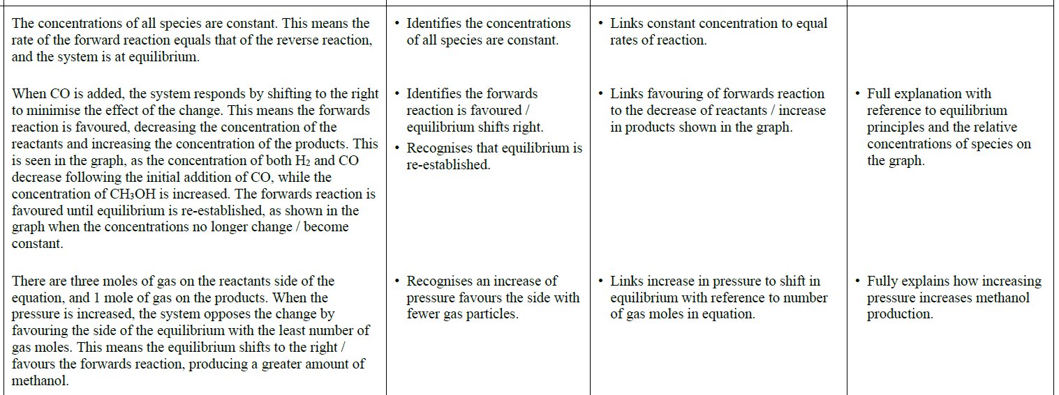

2021
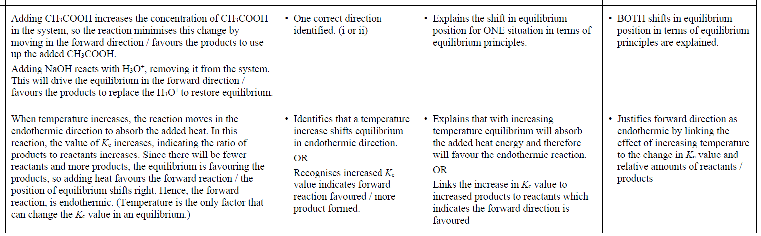
2020
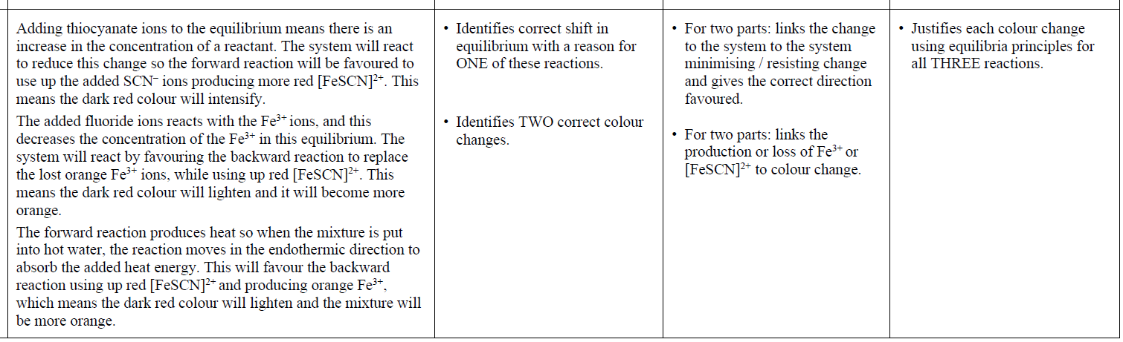
2019
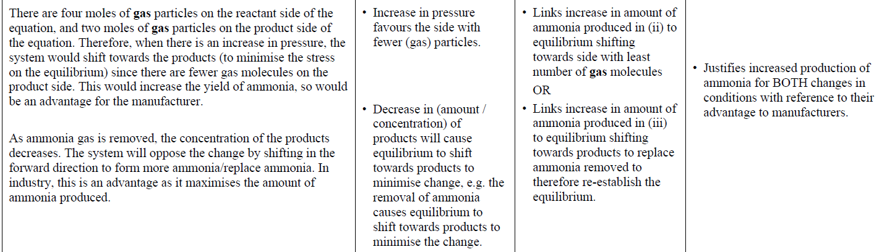

2018 | Evidence |  | Achievement | Merit |  | Excellence
(i)  (ii) | If the sulfur trioxide is removed as it is produced, [SO₃] will  decrease, so the equilibrium will move to minimise the change  (stress placed on the system). This means the reaction will move forward to replace the lost sulfur trioxide. This will increase the yield of the desired product.  Increasing the size of the reaction vessel decreases the pressure of the system. In order to minimise this change / stress, the reaction moves to increase the number of gaseous particles. For this reaction, the greatest number of gaseous particles is the reactants side so the reaction will move backwards towards the reactants. This has the effect of decreasing the amount of sulfur trioxide. |  | Identifies the forward direction with a generic reason, e.g. to minimise the change.  Identifies EITHER the backwards reaction with a generic reason OR side with more (gaseous) particles. | Links EITHER  change in concentration  OR  pressure to the direction the reaction will move, using equilibria principles.  Must refer to gaseous particles for pressure. |  | Analyses both situations (change in  concentration and change in volume /pressure) to link correctly to equilibrium principles and to yield of sulfur trioxide.  Must refer to idea of ‘replace the lost sulfur trioxide’ for (a).  Must refer to number of ‘gaseous’  particles for (b).
(iii) | When the temperature decreases to 450°C, the reaction moves in the exothermic direction to produce more heat. Since the Kc value increased, more products and less reactants are present.  This means the reaction produces more products when the temperature drops. This means the oxidation of sulfur dioxide to sulfur trioxide is an exothermic reaction. |  | States that a decrease in temperature favours the exothermic reaction. | Links increase in Kc value at lower temp to changes in the relative concentrations of reactants or products, e.g. favours products / forward reaction. |  | Justifies the forward reaction as exothermic by explaining how the decrease in temperature favours the  exothermic reaction, and the increasing Kc value results in a change in relative concentrations of reactants or products.  Must refer to heat energy released for E8.
2017 | Evidence | Achievement |  |  | Merit |  | Excellence
1. (i)  (ii) | Adding water to this equilibrium means there has been an increase in (concentration of) a product. The system will react to reduce this change, so the backward reaction will be favoured to use up (idea required for Excellence) some  of the extra product. This results in an increased concentration of the pink [Co(H₂O)₆]²⁺ ion, so the solution will turn pink or the pink colour will intensify.  The ice-cold water will cause the reaction to move in the exothermic direction to compensate for the loss of heat energy / release heat energy (for Excellence) into surroundings. Because this reaction is endothermic (positive ΔH value), the exothermic direction will be backwards, so the colour of the solution will become pink or the pink colour will intensify. | Identifies shift in equilibrium with a reason for (i) or (ii). e.g. shifts to left to minimise the change.  Identifies reaction turns pink for BOTH reactions. |  |  | Links increase in concentration / amount of product to the correct  direction and colour change, using equilibria principles  OR  Links exothermic direction to the colour change, using equilibria principles. |  | Demonstrates comprehensive  understanding of equilibria principles with respect to colour changes resulting from changes as evidenced by TWO out of THREE  from 1.(i), (ii) and 2.
2. | The increase in pressure favours the side with the fewest moles of gas on it, so the reaction will move in the forward direction because there is only one mole of N₂O₄ gas compared to 2 moles of NO₂ gas. This will cause the colour to fade from a darker to a lighter brown. (It won’t go colourless because both gases are still present in the mixture.) | Identifies that the brown colour will fade  OR  Recognises change in pressure / volume favours products or fewer number of gas moles. |  |  | Links the effect of pressure to moles of gaseous particles and to the change in colour. (Not colourless)

2016 | Evidence | Achievement | Merit | Excellence
(i)  (ii) | Adding dilute acid increases the concentration of the acid, so the reaction moves in the forward direction / favours the products to use up the added acid, so the colour of the solution will become more orange.  Adding base means that acid that reacts with the base is removed from the equilibrium / concentration of the acid decreases. This will drive the equilibrium in the backwards direction / favours the reactants to replace the H⁺ used up, causing the solution to become more yellow in colour.  May include the equation H⁺ + OH– → H₂O in their answer. | One correct colour / direction identified | Explains the shift in equilibrium position for ONE reaction in terms of equilibrium principles, e.g. (i) [acid] increased, so equilibrium moves towards products, turns orange / (ii) [acid] decreased, so equilibrium moves towards reactants, turns yellow. | Analyses ONE reaction to explain the shift in equilibrium position in terms of equilibrium principles. ((i) ‘use up added acid’ OR (ii) ‘acid removed to react with base’).

2015 | Evidence | Achievement |  | Merit |  | Excellence
(i)  (ii) | Adding more ethanol causes the equilibrium to move in the forward direction in order to use the extra added ethanol. This is because the equilibrium has to re-establish itself with the added reactant in order to maintain K_{c}.  A catalyst speeds up the rate of the reaction so both forward and backward reaction will speed up but no particular reaction is favoured. | - Identifies reaction moving forward / right / products  - Catalyst speeds up the reaction.  OR  Equilibrium established faster. |  | • Links addition of ethanol to equilibrium principles  • Explains catalyst speeds up reaction, but does not favour either the forward or the reverse reaction. |  | • Explains the effect of changing concentration and catalyst on the equilibrium system in terms of relevant equilibrium principles.
2014  1.(i)  (ii) | CuO catalyst:  Amount of methanol stays the same.  A catalyst, such as CuO, will speed up the rate of both the forward and the reverse reactions. The proportions of all of the reactants and products remain the same.  H₂ removed:  Amount of methanol will decrease.  As hydrogen gas is removed, the system will oppose the change and the position of the equilibrium will shift in the reverse direction as more hydrogen is formed. This means the amount of methanol will decrease. |  | - CH₃OH or reaction stays the same since the catalyst speeds up the reaction OR proportion of reactants & products stays the same.  - CH₃OH or reaction decreases, since shift is in the reverse direction OR reaction to form more hydrogen. |  | - CH₃OH stays the same since the catalyst speeds both reactions and equilibrium is established faster or the proportion (amount) of reactants & products stays the same.  - CH₃OH decreases since the shift is in the reverse direction in order to form more hydrogen or replace lost reactants.
2. | Increasing pressure resulted in the colour fading. This was due to the position of the equilibrium shifting in the forward direction to counteract this change. The system shifts in the direction of the least number of moles of gas since this will decrease the pressure. This forms more N₂O₄ (g), which is colourless, so the colour fades.  When the pressure is decreased again the system adjusts to increase the pressure, hence shifts in the direction of a greater number of moles, i.e. in the reverse direction, forming more NO₂, resulting in a darker colour due to the brown colour of this gas.  When the reaction container is placed in hot water, the system will adjust so that some of the heat is used up; therefore it will shift in the endothermic direction. In this case, the colour darkened, indicating that this favoured the reverse reaction which must be the endothermic direction. When the container was cooled, the colour faded indicating that the forward reaction, forming colourless N₂O₄, must be exothermic. |  | - One correct statement regarding pressure change.  • One correct statement  regarding temperature  change |  | - Changes when the pressure is altered explained in terms of equilibrium principles.  Change when the temperature is altered is explained in terms of equilibrium principles  AND  correctly identifies the forward reaction as exothermic. |  | Shows a thorough understanding of equilibrium principles relating to changes of pressure and temperature.

2013 | When a change is made to a system that is at equilibrium, the system responds to reduce the effect of that change. If there is an increase in pressure, the system responds by decreasing the pressure. This occurs by favouring the reaction that produces fewer gas particles. Because there are now fewer particles hitting the sides of the container, there is less pressure.  In Reaction One there are two moles of gas particles on each side of the equation. Because there are the same numbers of gas particles on both sides of the reaction, then a change in pressure will have no effect as neither reaction will be favoured.  In Reaction Two however, there are four moles of gas particles on the reactant side of the equation and two moles of gas particles on the product side of the equation. Therefore, when there is an increase in pressure, the system would shift and favour the forward reaction meaning there are now fewer gas particles overall and hence fewer gas particles hitting the sides of the container and therefore less pressure overall. | - If there is an increase in pressure, the system responds by decreasing the pressure.  - Increase in pressure favours the side with fewer moles of gas.  - For Reaction One reactant moles = product moles.  AND  For Reaction Two reactant side has more moles than product side. | - When a change is made to a system that is at equilibrium the system responds to reduce the effect of that change. If there is an increase in pressure the system responds by decreasing the pressure.  - In Reaction One there are the same number of gas particles on both sides of the equation and therefore neither reaction will be favoured.  AND  In Reaction Two there are less gas particles on the product side than on the reactant side. Therefore the forward reaction would be favoured

© https://www.chemical-minds.com
NCEA questions and answers reproduced with permission from NZQA

