ANSWERS: Explaining endothermic and exothermic reactions

2022
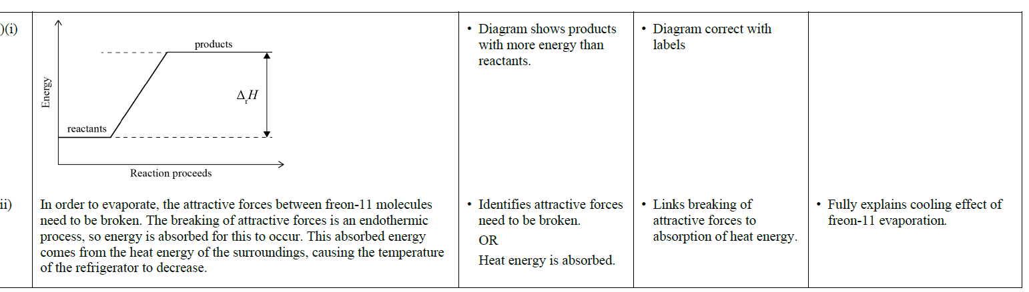
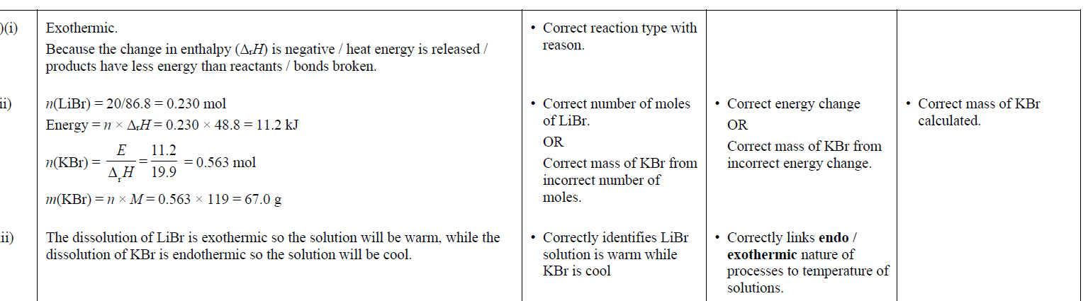
2021
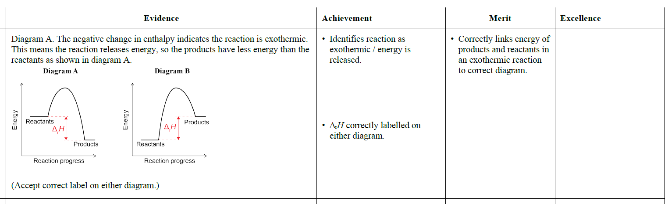
2020

2019 | Evidence | Achievement | Merit | Excellence
(a) | The melting of ice is endothermic, as (intermolecular) bonds are being broken as water changes from solid to liquid. This requires energy to be absorbed from the surroundings/the drink. This causes the temperature of the drink to decrease. | • Identifies the melting of ice is endothermic / absorbs or requires energy / breaks bonds. | • Links bond breaking to energy being absorbed from the surroundings / drink / environment. | • Full explanation that links  to the cooling of the drink.

2018 | Evidence | Achievement | Merit | Excellence
(a)  (b) | Exothermic because energy is released.  The evaporation of water is endothermic because energy is absorbed to break the attractive forces between water molecules.  This is an exothermic reaction; the total energy of the products is less than the total energy of the reactants. Therefore, as the change in enthalpy is the difference in energy between products  and reactants, the change is negative and the difference in energy is released as heat to the surroundings. | • Identifies endothermic.  • Recognises energy of products is less than reactants  OR  that the reaction is exothermic. | • Links absorption of energy (or heat) to breaking the attractive forces (or bonds) and in turn to endothermic.  • Identifies Energy (or enthalpy) is less for products than reactants and in turn  links the difference in energy or energy/heat lost to negative enthalpy.

2017 | Evidence | Achievement | Merit | Excellence
(a)  (b) | EXOthermic  The temperature increased / energy or heat has been released into the surroundings /energy is lost from the substance (CaCl₂)  The water in sweat is changing state from liquid to gas. It needs to absorb energy to break the forces / bonds between liquid water molecules. It absorbs this from the heat of the body. The temperature of the body increases when exercising, so more water can be evaporated. | Correct term with reason.  Identifies absorption of energy (or used)  OR  bonds breaking. | Identifies the state change as bond breaking and  EITHER  link this to (heat) energy used / endothermic  OR  links to increased / faster evaporation due to increased heat from exercise. | Full explanation including linking: state change to bond  breaking with energy used / endothermic, and in turn to  increased / faster evaporation due to increased heat from  exercise

2016 | Evidence | Achievement | Merit | Excellence
(a)  (b)  (c) | Endothermic  The temperature decreased OR heat / energy has been absorbed.  Exothermic.  The enthalpy of the reaction is negative / energy has been released.  Energy is required to change pentane from a liquid to a gas. The energy / heat is used to break weak intermolecular forces / bonds / attraction between pentane molecules. | Correct term with relevant reason in (a) OR (b).  - Identifies energy / heat is required / absorbed / taken in. | - Explains that energy / heat is required / absorbed for breaking (intermolecular) forces / bonds / attractions. | - Explains that energy / heat is required / absorbed for breaking (intermolecular) forces / bonds / attractions.

2015 | Evidence | Achievement | Merit | Excellence
(a)  (b) (i) | Exothermic because the temperature of the solution increases / heat is released / particles slow down / bonds are formed  Endothermic because the Δ_{r}Hº value is positive / it uses the sun’s energy | One of (a) or (b)(i) is correctly identified with reason.

2014 | Evidence | Achievement | Merit | Excellence
(a) (i)  (ii) | Exothermic, as the temperature increases, which shows energy is being released.  Exothermic, weak intermolecular attractions form between the water molecules, this releases energy. | - Exothermic because energy is being released.  - Exothermic because bonds are being formed, releasing energy.

2013 | Evidence | Achievement | Merit | Excellence
(a)  (b)  (c) | Endothermic  Gets colder  The process is endothermic since the enthalpy change (∆_{r}H°) is positive, which indicates that energy is absorbed by the system as the ammonium nitrate dissolves. Since heat energy is absorbed by the system from the surroundings (water & beaker), the water or beaker will get cooler as they lose heat energy.  Exothermic  The reaction is exothermic because the enthalpy change (∆_{r}H°) is negative; indicating that heat energy is produced during the reaction.  Endothermic.  Heat energy is needed to change the butane from a liquid to a gas; the energy is used to break the weak intermolecular forces between the butane molecules. | - In (a) the reaction is endothermic because the value is positive  OR because the ammonium nitrate is absorbing energy from the surroundings  - OR products have more energy than reactants  - In (a) beaker gets colder as heat energy is absorbed by ammonium nitrate.  - In (b)exothermic since value is negative or because glucose reacting is releasing energy  OR products have less energy than reactants.  - In (c) the process is endothermic since energy isneeded to boil butane. | - Explains that since reaction is endothermic heat energy is absorbed by the system from the surroundings (water / beaker) so the beaker feels colder.  - In (c)(i) explains the use of heat energy to break the weak intermolecular forces between butane molecules.

© https://www.chemical-minds.com
NCEA questions and answers reproduced with permission from NZQA

