ANSWERS: Explaining polarity of molecules

Key points to consider for an Excellence grade are...
Does the molecule…
1) contain polar bond(s)? you must refer to a difference in electronegativity between the relevant atoms.
2) have lone pair(s) around the central atom?
3) have a symmetrical shape?
4) whether the bond dipoles cancel.

2023
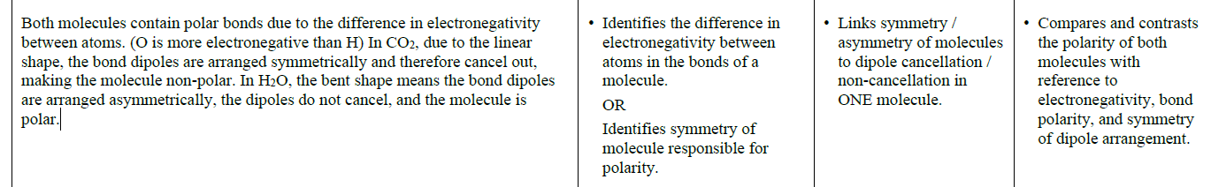

2022
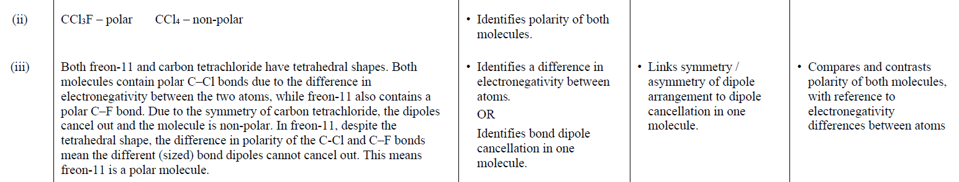

2021
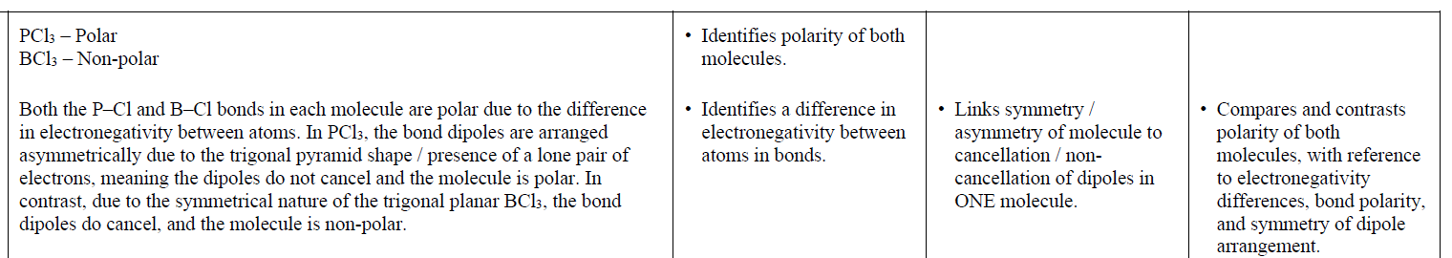
2020
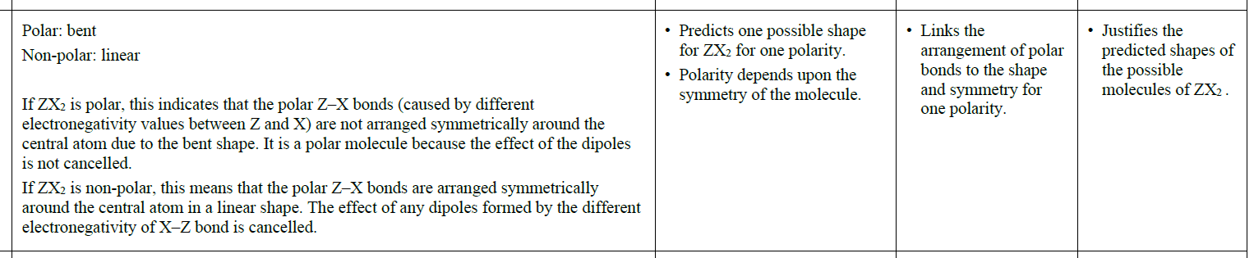

2019 | Evidence | Achievement |  | Merit |  | Excellence
(i)  (ii) | CHCl₃ is polar.  NH₃ is polar.  In CHCl₃, there are two types of bond, C–H and C–Cl, each polar, due to the difference in electronegativity between C and H and C and Cl atoms. These dipoles have different polarities / sizes as H and Cl have different electronegativities. (Despite the tetrahedral arrangement appearing symmetrical) the different (sized) bond dipoles do not cancel each other out, so CHCl₃ is polar.  In NH₃, the three N–H bonds are polar, i.e. have a dipole, due to the difference in electronegativity between N and H atoms. These (equally sized) dipoles are arranged in a non-symmetrical trigonal pyramidal shape, resulting in the bond dipoles not  cancelling each other out, so NH₃ is polar. | • Identifies polarity of both molecules.  • Identifies bonded atoms have different  electronegativity (values). |  | • Links bond polarity to  electronegativity differences  between bonded atoms for all  bonds in one molecule.  OR  Uses lack of symmetry for NH₃  OR  differing bond dipoles for  CHCl₃ to link molecule polarity  to dipoles not cancelling in one  molecule. |  | • Justifies polarity of  both molecules by referring to  differences in electronegativity,  dipoles, and non-symmetrical  arrangement of NH₃ dipoles.
2018 | Evidence |  | Achievement |  | Merit | Excellence
 | In HCN, the two bonds are polar due the difference in electronegativity between H and C, and C and N. The resulting bond dipoles are differing in size as H and N have different electronegativities, so despite the symmetric linear arrangement the bond dipoles do not cancel and HCN is overall polar.  The C=O bond is also polar due to O being more electronegative than C giving these bonds dipoles. But because both bonds are identical and are arranged symmetrically in a linear shape, the bond dipoles cancel and the molecule is non-polar overall. |  | • Identifies that the atoms within a bond have different electronegativities.  OR  Linear is recognised as symmetric. |  | • Links bond polarity to  electronegativity differences  between atoms for ONE  molecule OR uses symmetry  to link polarity to bond  dipoles cancelling / not  cancelling for ONE molecule. | • Justifies polarity of BOTH molecules by referring to differences in electronegativity,  dipoles and symmetry of molecules.

2017 | Evidence | Achievement | Merit | Excellence
(i)  (ii) | Dichloromethane is polar. Tetrachloromethane is non-polar.  In CCl₄, the four C–Cl bonds are polar, i.e. have a dipole, due to the difference in electronegativity between C and Cl. These (equally sized) dipoles are arranged in a symmetric tetrahedral shape, resulting in the dipoles / bond polarities cancelling each other out, so CCl₄ is non-polar.  In CH₂Cl₂, there are two types of bond, C–H and C–Cl, each polar with dipoles due to the difference in electronegativity between C and H and C and Cl. These dipoles have different polarities / sizes as H and Cl have different electronegativities. (Despite the symmetric tetrahedral arrangement) the different (sized) dipoles / bond polarities do not cancel each other out, so CH₂Cl₂ is polar. | Identifies polarity of both molecules.  Identifies that the atoms within the  bonds have different electronegativities.  (For one type of bond) | Links bond polarity / or bond dipoles / atoms δ- and δ+ to  electronegativity differences between bonded atoms for one  molecule.  OR  Uses symmetry / differing  dipoles to link molecule polarity to dipoles cancelling / not cancelling for one molecule. | Justifies polarity of dichloromethane and non-polarity of tetrachloromethane by referring to differences in electronegativity,  dipoles, and symmetry of molecules.

2016 | Evidence | Achievement | Merit | Excellence
 | Each N-H bond in NH₃ is polar / forms a dipole because the N and H atoms have different electronegativities. The shape of the molecule (due to the presence of one non-bonding electron pair) is trigonal pyramidal which is asymmetrical, so the dipoles / bond polarities do not cancel. The resulting NH₃ molecule is polar.  Each B-H bond in BH₃ is polar / forms a dipole because the B and H atoms have different electronegativities. The shape of the molecule is trigonal planar which is symmetrical, so the dipoles / bond polarities cancel. The resulting BH₃ molecule is non-polar. | Identifies that the atoms within the bonds have different electronegativities. | Links bond polarity to  electronegativity differences  between atoms for one molecule  OR  Uses symmetry to link molecule polarity to bond dipoles cancelling / not cancelling for 1 molecule | Justifies polarity of ammonia and borane referring to differences in electronegativity, dipoles, and symmetry (shape) of molecules.

2015 | Evidence | Achievement | Merit | Excellence
 | Both molecules are non-polar.  The Be-Cl bond is polar because Cl is more electronegative than Be / the atoms have different electronegativities.  Since both the bonds are the same and arranged symmetrically around the central atom, in a linear arrangement, the bond dipoles cancel out, resulting in a non-polar molecule.  The B-F bond is polar because F is more electronegative than B / the atoms have different electronegativities. Since all three bonds are the same and arranged symmetrically around the central atom, in a trigonal planar arrangement, the bond dipoles cancel out, resulting in another non-polar molecule. | - Identifies electronegativity difference between atoms.  OR  Identifies the polarity of either the Be-Cl or B-F bond correctly.  OR  States that polarity of the molecule depends on the symmetry of the molecule. | - Non polar circled PLUS  Links the polarity of either Be-Cl or B-F bonds to the differences in electronegativity of the atoms involved.  OR  Links the even spread of polar bonds / bond dipoles around the central atom to their cancelling out and therefore to the overall non-polarity of the molecule. | - Justifies choice of polarity in terms of polarity of bonds, due to differences in electro negativities of the atoms, and the cancelling out of bond dipoles / polar bonds due to the symmetry and shape of each molecule.

2014 | Evidence | Achievement | Merit | Excellence
 | SO₂ molecule is polar.  CO₂ molecule is non-polar.  The S–O / S=O bond is polar due to the difference in electronegativity between S and O atoms. The bonds are arranged asymmetrically in a bent shape around the central S atom; therefore the (bond) dipoles do not cancel and the molecule is polar.  The C=O bond is polar due to the difference in electronegativity between C and O atoms. The bonds are arranged symmetrically in a linear shape around the central C atom; therefore the (bond) dipoles cancel and the molecule is non-polar. | - One bond correctly identified as being polar.  OR  Atoms have different electronegativities | - Explains polar bonds is due to the difference in electronegativity between  S and O (atoms) or  C and O (atoms).  OR  Bond dipoles cancelling or not cancelling linked to the overall molecule polarity of either SO₂ or CO₂ molecule. | The polarity of both molecules is justified with reference to the polarity of the bonds, the shape and the polarity of the molecule.
© https://www.chemical-minds.com
NCEA questions and answers reproduced with permission from NZQA

