ANSWERS: Ionisation Energy

2020
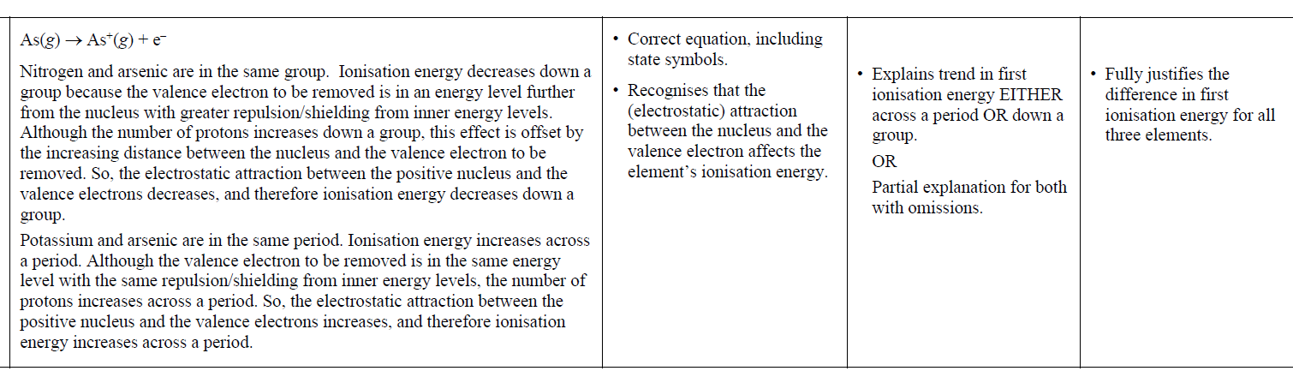

2018 | Evidence | Achievement | Achievement with Merit | Achievement with Excellence
 | The first ionisation energy increases across the second period. There is an increase in the number of protons therefore the nuclear charge / attractive force of the nucleus increases. As the electrons are added to the same energy level across the second period, the electrostatic attraction for the valence electrons increases. This means more energy is required to remove an electron from the valence shell.  The atomic radius decreases across the second period. There is an increase in the number of protons therefore the nuclear charge / attractive force of the nucleus increases. Electrons are added to the same energy level as well. This causes the electrostatic attraction between the positive nucleus and the valence electrons to increase across the period pulling the valence electrons closer to the nucleus, so the atomic radius decreases.  As the ionisation energy increases, the atomic radius decreases, this is due to the same factor of increased nuclear charge due to more protons in the nucleus going across the period whilst electrons are adding to the same energy level. This decreased radius means more energy is required to remove the valence electron due to stronger attractive forces. | • Identifies both trends  correctly.  • Recognises one factor  influencing trends. | • Explains trend in first  ionisation energy across a period.  • OR  Explains trend in atomic  radius across a period. | • Full explanation of trends in first ionisation energy and atomic radius across a period,  including relating the two trends to each other.

2017 | Evidence | Achievement | Achievement with Merit | Achievement with Excellence
(i)  (ii) | Ca(g) → Ca+(g) + e–  The first ionisation energy is the energy required to remove one mole of the most loosely held electrons from one mole of gaseous atoms.  The trend is that the ionisation energy decreases going down the group two elements.  Although the nuclear charge increases due to more protons in the atoms going down a group, it is offset by the increasing distance of the outer electrons from the nucleus as the atomic radius increases due to more energy levels being added.  The full inner energy levels shield the outer electrons from the protons in the nucleus so the electrostatic attraction is less. Additional energy levels result in greater shielding/repulsion between energy levels. The further the outer electron is from the nucleus, the less energy needed to remove it.  The trend is important, not the ‘kink’ at Ca, which requires no explanation. | Correct equation.  ONE correct statement. | Links increasing atomic radius / distance between nucleus and outer electron / shielding effect to trend. | Explanation acknowledges nuclear charge but fully links the trend to the effect of increasing distance from the nucleus.

2016 | Evidence | Achievement | Achievement with Merit | Achievement with Excellence
 | Electronegativity decreases down a group. Electronegativity is a measure of how strongly an atom attracts bonding electrons. Although the nucleus will become increasingly positive down a group (number of protons increases), the atomic radius increases down a group as more energy levels are added and shielding / repulsion from inner shells increases. Therefore, the bonding electrons in the valence shell will be further from the positive nucleus, resulting in a weaker electrostatic attraction between the nucleus and the bonding electrons.  First ionisation energy is a measure of how easily the first mole of electrons is removed from one mole of gaseous atoms. It becomes easier to remove an electron down a group / first IE decreases down a group as the valence electrons are further from nucleus with greater repulsion / shielding from inner shells, so there is less electrostatic attraction between protons in the nucleus and valence electron to be removed.  For both EN and first IE, the attraction between the positive nucleus and bonding / valence electrons in the outer shell is decreasing down a group, so both EN and first IE decrease down a group. | - Trend in electronegativity and first ionisation energy correctly identified.  OR  Correct definitions for electronegativity and first ionisation energy.  OR  Both the definition AND the trend are correct for either electronegativity or first ionisation energy. | - Links trend in electronegativity  AND ionisation energy to  EITHER  the size of atom / shielding  OR  to the electrostatic attraction between the nucleus and bonding electrons. | Full explanation, including the relationship between electronegativity and first ionisation energy.

2015 | Evidence | Achievement | Achievement with Merit | Achievement with Excellence
(a)  (b) | First ionisation energy is the minimum energy required to remove one mole of electrons from one mole of gaseous atoms.  First ionisation energy increases from 502 in Na to1527 in Ar. There is an increase in the number of protons and thus the nuclear charge / attractive force of the nucleus. As the electrons are added to the same energy level, there is no increase in repulsion between energy levels. The nuclei with a greater number of protons have a stronger electrostatic attraction for the valence electrons in the third shell, thus the first ionisation energy increases across a period. | Correct

2014 | Evidence | Achievement | Achievement with Merit | Achievement with Excellence
 | lowest B N Ne He highest | correct order

2013 | Evidence | Achievement | Achievement with Merit | Achievement with Excellence
Cl has more protons than Li. Therefore there is a greater attraction between the nucleus and outer electrons/electrons held more tightly so it is harder to remove an electron from Cl than Li.

Even though the valence electrons of Cl are in the 3rd energy level/has an extra energy level the extra shielding is not as significant as the effect of the increased nuclear charge, so Cl has a higher first ionisation energy than Li

2013 Sample | Evidence | Achievement | Achievement with Merit | Achievement with Excellence
Cl and Na have the same number of energy levels. However, Cl has a greater number of protons causing a stronger attraction to electrons than Na.
Hence Cl has a greater first ionisation energy.

2011 | Evidence | Achievement | Achievement with Merit | Achievement with Excellence
 | Li(g) → Li⁺(g) + e– | correct (states needed)
 | As you move across a period from Li to Ne, the ionisation energies increase. Electrons are added to the same valence shell / the same distance from the nucleus. Extra protons in the nucleus increase the nuclear charge, so the electrons in the valence shell are held more tightly and ionisation energy is greater.  As you go down a group, ionisation energy decreases. This is due to a new energy level being added, which is further from the nucleus. Electrons can be removed more easily and the ionisation energy is less/shielding increase explained  The drop Be and B is due to B having 1 electron in the p subshell (2p¹) and Be being 2s². Although B has a greater nuclear charge, the electron in the p-subshell is further from the nucleus/has less stability. Thus the p-electron in B’s valence shell is not held so tightly/is more easily removed.  Drop N – O N has 1/2 full subshell (2p³) and O 1 more electron giving it a partly full subshell (2p⁴). added electron going into suborbital already occupied by an electron – increased electron electron repulsion so makes electron more easily removed / partly full subshell less stable so electron more easily removed | OR  Recognises that ionisation energy increases across a period AND decreases down a group.  (Mentioned or implied.)  OR  Links increasing OR decreasing ionisation energy  to increase in protons / energy levels / shielding (explained) down group. | AND  Increase across period OR decrease down group fully explained  OR  Increase AND decrease partly explained  OR  Correctly links dip between Be and B or N and O to s and p sub-energy (sub-shell) level. | Links increase and decrease of ionisation energies to correct explanation.  AND  Acceptable explanation of dip between Be and B. (must refer to electron arrangements of both)  OR  Acceptable explanation of the dip between N and O. (Must refer to electron arrangements of both.)  *if electron arrangement penalised in (a) not penalised again in (c)

2009 | Evidence | Achievement | Achievement with Merit | Achievement with Excellence
Valence electrons are added to same shell / distance from nucleus similar.
In Br, there is a greater number of protons / nuclear attraction greater (ENC), so valence electron more strongly held (implying IE).

2008 | Evidence | Achievement | Achievement with Merit | Achievement with Excellence
• Br electrons closer to the nucleus / smaller radius / bromine is smaller
OR
• Br has greater nuclear charge / number of protons
• But same number of shells / energy levels
OR
• Br has greater ENC than Sc,
AND
• causing stronger attraction to the electrons
OR
Same answer as above.

© http://www.chemical-minds.com
NCEA questions and answers reproduced with permission from NZQA

