**Isomers**

**2022**

1. Circle the form of isomerism that exists between **Compounds B** and **C**.

**constitutional (structural) isomerism geometric isomerism**

Explain your choice

2.

**Compounds A** and **D** both contain a carbon-carbon double bond, yet only one is capable of forming geometric (*cis* / *trans*) isomers.

(i) Identify which compound can form geometric isomers.

(ii) Draw the two isomers it forms

**(iii)** Explain why only one of these compounds can form geometric isomers.

In your answer you should:

• describe the requirements for geometric isomerism

• explain the importance of the C=C double bond

• refer to the structures of each compound.

**2021**

A variety of alkanes and alkenes are shown in the table below. Refer to these compounds in order to answer parts (a) and (b)

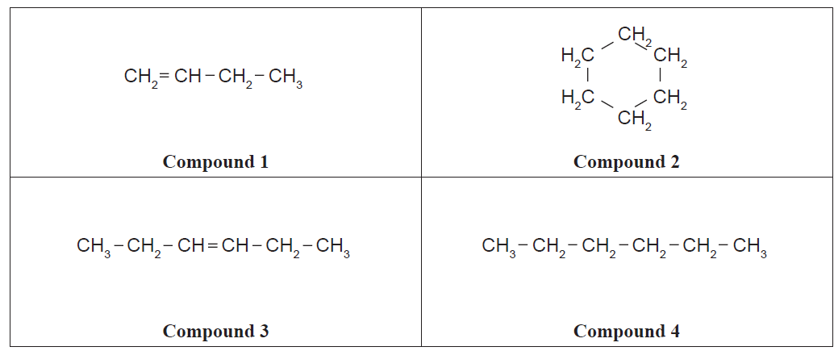

(a) TWO compounds in the table above are constitutional (structural) isomers of one another.

(i) Name these two compounds.

(ii) Justify your choices.

(b) **Compound 3** from the table can form geometric (*cis* / *trans*) isomers.

(i) Draw the geometric isomers of this compound.

(ii) Elaborate on the features of **Compound 3** that allow it to form geometric isomers.

2. (i) Complete the table by classifying each as primary, secondary, or tertiary alcohols / haloalkanes.

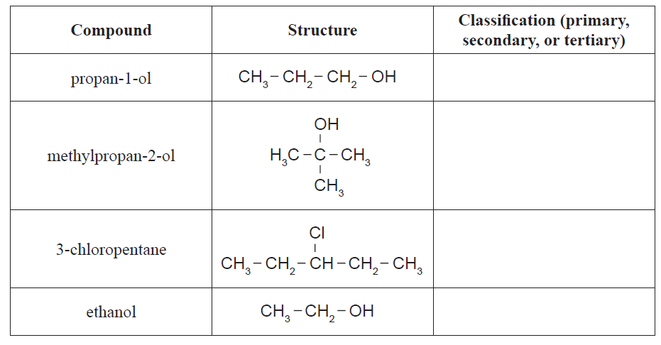

(ii) Explain the difference in classification of propan-1-ol compared with methylpropan-2-ol.

**2020**

The C4H8 (butene) molecule can display different forms of isomerism.

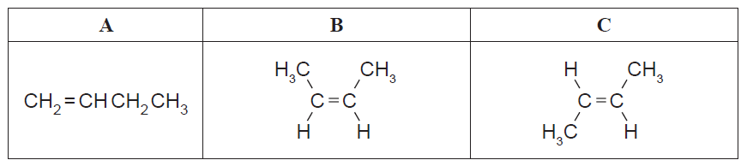

(i) Circle the form of isomerism that exists between molecules **A** and **B**.

**constitutional / structural geometric**

(ii) Circle the form of isomerism that exists between molecules **B** and **C**.

**constitutional / structural geometric**

(iii) Compare and contrast the two forms of isomerism. In your answer, you should:

• explain the requirements for each form of isomerism

• refer to molecules **A**, **B**, and **C** above.

**2019**

(a) Draw four structural (constitutional) isomers of C4H10O that are alcohols.

Classify the alcohols as either primary, secondary or tertiary.

(b)



(i) Draw and name the two geometric (*cis*-*trans*) isomers of compound **A**.

(ii) Explain why compound **A** exists as geometric (*cis*-*trans*) isomers while compound **B** does not.

**2018**

**1.** Justify whether or not the **monomer** used to produce Perspex® is a geometric (cis-trans) isomer by explaining the features required for this type of isomerism.

|  |
| --- |
|  |
| monomer |

**2.** Draw structural formulae for primary, secondary, and tertiary chloroalkane molecules that are

constitutional (structural) isomers with the molecular formula C4H9Cl.

**2017**

(i) Draw four alkene isomers for the organic compound C4H8

(ii)Identify the compounds from (i) that are *cis* and *trans* (geometric) isomers.

Justify your choices and explain why only these two compounds are *cis* and *trans* (geometric) isomers.

**2016**

(a) Draw and name the THREE constitutional (structural) isomers of the organic compound C5H12.

(b) (i) Classify the following haloalkanes as primary, secondary or tertiary.

(ii) Explain your choice for haloalkane **A**.

(c)Some alkenes are able to form *cis* and *trans* (geometric) isomers.

(i) Complete the names of structures **A** and **B** in the table below.



(ii) Elaborate on the structure of the organic compound 1,2-dibromoethene to explain why it is able to form *cis* and *trans* (geometric) isomers.

<https://www.chemical-minds.com>

NCEA questions and answers reproduced with permission from NZQA