**IUPAC naming**

**i) Write the IUPAC ii) name the homologous series and iii) circle the functional group of each substance**

|  |  |  |
| --- | --- | --- |
|  |  |  |
|  |  |  |
|  |  |  |
|  |  |  |
|  |  |  |
|  |  |  |
|  |  |  |
|  |  |  |
| Chemistry 2 |  |  |
| Chemistry 2 |  |  |
| **Chemistry 2** |  |  |
|  | **Q1, Comp A, 90309** |  |
|  |  | Q1, Comp B 90309 |
|  |  | Q1, Comp C, 90309 |
| 90309q4aa | 90309q1(i) | 90309q1-1 |
| 90309q4ab | **90698q1a** | 90309q1-2 |
| **90309q4ad** |  | 90309q4ae |

**Additional questions...**

**1.** The organic compound, 4-chloro-3-methylpent-4-ene has been named incorrectly. Draw the implied structure and explain why it is named incorrectly.

**2.** The compound **2-chloro-4-ethylpentane** has been named **incorrectly**.

(a) Draw the structure implied by the name

(b) Explain why the given name is incorrect

(c) Write the correct IUPAC name

**3.** Vitamin A has the structure shown. Circle and name TWO **different** functional groups in the Vitamin A molecule above.

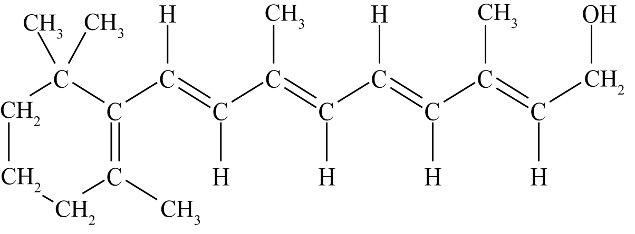

<https://www.chemical-minds.com>

NCEA questions and answers reproduced with permission from NZQA