**ANSWERS: IUPAC naming**

|  |  |  |
| --- | --- | --- |
|  |  | propan-2-amine / 2-aminopropane  *amine* |
| 2,3-dimethylbutane  *alkane* | Ethanamine/aminoethane  *amine* | 3-ethylpentane *alkane* |
| pentan-2-ol  *alcohol* | 5-chloropent-1-ene  *alkene* | 2-methylhex-2-ene  *alkene* |
| pent-1-ene  *alkene* | 3-methylbutan-2-ol  *alcohol* | 2-iodohexane  *haloalkane* |
| 1-aminopropane  *amine* | 3-methylhexan-2-ol  *alcohol* | 2-bromopropane  *haloalkane* |
| 1-aminopentane  *amine* | 3-methylhexanoic acid  *carboxylic acid* | 2,4-dichlorohex-3-ene  *alkene* |
| propylamine or 1-aminopropane  or 1-propanamine  *amine* | 2-chloropropan-1-ol  *alcohol* | 3-methylhexane  *alkane* |
| 2,2-dichloropropane  *chloroalkane/haloalkane* | 5-bromo-2-methylpentanoic acid  *carboxylic acid* | Methanamine or aminomethane  *amine* |
| Chemistry 2  2-choropentane  *chloroalkane/haloalkane* | propyne  ***alkyne*** | pentanoic acid  *carboxylic acid* |
| Chemistry 2  propanoic acid  *carboxylic acid* | 2-methylbutane  ***alkane*** | 1-aminobutane  ***amine*** |
| **Chemistry 2**  3, 4- dimethylpent-2-ene  *alkene* | **1-bromobutane**  ***bromoalkane/haloalkane*** | Pent-2-yne (2-pentyne)  ***alkyne*** |
| 1,2-dichlorobutane  *chloroalkane/haloalkane* | **Q1, Comp A, 90309**  1,2–dibromobutane  *bromoalkane/haloalkane* | 3-methylbutan-1-ol  *alcohol* |
| 2-methylbutan-1-ol  *alcohol* | fluoroethanoic acid (2-fluoroethanoic acid)  *carboxylic acid* | Q1, Comp B 90309  pent–2–yne  *alkyne* |
| 2,2 dimethyl propan-1-ol  or dimethyl propanol  or dimethylpropan-1-ol  *alcohol* | 3,3-dimethylbutanoic acid  *carboxylic acid* | Q1, Comp C, 90309  propanoic acid  *carboxylic acid* |
| 90309q4aa  methylbutane or 2-methylbutane  *alkane* | 90309q1(i)  **1-chloropropane**  ***chloroalkane/haloalkane*** | 90309q1-1  butan−2−ol / 2-butanol  ***alcohol*** |
| 90309q4ab  3–chlorobutan-2-ol  *alcohol* | **90698q1a**  1-amino-3-methylbutane  ***amine*** | 90309q1-2  3-chlorobutanoic acid  ***carboxylic acid*** |
| **90309q4ad**  2–bromopropene  *alkene* | 2-aminobutanoic acid  *amine* | 90309q4ae  pentanoic acid  *carboxylic acid* |

**1.** 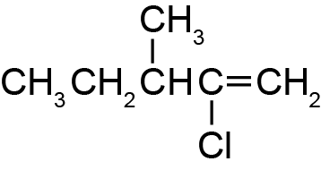

Numbering of the chain starts from the end that carries the main functional group, the double bond. Once counted from this end, the number of the double bond and chlorine change.

2-chloro-3-methylpent-1-ene.

**2.**

|  |  |
| --- | --- |
| **90309q2aass**  2-chloro-4-ethylpentane | The longest chain contains 6 C atoms not 5.  The correct name is 2-chloro-4-methylhexane |

**3.**

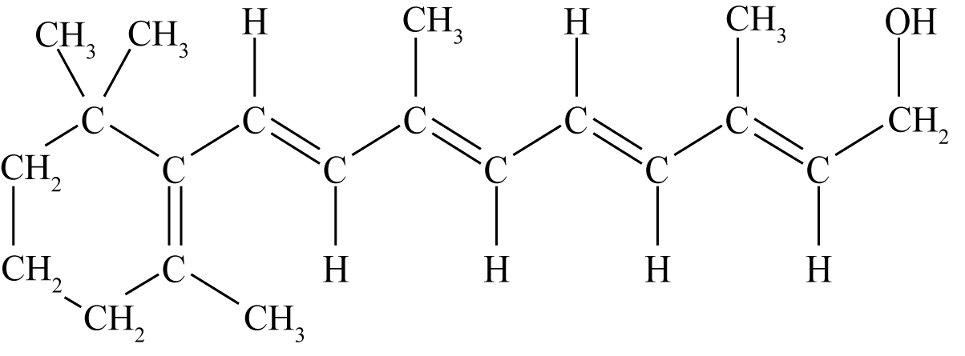

alcohol (or hydroxy)

alkene (or any other double bond circled)

<https://www.chemical-minds.com>

NCEA questions and answers reproduced with permission from NZQA