ANSWERS: Justifying the properties of substances
2022
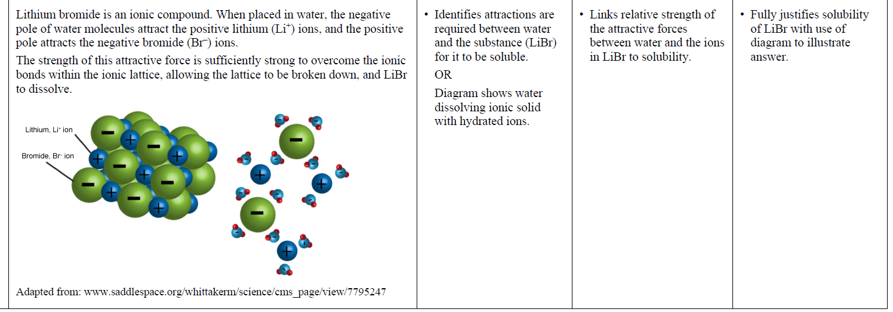
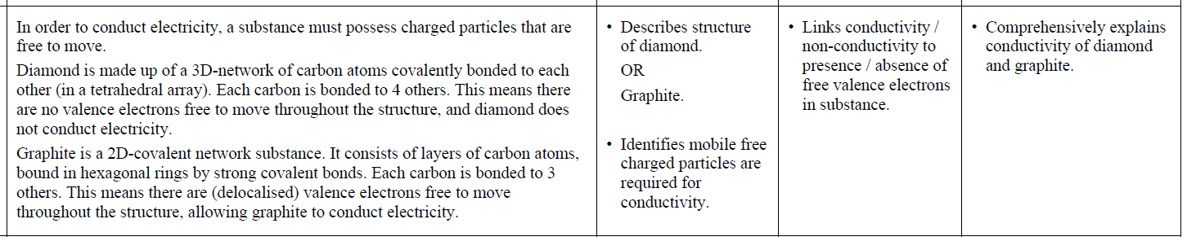

2021
(a)
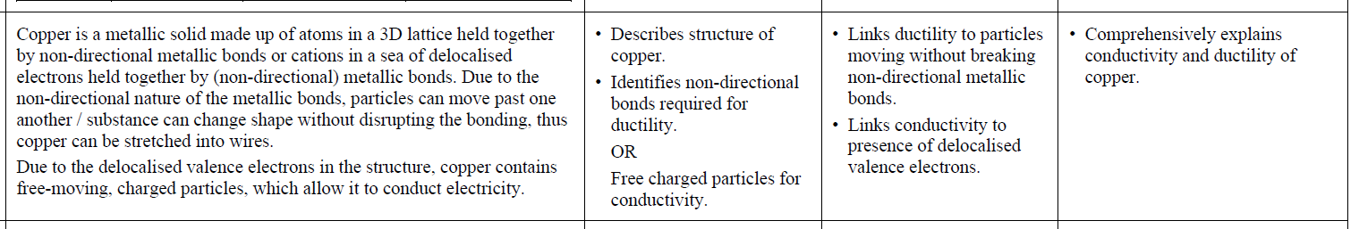
(b)
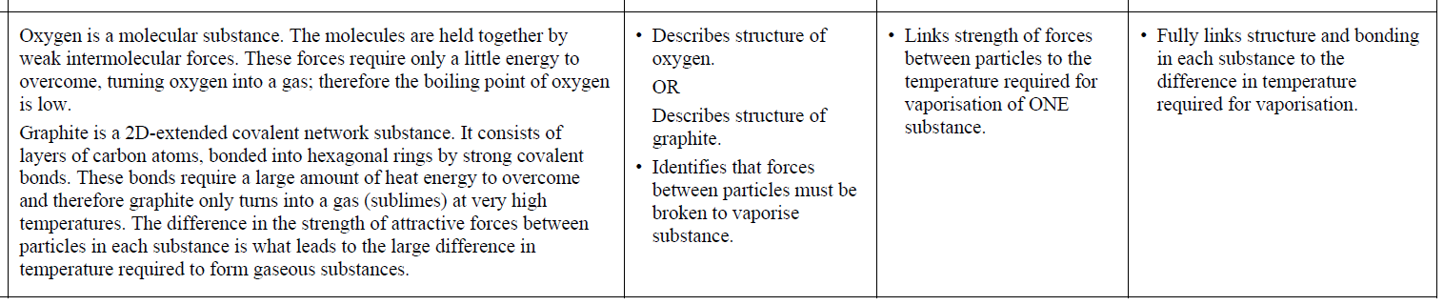

2020
(a)
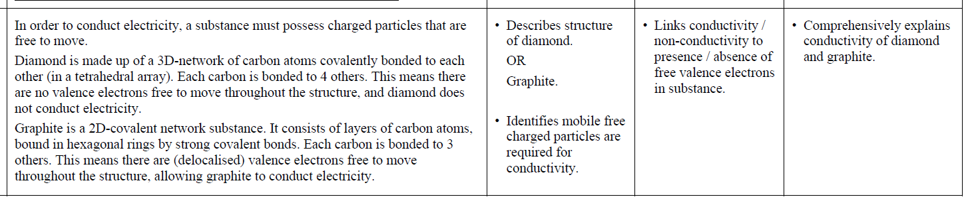
(b)
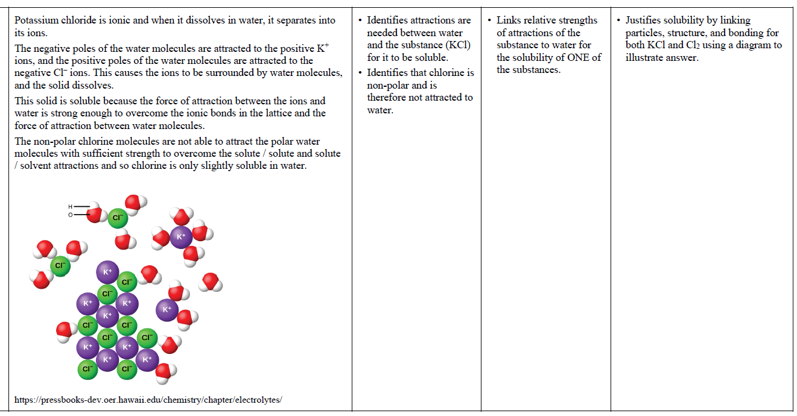

2019 | Evidence | Achievement | Merit | Excellence
(a)  (b) | Sodium is a metallic solid made up of atoms in 3D lattice held together by nondirectional metallic bonds (or cations non-directionally electrostatically attracted to a surrounding sea of electrons). When a force (or pressure) is applied, the atoms / layers can move without breaking / disrupting these non-directional bonds; thus the structure can change shape.  NaI is made up of alternating positive ions / Na+ ions, and negative ions / I– ions, ionically bonded in a 3D lattice. NaI is not malleable because if pressure is applied to an ionic lattice, it forces ions with the same charge next to each other; they repel each other and break the structure.  Iodine is a non-polar (covalent) molecular substance made up of I2 molecules held together by weak intermolecular forces.  Iodine is soluble in cyclohexane, but does not easily dissolve in water.  For iodine in water, the iodine-water attractions are not strong enough to overcome both the iodine-iodine / solute-solute and the strong water-water / solvent-solvent attractions.  For iodine in cyclohexane, the iodine-cyclohexane attractions are strong enough to overcome iodine-iodine / solute-solute and cyclohexane-cyclohexane / solvent-solvent attractions because all attractive forces are similar (nonpolar). | • Describes structure of sodium.  OR  Recognises metallic bonding as non-directional.  • Describes structure of sodium iodide.  OR  Describes ionic bonding is  directional.  • Recognises I2 as a non-polar  molecule.  • Identifies iodine as (more)  soluble in cyclohexane and  insoluble/less soluble in water. | • Describes malleability and  Links this to nondirectional  metallic bonding of sodium.  • Describes brittleness of sodium iodide and links it to directional  ionic bonding /repulsion of like  charged ions.  • Links attractions (or lack of) of water OR cyclohexane for nonpolar iodine to solubility. | • Comprehensively explains  malleability of sodium and brittleness of sodium iodide.  • Comprehensively explains  iodine’s solubility in cyclohexane and insolubility (low solubility) in water linking polarity, strength  of attraction and overcoming / not  overcoming existing bonding within the solvent or solid.

2018 | Evidence | Achievement | Merit | Excellence
(a)  (b)  (c) | A – Ionic  B – Molecular  C – Covalent Network  D – Metallic  Electrical conductivity requires a substance to have mobile charged particles. Solid A is an ionic solid made up of a 3-D lattice of positive and negative ions (cations and anions) that are attracted to each other. In the solid state, these ions are rigidly held in a lattice by strong ionic bonds, so cannot move around. When molten, the ions are able to move freely so it can conduct electricity. In aqueous solution, the ions are also free to move so the solution can also conduct electricity.  Solid B is composed of discrete covalent molecules which are held together by weak intermolecular forces. These weak intermolecular forces are easily broken, so the molecules can be separated with little energy, therefore the melting point is low.  Solid D is a metal made of a 3-D lattice of metal atoms surrounded by a sea of delocalised valence electrons, which are strongly attracted to all the nuclei in the lattice. This forms a strong metallic bond which requires a large amount of energy to break, therefore the melting point is high at 660ºC. | • Types of solid all correct.  • Recognises need for mobile charged particles for conductivity.  • Recognises positive and negative ions (or cations and anions).  • Describes the weak  intermolecular forces for  molecules.  • Describes strong metallic  bonding. | • Conductivity correctly linked to movement of Compound A’s cations and anions.  • Melting point linked to strength of forces between particles for  BOTH solids.  OR  Melting point linked to the energy requirements to break forces and in turn the strength of the appropriate force for ONE solid. | • Conductivity explained  with reference to particles,  type of solid and the  freedom (or restriction) of  movement of cations and  anions for ionic  compounds in all 3 states.  • Melting point explained with reference to particles, type of solid, attractive forces and the energy  required to break these forces for BOTH solids.

2017 | Evidence | Achievement | Merit | Excellence
(a)  (b) | Sulfur has the lowest melting point.  Sulfur is a molecular substance with weak intermolecular forces between the molecules.  These forces do not require much energy to overcome, so they will break at lower temperatures, giving sulfur a lower melting point.  Al is a metal with strong metallic bonds. These attractions require a lot of energy to overcome, so the melting point is higher than sulfur’s melting point.  MgCl₂ is an ionic compound with strong ionic bonds between the cations and anions. These bonds also require a lot of energy to overcome, so the melting point is also higher  than sulfur’s melting point.  (Candidates are not expected to know whether Al or MgCl₂ has the higher melting point.)  Aluminium is malleable.  Aluminium is a metal made up of atoms / cations in a sea of electrons which are held together by non-directional metallic bonds in a (3D) lattice. The metallic bonds are non-directional  as the (bonding) electrons are delocalised across the lattice / shared by many atoms. When a force (or pressure) is applied the atoms / layers can move without breaking / disrupting these non-directional bonds thus the structure can change shape  without breaking the lattice. | Describes the attractive intermolecular forces as weak or requires a small amount of heat / energy to break for S₈.  • Describes the attractive intermolecular forces as strong or requires a large  amount of heat / energy to break for MgCl₂.  • Describes the attractive intermolecular forces as strong or requires a large  amount of heat / energy to break for Al.  Identifies aluminium and describes bonding as non-directional.  OR  Describes structure of aluminium (could be shown in a diagram) as a lattice. | Links the correct attractive forces / bonding strength to  energy / heat requirements for  TWO of the substances.  Links malleability of aluminium to nondirectional metallic  bonding.  OR  Links malleability of aluminium to layers /atoms able to move  past each other with pressure / force or without breaking bonds. | Justifies choice by linking the correct attractive forces / bonding strength for ALL three substances  to energy requirements and in turn to melting point.  Justifies choice with respect to structure and non-directional  bonding for aluminium.

2016 | Evidence | Achievement | Merit | Excellence
(a) | Electrical conductivity depends on the presence of charged particles that are free to move.  Graphite is a covalent network substance made up of carbon atoms covalently bonded to 3 other carbon atoms. This leaves one valence non-bonded / delocalised electron from each carbon atom. These electrons are free to move and so graphite is able to conduct electricity.  ZnCl₂ is an ionic compound that cannot conduct electricity when solid because the ions (charged particles) are fixed in place in a 3D lattice structure and unable to move. When molten, the ionic bonds between the ions break, so the ions are free to move in the molten liquid. With charged particles / ions free to move, ZnCl₂ can then conduct electricity.  Polar water molecules attract the ions in zinc chloride’s 3-D lattice strongly enough to separate and dissolve them. The negative charges on the oxygen ends of the water molecules are attracted to the positive Zn²⁺ ions, and the positive hydrogen ends of the water molecules are attracted to the negative Cl– ions, forming hydrated ions that can spread out through the solution.  The polar water molecules are unable to interact with the non-polar carbon dioxide molecules strongly enough to break the intermolecular forces between the carbon dioxide molecules. | - Identifies that charged particles which are free to move are required for electrical conductivity.  - Identifies ZnCl₂(s) as not having ions / charges particles that are free to move  OR  identifies ZnCl₂(l) does have ions / charged particles that are free to move  OR  Identifies C(s) does have electrons /  charged particles that are free to move.  Identifies attractions are needed between water and the substance for it to be soluble. | - Explains conductivity by linking particles, structures, and bonding to either the conductivity of C (graphite)  OR  ZnCl₂ in both solid and liquid (molten) states.  Links relative strengths of attractions of the substance to water for the solubility of ONE of the substances. | - Justifies conductivity by relating particles, structures, and bonding to the conductivity of C (graphite)  AND  ZnCl₂ in both solid and liquid (molten) states.  Justifies solubility by linking particles, structure, and bonding for both ZnCl₂ and CO₂.

2015 | Evidence | Achievement | Merit | Excellence
(a) | Phosphorus trichloride, PCl₃, is a molecular solid, made up of non-metal phosphorus and chlorine atoms covalently bonded together. The molecules are held together by weak intermolecular forces. Since these forces are weak, not much energy is required to overcome them, resulting in low melting / boiling points. (In the case of PCl₃, its melting point is lower than, and its boiling point is higher than room temperature, so it is liquid.)  PCl₃ does not contain free moving ions nor any delocalised / free moving valence electrons, meaning PCl₃ does not contain any charged particles. Since free moving ions / electrons / charged particles are required to carry electrical current, PCl₃ is unable to conduct electricity. | Reason given for one property of PCl₃. | Links either state or conductivity to structure and bonding for PCl₃. | Explanation links both state and conductivity to structure and bonding for PCl₃.
(b) | Cu is insoluble in water and malleable.  Copper is a metal made up of an array of atoms / ions / nuclei held together by non-directional forces between the positive nuclei of the atoms and the delocalised / free moving valence electrons. There is no attraction between the copper atoms and the (polar) water molecules, therefore Cu is insoluble in water.  Since the attractive forces are non-directional, when pressure is applied, the Cu atoms can move past each other to change shape without the bonds breaking, so Cu is malleable. (Note – labelled diagrams can provide replacement evidence).  KCl is soluble in water and not malleable.  KCl is made up of positive / K⁺ ions, and negative / Cl– ions, ionically bonded in a 3D lattice. When added to water, polar water molecules form electrostatic attractions with the K⁺ and Cl– ions. The partial negative charge, δ–, on oxygen atoms in water are attracted to the K⁺ ions and the partial positive, δ⁺, charges on the H’s in water are attracted to the Cl– ions, causing KCl to dissolve in water.  KCl is not malleable because if pressure is applied to an ionic lattice, it forces ions with the same charge next to each other; they repel each other and break the structure. (Note – labelled diagrams can provide replacement evidence).  SiO₂ is insoluble in water and not malleable.  SiO₂ is a covalent network made up of atoms covalently bonded together in a 3D lattice structure. (Covalent bonds are strong), Polar water molecules are not strong / insufficiently attracted to the Si and O atoms, therefore SiO₂ is insoluble in water.  SiO₂ is not malleable because if pressure is applied, the directional / strong covalent bonds have to be broken before the atoms can move.  (Note - labelled diagrams can provide replacement evidence). | - Table completely correct.  - Reason given for malleability for any substance.  - Reason given for solubility for any substance. | - Links ONE property for ONE substance to its particles, structure, and bonding.  - Links ONE property for A SECOND substance to its particles, structure, and bonding. | - Justification links BOTH properties for ONE substance to its particles, structure, and bonding.  - Justification links BOTH properties for A SECOND substance to its particles, structure, and bonding.

2014 | Evidence | Achievement | Merit | Excellence
(a)  (b)  (c) | Graphene has strong covalent bonds. Because the covalent bonds are strong / there are a large number of covalent bonds, it requires a lot of energy to break these bonds, and therefore the melting point is high.  Each carbon atom is bonded to only three other carbon atoms. Therefore each carbon atom has free / delocalised /valence electron(s), to conduct electricity  Magnesium atoms are held together in a 3–D lattice by metallic bonding in which valence electrons are attracted to the nuclei of neighbouring atoms.  Iodine molecules are held together by weak intermolecular forces.  Ductility  The attraction of the Mg atoms for the valence electrons is not in any particular direction; therefore Mg atoms can move past one another without disrupting the metallic bonding, therefore Mg is ductile.  The attractions between iodine molecules are directional. If pressure is applied the repulsion between like-charged ions will break the solid, therefore I₂ is not ductile.  Dissolving in cyclohexane  Magnesium does not dissolve in cyclohexane because cyclohexane molecules are not attracted to the magnesium atoms in the metallic lattice.  Iodine is soluble, as iodine is a non-polar molecule. The iodine molecules and cyclohexane molecules form weak intermolecular attractions.  Electrical conductivity  Valence electrons of Mg atoms are free to move throughout the structure. This means that magnesium can conduct electricity.  Iodine does not conduct electricity as it does not contain delocalised electrons.  Solubility  When sodium chloride is dissolved in water the attractions between the polar water molecules and between the ions in the salt are replaced by attractions between the water molecules and the ions. The negative charges on the oxygen ends of the water molecules are attracted to the positive Na⁺ ions, and the positive hydrogen ends of the water molecules are attracted to the negative Cl– ions.  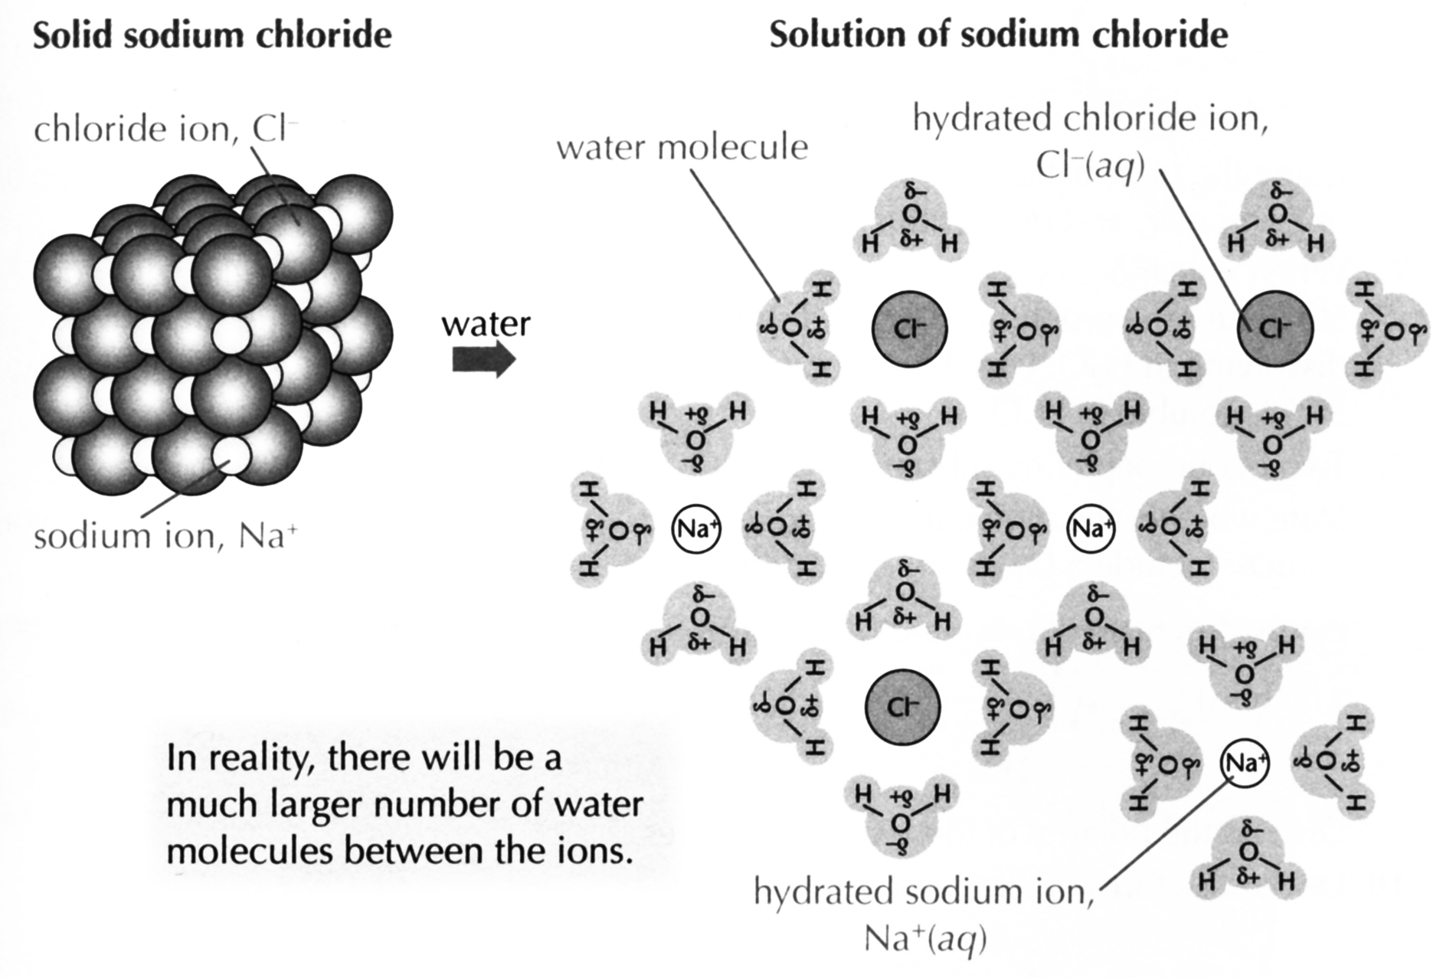  Suzanne Boniface, ESA Study Guide Level 2 Chemistry, page 115 (Auckland: ESA Publications (NZ) Ltd, 2012), p 115. | - Graphene has strong covalent bonds.  Graphene has delocalised electron(s).  - For magnesium OR iodine, reason for ductility given.  - For magnesium OR iodine, reason for solubility given.  - For magnesium OR iodine, reason for electrical conductivity given.  - NaCl is ionic / Na⁺ and Cl–  - H₂O with δ+ and δ –. | Explains why graphene has a high melting point OR conducts electricity, linked to structure and bonding.  - Links structure and bonding in magnesium to TWO of its properties.  - Links structure and bonding in iodine to TWO of its properties.  - Explains the attractions between water molecules and the ions. | - Justifies both properties of graphene in terms of structure and bonding.  - Explains properties of magnesium by linking structure and bonding to all three properties.  Explains properties of iodine by linking structure and bonding to all three properties.  Solubility of NaCl explained, supported by annotated diagram.

2013 | Evidence | Achievement | Merit | Excellence
(i)  (ii) | Chlorine is a molecular substance composed of chlorine molecules held together by weak intermolecular forces. The weak intermolecular forces do not require much heat energy to break, so the boiling point is low (lower than room temperature); therefore chlorine is a gas at room temperature.  Copper chloride is an ionic substance. It is composed of a lattice of positive copper ions and negative chloride ions held together by electrostatic attraction between these positive and negative ions. These are strong forces, therefore they require considerable energy to disrupt them and melt the copper chloride; hence copper chloride is a solid at room temperature.  For a substance to conduct electricity, it must have charged particles which are free to move.  Graphite is a covalent network solid composed of layers of C atoms covalently bonded to three other C atoms. The remaining valence electron is delocalised (ie free to move) between layers; therefore these delocalised electrons are able to conduct electricity.  Copper is a metallic substance composed of copper atoms packed together. Valence electrons are loosely held and are attracted to the nuclei of the neighbouring Cu atoms; ie the bonding is non-directional. These delocalised valence electrons are able to conduct an electrical current.  For a substance to be made into wires, it needs to be stretched or drawn out without breaking. | - Chlorine:  low melting point  OR  is a gas at room temperature  AND  because it has weak intermolecular forces  OR  little energy is needed to turn it into a gas.  - Copper chloride:  High melting point  OR  is a solid at room temperature  AND  because it has strong ionic bonds  OR  a lot of energy would be needed to change it from a solid.  - For something to conduct there must be free moving charged particles.  - Graphite conducts because it has free moving electrons  - Copper conducts because it has free moving electrons.  - For something to be made into wires it needs to be able to be stretched without breaking / ductile | - Explains and links why chlorine is a gas and copper chloride is a solid at room temperature.  Eg: Chlorine:  has low melting point and is a gas at room temperature  because it has weak intermolecular forces and little energy is needed to turn it into a gas  Eg: CuCl₂:  High melting point and is a solid at room temperature  because it has strong ionic bonds and  a lot of energy would be needed to change it from a solid.  - Explains why both graphite and copper conduct electricity.  - Explains why copper is ductile but graphite is not. | Contrasts with reference to bonding and structure why chlorine is a gas at room temperature and copper chloride is a solid at room temperature.  Contrasts with reference to bonding and structure why both graphite and copper can conduct electricity, however only copper is ductile.

2012 | Evidence | Achievement | Merit | Excellence
(i)  (ii) | Silicon dioxide is a covalent network solid. It is made up of silicon and oxygen atoms, with only strong covalent bonds between them. Because the covalent bonds are strong / there are a large number of covalent bonds, it requires a lot of energy to break these bonds and therefore the melting point is high.  Zinc atoms are held together in a 3–D lattice by metallic bonding in which valence electrons are attracted to the nuclei of neighbouring atoms.  Zinc chloride is made up of positive zinc ions and negative chloride ions held together by electrostatic attractions in a 3–D lattice.  Conductivity  Zinc chloride does not conduct electricity as a solid as these ions are not free to move around. (When dissolved in water, the ions are free to move and carry the charge so zinc chloride solution conducts electricity.)  In zinc metal the delocalised electrons / valence electrons are free to move through the lattice; therefore they are able to conduct electricity.  Solubility  Zinc does not dissolve in water because water molecules are not attracted to the zinc atoms in the metallic lattice.  Water molecules are polar. When zinc chloride is dissolved in water the attractions between the polar water molecules and between the ions in the salt are replaced by attractions between the water molecules and the ions. The negative charge on the oxygen ends of the water molecules are attracted to the positive Zn²⁺ ions, and the positive hydrogen ends of the water molecules are attracted to the negative Cl– ions. | - Silicon dioxide has strong covalent bonds.  - High melting point because a lot of energy is required to break the covalent bonds.  - Zinc chloride is made up of zinc ions OR it is held together by ionic bonds.  - For something to conduct there must be free moving charged particles.  - Zinc conducts, because it has free moving electrons.  - Zinc chloride does not conduct as a solid, as the ions are fixed in position.  - Zinc chloride conducts when aqueous or molten, as the ions are free to move.  - Zinc is not soluble, it is a metallic substance.  • Zinc chloride does dissolve  in water, as it is an ionic  substance. | - Explains why silicon dioxide has a high melting point  AND  - Explains why zinc conducts and why zinc chloride does not as a solid  OR  Explains why zinc is insoluble but zinc chloride is soluble. | - In (b) the high melting point of silicon dioxide is explained and justified by the type of bonding.  - Contrasts with reference to bonding and structure why zinc conducts and why zinc chloride will not conduct as a solid.

2011 | Evidence | Achievement | Merit | Excellence
1. (i)  (ii)  2. (a) (i)  (ii)  (b) | Diamond does not conduct electricity and is hard.  Graphite does conduct electricity and is soft.  Diamond consists of C atoms each covalently bonded to four other C atoms, forming a 3-D tetrahedral arrangement.  Graphite consists of C atoms each covalently bonded to three other C atoms in a 2-D or layered arrangement with weak intermolecular forces of attraction between the layers or sheets.  In diamond, the covalent bonds between the carbon atoms are very strong and hold the atoms in place, making it difficult to break the bonds.  Therefore diamond is a very hard substance.  However in graphite, although the bonds between the covalently bonded carbon atoms in the layers are strong, the forces between the layers are weak, resulting in the layers sliding over each other. Therefore graphite is a soft substance.  However, in graphite each carbon atom is bonded to three others in the layers and has one valence electron, which is free to move. These delocalised electrons result in the ability of  graphite to conduct electricity.  In diamond, all of the valence electrons in each carbon atom are involved in bonding to other carbons. There are no mobile electrons to carry charge. Therefore, diamond is unable to conduct.  H₂O – weak force of attraction circled (force between adjacent molecules).  NaCl – ionic bond circled (force between positive and negative ions).  Sodium and chloride ions are held together by strong ionic bonds. A large amount of energy is required to overcome these forces. Hence NaCl has a high melting point.  The forces of attraction between neighbouring water molecules in ice are weak. Only a small amount of energy is required to separate the water molecules from each other, hence ice has a low melting point.  When sodium chloride dissolves in water the ionic lattice breaks up.  Water molecules are polar. The positive hydrogen ends of the water molecules are attracted to the negative ions (Cl–) in the  lattice, and the negative oxygen ends of the water molecules are attracted to the positive ions (Na⁺).  The attraction of the polar water molecules for the ions is sufficient to overcome the attractive forces between the Na⁺ and Cl– ions, allowing them to be removed from the lattice. Hence the sodium chloride solid dissolves, forming separate Na⁺ and Cl– (ions) in aqueous solution. | • BOTH properties of diamond or graphite described.  OR  ONE property described for both substances.  • Structure of both diamond and  graphite described.  OR  Bonding of both diamond and graphite  described.  TWO of  • Two forces / bonds circled  correctly. (Reason used to clarify circled force.) OR Intermolecular attractions in ice are weak and ionic bonds in NaCl are  strong  More energy is required to separate the ions in NaCl (as NaCl has a higher  melting point). OR Less energy is required to melt ice (as ice has a lower melting point).  Polar water molecules attract or surround ions from the lattice.  OR Negative end of water attract or  surround Na⁺ / positive end of water attract or surround Cl–.  (Diagram may be used as evidence.) | For EITHER diamond OR graphite,  BOTH  properties explained in terms of the structure and bonding.  OR  One property explained for both diamond and graphite.  Links made between the energy required to overcome the forces of attraction and the melting point for both substances.  OR  Links made between dissolving and the forces of attraction between ions and the polar  water molecules. | For BOTH diamond AND graphite, BOTH the properties of  diamond and graphite fully  discussed in terms of structure and  bonding.  Links made between the energy required to overcome the forces of  attraction and the melting point for  both substances.  OR  Links made between dissolving and the forces of attraction between ions and the polar  water molecules.

© https://www.chemical-minds.com
NCEA questions and answers reproduced with permission from NZQA

